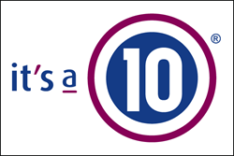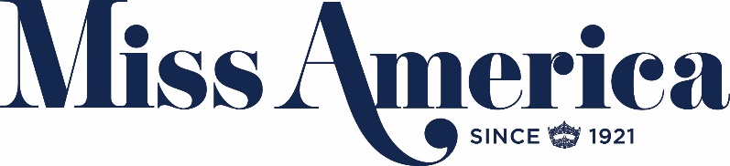

It’s a 10 Haircare Announces Role as Official Professional Hair Care
Sponsor of “The 2018 Miss America Competition”

National Campaign Will Offer Free Miracle Leave-In Product

New York, August 23, 2017 – It’s a 10 Haircare, the go-to hair care brand for professional stylists and clients across the globe, is proud to announce its role as the Official Professional Hair Care Sponsor of “The 2018 Miss America® Competition.” To celebrate, the brand is launching an unprecedented, interactive campaign offering everyone in America a chance to receive a free bottle of the brand’s #1 selling Miracle Leave-In Product if the newly crowned Miss America comes from their state.
Starting today, residents of the fifty states and the District of Columbia can visit http://missamerica.itsa10haircare.com/ to register for this campaign. Registered residents of the state from which the new Miss America hails will automatically receive a free 2 oz. Miracle Leave-In Product in the mail, courtesy of It’s a 10 Haircare. In addition, everyone else who registered coast to coast and in Alaska and Hawaii will also receive a coupon code for a free gift with purchase at Itsa10Haircare.com, regardless of their state.
“This campaign is a way to celebrate not only the women making a difference in the Miss America Competition, but also our fans nationwide who are pursuing their unique dreams, careers and philanthropic endeavors,” said Carolyn Aronson, Founder and CEO of It’s a 10 Haircare. “The Miss America Organization’s philanthropic arm is particularly appealing to me, as I have made it my mission to give back in ways that empower women and celebrate diversity. Together, we are going to reach millions of Americans and help them feel recognized and inspired – we couldn’t have hoped for a better partnership.”

During the broadcast of “The 2018 Miss America Competition,” Aronson will share her story and talk about the promotion.
Registration at http://missamerica.itsa10haircare.com/ will close at the end of the broadcast of “The 2018 Miss America Competition” in each local time zone, meaning all who wish to register should do so before the new Miss America is announced on their local broadcast. For full terms and conditions, please refer to the site.
“The 2018 Miss America Competition” will broadcast live on ABC from Atlantic City’s Boardwalk Hall on Sunday, September 10th (9:00 – 11:00p.m. ET and PT).

The Miss America Competition showcases the intellect, grace, and exceptional talent of 51 accomplished women representing their home states (and District of Columbia) as they compete for the coveted title of Miss America. As previously announced, Chris Harrison (ABC’s “The Bachelor” franchise and “Who Wants To Be A Millionaire”) returns to host the legendary competition, with Sage Steele (ESPN’s “SportsCenter on the Road” and “SportsCenter: AM”) joining as co-host. Celebrity judges for the final night of the competition include Thomas Rhett, Molly Sims, Jordin Sparks, and Jess Cagle.

For the latest news, be sure to follow Miss America (@MissAmerica) and It’s a 10 Haircare (@itsa10haircare) on social and join the conversation by using the official hashtag for the show, #MissAmerica.

About It’s a 10 Haircare:
It's a 10 Haircare is an established, professional hair care line offering exceptional multipurpose products via salons and beauty supply stores worldwide. As one of the only female-owned professional hair care brands in the world, It’s a 10 Haircare is dedicated to providing customers with the best hair experience possible. It’s a 10 Haircare’s collections include exceptional 10-in-1 multi-purpose products perfected and simplified to one unique lineup, providing solutions to all possible hair care needs.

About The Miss America Organization:
The Miss America Organization, a 501(c) 4 non-profit corporation, awards millions of dollars in annual college scholarship assistance making it the largest scholarship program for women in the United States. MAO is comprised of 51 organizations, including all 50 states and the District of Columbia. MAO contestants contribute over 500,000 hours of community service annually and have raised over $16 million for Children's Miracle Network Hospitals since 2007.

About dick clark productions:
dick clark productions (dcp) is the world's largest producer and proprietor of televised live event entertainment programming with the "Academy of Country Music Awards," "American Music Awards," "Billboard Music Awards," "Dick Clark's New Year's Rockin' Eve with Ryan Seacrest," "Golden Globe Awards," “Miss America,” “Hollywood Film Awards” and the “Streamy Awards.” Weekly television programming includes "So You Think You Can Dance" from 19 Entertainment and dcp. dcp also owns one of the world's most unique and extensive entertainment archive libraries with more than 55 years of award-winning shows, historic programs, specials, performances, and legendary programming. For additional information, visit www.dickclark.com.

# # #

MEDIA CONTACTS:
It’s a 10 Haircare:
Alise Edgcomb ItsA10@5wpr.com
646-653-7097

Miss America Organization:
Chelsea Mineur
chelsea.mineur@missamerica.org
609-344-1800

dick clark productions:
Allie Stockton
astockton@dickclark.com
310-255-0321

