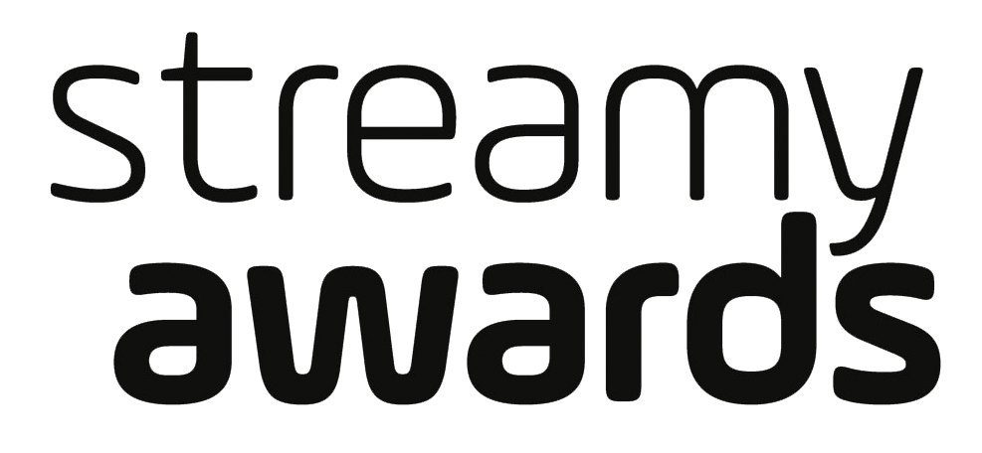

SOCIAL MEDIA SUPERSTAR JON COZART TO HOST

7TH ANNUAL STREAMY AWARDS

Connor Franta, Gigi Gorgeous, Mamrie Hart, Grace Helbig, Laura Marano, Tyler Oakley, Lilly Singh, The Try Guys, And More To Present

The 7th Annual Streamy Awards will be streamed LIVE on Twitter on Tuesday, September 26, 2017 at 9:30PM ET / 6:30PM PT from The Beverly Hilton

Fan Voting for Creator of the Year and Show of the Year Still Open

For AMAZING Streamy Awards + Jon Cozart photos and video assets, please go to: http://bit.ly/Streamys17

SANTA MONICA, CA (September 19, 2017) – dick clark productions and Tubefilter announced today that comedian and musical YouTube star Jon Cozart will host the 7th Annual Streamy Awards. Also joining him on stage will be presenters Zach Anner, Gabriel & Jess Conte, Ricky Dillon, Connor Franta, Brittany Furlan, AJ Gibson, Gigi Gorgeous, GloZell Green, Eva Gutowski, Mamrie Hart, Ian Hecox, Grace Helbig, Kandee Johnson, King Bach, Liza Koshy, LaurDIY, Laura Marano, Jenna Marbles, Shaun McBride (Shonduras), Merrell Twins, Niki & Gabi, Tyler Oakley, Rosanna Pansino, DeStorm Power, Andrea Russett, Lilly Singh, Matt Steffanina, Mari Takahashi, Meghan Tonjes, The Try Guys, What’s Up Moms, and Juanpa Zurita. They join previously announced performers, iconic 70s disco group, Village People, who will close out the night with a medley of their most beloved songs.

The 2017 Streamy Awards will take place at the iconic Beverly Hilton on Tuesday, September 26 at 9:30PM ET / 6:30PM PT and will be streamed worldwide to logged-in and logged-out audiences on Twitter and connected devices at streamys.twitter.com or via @streamys.

“I'd say me hosting this year goes along with everything else happening in 2017. So, like, poor decisions all around but I guess I'm happy about it,” said host Jon Cozart.
Jon Cozart is a filmmaker, musical comedian, and entrepreneur, having spent a decade in the online video space and graduating from The University of Texas' film program. With an emphasis on high concept, high quality, highly offensive acapella comedy, Cozart has garnered four million YouTube subscribers on his channel, Paint, with only forty videos to his name, a rarity in the space. Drawing inspiration from the likes of Tim Minchin and Bo Burnham, Jon performed a one man show for the duration of the 2015 Edinburgh Fringe Festival, 25 shows back to back, and now has his sights set on TV writing, gay tinder, and furthering his comedic sensibilities. He’s looking forward to leaving his mark on the 2017 Streamy Awards. Cozart is represented by Sarah Weichel and WME.

The nominees for the 7th Annual Streamy Awards were announced last month. YouTube personality and filmmaker Casey Neistat and go90’s original series Mr. Student Body President led with six nominations each. DeStorm Power’s independent drama series Caught, actor, comedian and author Lilly Singh, and Steven Suptic’s breakout show Sugar Pine 7 garnered four nominations each.

Additionally, fan voting for the two Audience Choice categories – Creator of the Year and Show of the Year - is still open. Fans can vote once per day per category by tweeting out a nominee’s specific hashtag. Voting for both categories will close at 7PM PT on Tuesday, September 26, which is 30 minutes into the live stream of the 7th Annual Streamy Awards. Fans should be sure to only include one of the below hashtags per voting tweet!

Creator of the Year:

Cameron Dallas - #CameronForStreamys
Casey Neistat - #CaseyForStreamys
David Dobrik - #DavidForStreamys
Dolan Twins - #DolanForStreamys
Jake Paul - #JakeForStreamys
Jenna Marbles - #JennaForStreamys
Lilly Singh - #LillyForStreamys
Liza Koshy - #LizaForStreamys
Logan Paul - #LoganForStreamys
Shane Dawson - #ShaneForStreamys

Show of the Year:

Good Mythical Morning - #GMMForStreamys
Kian & JC - #KianJCForStreamys
The King of Random - #TKORForStreamys
The Philip DeFranco Show - #DeFrancoShowForStreamys
REACT - #REACTForStreamys
Rooster Teeth - #RoosterTeethForStreamys
Sugar Pine 7 - #SP7ForStreamys
The Try Guys - #TryGuysForStreamys
UNHhhh - #UNHhhhForStreamys
The Young Turks - #TYTForStreamys

Winners of the Streamy Awards will be determined by the Streamys Blue Ribbon Panel, a judging body of creators, executives, and other experts in the online video industry. Fans will be able to vote for their favorite nominees in the two Audience Choice categories – Creator of the Year and Show of the Year – leading up to the live show on September 26.

Continuing to reflect the current state of original programming native to online and social video, the 7th Annual Streamy Awards have made the following updates, including:
- An expansion of the Branded and Social Good categories, including the establishment of “The Purpose Awards,” which takes place during Streamy week on Sept. 25.
- Greater emphasis on original series with the addition of Comedy and Drama Series awards
- The removal of gender distinction in the performance categories
- Select categories encompassed submissions from creators who distribute video primarily via social media platforms

The live stream of the 6th Annual Streamy Awards garnered over 2.1 million live + VOD views, including an 128% increase in live stream views over the prior year. Additionally, over 6.8MM total votes were cast for the Audience Choice categories at the 6th Annual Streamy Awards, which was an 81% increase from the year prior.

The 7th Annual Streamy Awards is Executive Produced by dick clark productions’ Allen Shapiro, Mike Mahan and Ariel Elazar, as well as Streamy Awards founders Drew Baldwin and Joshua Cohen. Producers include dick clark productions’ Rika Camizianos, Alexi Mazareas and Michael Nieporent.

For more information, visit www.streamys.org. Join the conversation on social media with #streamys and be sure to follow Streamy Awards on Facebook, Twitter, Instagram, Tumblr, and Snapchat.

Cheat Tweet: .@joncozart is hosting the 7th Annual @streamys! LIVE 9/26 on Twitter: streamys.news/joncozart #streamys

About the Streamy Awards
The Streamy Awards honor the best in online video and the creators behind it. The annual event brings together the biggest names in YouTube and online video for a night of celebration, discovery, and meaningful recognition. 2017 also marks the first ever installment of ““The Purpose Awards @ The Streamy Awards,” an annual event recognizing individuals and organizations making a difference in their communities and positively impacting humankind.

About dick clark productions
dick clark productions (dcp) is the world's largest producer and proprietor of televised live event entertainment programming with the "Academy of Country Music Awards," "American Music Awards," "Billboard Music Awards," "Dick Clark's New Year's Rockin' Eve with Ryan Seacrest," "Golden Globe Awards," “Miss America,” “Hollywood Film Awards” and the “Streamy Awards.” Weekly television programming includes "So You Think You Can Dance" from 19 Entertainment and dcp. dcp also owns one of the world's most unique and extensive entertainment archive libraries with more than 55 years of award-winning shows, historic programs, specials, performances and legendary programming. For additional information, visit www.dickclark.com.

About Tubefilter
Tubefilter is the most trusted and widely read source for YouTube and online video news, analysis, and events. Through its trade news and analysis, community events, and creator advocacy programs, Tubefilter has helped to foster the growth, promotion, and legitimization of a new, independent professional entertainment industry. Tubefilter properties include its flagship publication, Tubefilter News, the Tubefilter Charts, its popular YouTube Millionaires series, and the Streamy Awards. For additional information, visit www.tubefilter.com.

# # #

For Press Inquiries:

SLATE PR

Andy Gelb, 310-461-0111, andy@slate-pr.com

Elyse Weissman, 310-461-0114, elyse@slate-pr.com

dick clark productions

Kelly Striewski, 310-255-4602, kstriewski@dickclark.com

Allie Stockton, 310-255-0321, astockton@dickclark.com

For Talent Booking:

Krissy Lindquist, 310-255-4671, krissylindquist@gmail.com

To Purchase Tickets, Tables or Partnership Opportunities:

Marisa Pratt, 310-255-4618, mpratt@dickclark.com

