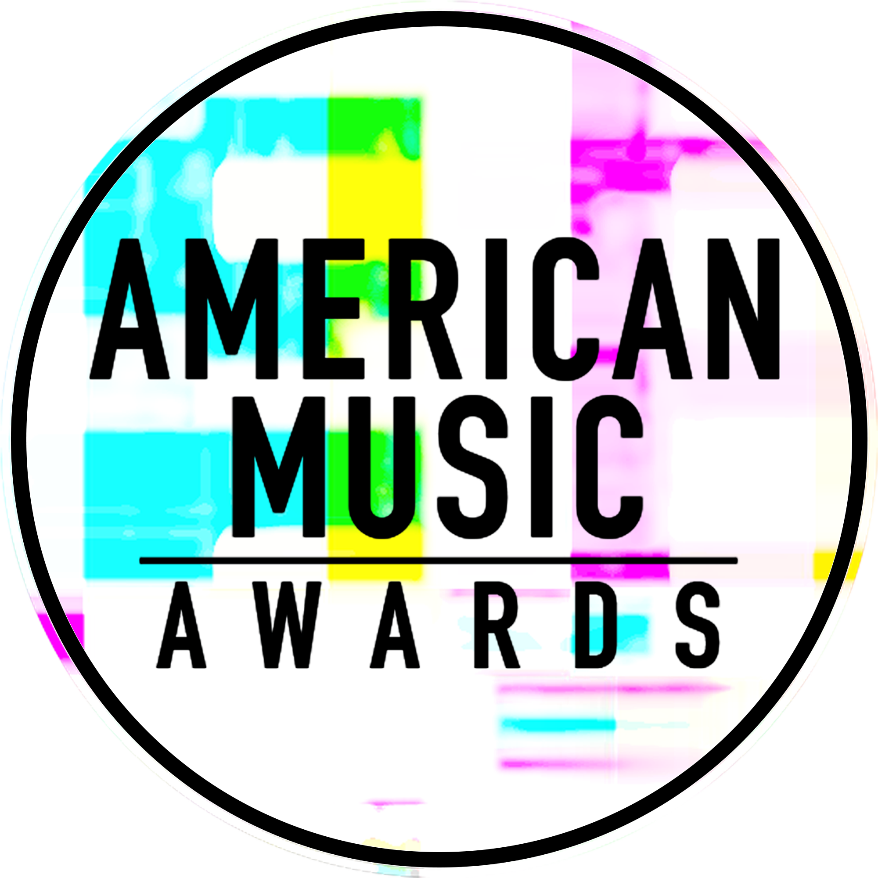

THE “AMERICAN MUSIC AWARDS®” ANNOUNCES 2017 NOMINEES

WORLD’S LARGEST FAN-VOTED AWARDS SHOW TO
CELEBRATE 45 YEARS OF GIVING FANS THE VERY BEST IN MUSIC

SUNDAY, NOVEMBER 19, ON ABC

Bruno Mars Earns 8 Nominations, While The Chainsmokers, Drake, Kendrick Lamar,
Ed Sheeran and The Weeknd Tie with Five Nominations Each

2017 Artist of the Year Nominees Include Bruno Mars, The Chainsmokers,
Drake, Kendrick Lamar and Ed Sheeran

For digital assets and nominee gif galleries, please go to: http://bit.ly/AMAsMedia17

Los Angeles, CA (October 12, 2017) – The “2017 American Music Awards” will mark the 45th anniversary of the legendary music awards show that has brought fans the biggest musical superstars and most compelling live performances over the last four decades. As the kick-off to this year’s highly anticipated show, international music sensation Ciara today announced six categories from the “2017 American Music Awards” nominees live on ABC’s “Good Morning America,” followed by a full reveal of all nominees via Facebook Live on the American Music Awards and Billboard pages.

The “2017 American Music Awards” will broadcast live from the Microsoft Theater in Los Angeles on Sunday, November 19, 2017 at 8:00pm ET on ABC. The American Music Awards, the world’s largest fan-voted awards show, is where music enthusiasts watch their favorite artists and pop culture icons come together to honor idols, newcomers and record-breakers in the contemporary music scene. From Pop and Rock, to Country, Hip Hop and beyond, this year’s show will celebrate 45 years of the best moments in music with appearances by today’s brightest stars and live performances from the biggest names in music.

Bruno Mars leads with eight nominations, including Artist of the Year, Video of the Year, and Favorite Male Artist – Pop/Rock. The Chainsmokers, Drake, Kendrick Lamar, Ed Sheeran and The Weeknd tied with five nominations each. Justin Bieber, Daddy Yankee and Luis Fonsi received four nominations each. Additionally, Keith Urban earned three nominations.

The Artist of the Year nominees are Bruno Mars, The Chainsmokers, Drake, Kendrick Lamar and Ed Sheeran. Voting for Artist of the Year opened today and will close on Thursday, November 16 at 8:59:59pm PT. Voting for all other editorial categories closes on Monday, November 13 at 8:59:59am PT.

American Music Awards nominees are based on key fan interactions as reflected in Billboard Magazine and on Billboard.com, including album and digital song sales, radio airplay, streaming, social activity and touring. These measurements are tracked by Billboard and its data partners, including Nielsen Music and Next Big Sound.

The American Music Awards winners are voted entirely by fans. Voting opened today in all categories except New Artist of the Year presented by T-Mobile and Collaboration of the Year presented by Xfinity, which will both open on Wednesday, November 1.
For New Artist of the Year presented by T-Mobile and Collaboration of the Year presented by Xfinity, fans can vote for each award 100 times per day, per voting platform in one or both of the ways below. Fans can vote for all other awards once per day, per voting platform.
- Via web at billboard.com/amas and theamas.com/vote
- Posting a tweet on Twitter that includes the nominee's name or Twitter handle, the category name and #AMAs within the tweet
2017 AMERICAN MUSIC AWARDS TOP NOMINATED ARTISTS CHART FACTS:
- Celebrated musician Bruno Mars’ third full-length studio album, 24K Magic, debuted at No. 2 on the Billboard 200 chart, granting the performer his third top 10 effort. The album spun off a trio of top 40-charting hits on the Billboard Hot 100, so far: “24K Magic,” “That’s What I Like” and “Versace On the Floor.” In 2017, “That’s What I Like” became Mars’ seventh No. 1 on the Billboard Hot 100, following his previous leaders “Uptown Funk!” (Mark Ronson featuring Mars), “When I Was Your Man,” “Locked Out of Heaven,” “Grenade,” “Just the Way You Are” and “Nothin’ On You” (B.o.B featuring Mars).
- Debuting at No. 1 on the Billboard 200 chart in December of 2016, The Weeknd’s Starboy album marked his second straight No. 1, following 2015’s Beauty Behind the Madness. Starboy yielded a No. 1 Billboard Hot 100 hit with its title track, as well as a No. 4 smash with “I Feel It Coming.” Both tracks feature Daft Punk. All 18 songs from Starboy charted on the Billboard Hot 100.
- R&B singer Drake’s More Life was his seventh straight album to debut at No. 1 on the Billboard 200 chart. More Life became the first album to earn over 375 million on-demand U.S. audio streams of its tracks in a single week, according to Nielsen Music. The album set the record in the week ending March 24. Drake wrapped a record 431 consecutive weeks on the Billboard Hot 100 in August, which dates back to his first appearance in 2009. The streak is the longest among all artists in Hot 100 history. Drake placed a record 24 titles on the Hot 100 at once, on the chart dated April 8, 2017. Drake linked 51 straight weeks in the Hot 100’s top 10, the longest streak by a male act. His run began on Oct. 3, 2015 with “Hotline Bling” and ended on Sept. 24, 2016, when “One Dance” fell from the tier. Drake has placed a record 157 songs on the Billboard Hot 100 in his career.
- Rapper and song-writer Kendrick Lamar earned his first Billboard Hot 100 No. 1 hit as a lead act with “Humble.” in 2017. He scored his second No. 1 album on the Billboard 200 with DAMN., which had the best first-sales week of his career (353,000 copies sold in its first week, according to Nielsen Music). Lamar was the first artist of 2017 to post two concurrent titles in the Hot 100’s top five with “Humble.” and “DNA.” on May 6.
- Ed Sheeran scored his first Billboard Hot 100 No. 1 in 2017 with "Shape of You," which debuted at No. 1 and reigned for 12 weeks. "Shape of You" broke the record for the most time spent in the Billboard Hot 100's top 10: 33 weeks. Sheeran became the first artist to debut two titles in the Billboard Hot 100's top 10 simultaneously, with "Shape of You" and "Castle on the Hill." Sheeran earned his second Billboard 200 No. 1 album with ÷ (Divide). Upon its No. 1 debut on the Billboard 200, ÷ (Divide) generated 13 simultaneous entries on the Billboard Hot 100 songs chart.
- Music duo of Drew Taggart and Andrew Pall, The Chainsmokers, charted three songs in the Billboard Hot 100's top 10 in the past year, including the chart-topping “Closer,” featuring Halsey. “Closer” became just the 17th song in the Hot 100's history to spend at least 12 weeks at No. 1. “Closer” spent 27 weeks at No. 1 on Hot Dance/Electronic Songs, breaking the 26-week record previously held by Avicii's "Wake Me Up!" The Chainsmokers earned three No. 1 hits on the Hot Dance/Electronic Songs chart over the past year: "Closer," "Paris" and "Something Just Like This," with Coldplay. Their debut full-length set Memories...Do Not Open opened at No. 1 on the Billboard 200. It was the first No. 1 for a dance/electronic album in three-and-a-half years.
- Pop superstar Justin Bieber joined Luis Fonsi and Daddy Yankee on the No. 1 Billboard Hot 100 hit "Despacito." It tied the record for the longest run at No. 1 — 16 weeks. With "Despacito," Bieber jumped to his first No. 1 on Billboard's Hot Latin Songs chart. Bieber banked his first No. 1 on both the Hot R&B/Hip-Hop Songs and Hot Rap Songs charts as featured on DJ Khaled's all-star "I'm the One." Bieber became the first artist ever to tally new No. 1s on the Billboard Hot 100 in back-to-back weeks, with "I'm the One" and "Despacito" (on charts May 20 and 27). Bieber has spent more than three years cumulatively at No. 1 on Billboard's Social 50 chart, easily the most among all acts since the list's inception at the start of the decade.
- Daddy Yankee claimed his first No. 1 on the Billboard Hot 100 with "Despacito" (Luis Fonsi and Daddy Yankee featuring Justin Bieber), which tied the record for most weeks spent at No. 1: 16 weeks. “Despacito” spent 16 weeks at No. 1 on the Billboard Hot 100 – tying the record for the longest run at No. 1 in the chart’s history. He has tallied more than 50 hits on the Hot Latin Songs chart, including top 40-charting singles in the past year like “Hula Hoop” and “La Rompe Corazones,” with Ozuna.
- Puerto Rican singer-songwriter Luis Fonsi’s “Despacito,” with Daddy Yankee and featuring Justin Bieber, spent 16 weeks at No. 1 on the Billboard Hot 100 – tying the record for the longest run at No. 1 in the chart’s history. “Despacito” marked Fonsi’s third hit on the Hot 100, but he’s been charting hits on the Hot Latin Songs chart since 1998, where he’s notched 30 hits. Overall, on Hot Latin Songs, Fonsi has collected 11 top 10 hits, seven of which reached No. 1 (including “Despacito”).
- Premier country musician Keith Urban’s “The Fighter,” featuring Carrie Underwood, marked the former’s 38th straight top 10 on the Hot Country Songs chart. Urban’s hit “Blue Ain’t Your Color” topped Hot Country Songs for 12 weeks from Nov. 19, 2016 – Feb. 4, 2017. His latest album, 2016’s Ripcord, became his fifth Top Country Albums No. 1 and sixth top 10 on the Billboard 200. “The Fighter” reached No. 40 on Billboard’s Adult Pop Songs airplay chart, his first hit on the chart since 2009’s “Kiss a Girl.” Further, the crossover track climbed to No. 15 on Billboard’s Adult Contemporary chart.
- Pop superstar Rihanna notched her 60th hit on the Billboard Hot 100 with “Wild Thoughts” (DJ Khaled featuring Rihanna and Bryson Tiller). “Wild Thoughts” became the diva’s 31st top 10 hit on the Hot 100 and seventh No. 1 on the Hot R&B/Hip-Hop Songs chart. She added three new No. 1s on the Rhythmic Songs airplay chart in the past year: "Too Good" (Drake featuring Rihanna), "Loyalty." (Kendrick Lamar featuring Rihanna) and "Wild Thoughts."
Sponsors for the “2017 American Music Awards” include Comcast’s Xfinity and T-Mobile. Media partners include Cumulus Media/ Westwood One and Music Choice.

The “2017 American Music Awards” is produced by dick clark productions. Allen Shapiro and Mike Mahan are Executive Producers. Larry Klein, Barry Adelman and Mark Bracco are Producers.

Below please find the full list of nominations for the 2017 American Music Awards®:

2017 AMERICAN MUSIC AWARDS® NOMINEES – nomination GIFs are hyperlinked to the category names

ARTIST OF THE YEAR
- Bruno Mars
- The Chainsmokers
- Drake
- Kendrick Lamar
- Ed Sheeran

NEW ARTIST OF THE YEAR PRESENTED BY T-MOBILE
- James Arthur
- Niall Horan
- Julia Michaels
- Post Malone
- Rae Sremmurd

COLLABORATION OF THE YEAR PRESENTED BY XFINITY
- The Chainsmokers featuring Halsey “Closer”
- DJ Khaled featuring Justin Bieber, Quavo, Chance the Rapper and Lil Wayne “I’m the One”
- Luis Fonsi and Daddy Yankee featuring Justin Bieber “Despacito”
- Maroon 5 featuring Kendrick Lamar “Don’t Wanna Know”
- The Weeknd featuring Daft Punk “Starboy”

TOUR OF THE YEAR
- Garth Brooks
- Coldplay
- U2

VIDEO OF THE YEAR
- Bruno Mars “That’s What I Like”
- Luis Fonsi featuring Daddy Yankee “Despacito”
- Ed Sheeran “Shape of You”

FAVORITE MALE ARTIST – POP/ROCK
- Bruno Mars
- Drake
- Ed Sheeran

FAVORITE FEMALE ARTIST – POP/ROCK
- Alessia Cara
- Lady Gaga
- Rihanna

FAVORITE DUO OR GROUP – POP/ROCK
- The Chainsmokers
- Coldplay
- Imagine Dragons

FAVORITE ALBUM – POP/ROCK
- Bruno Mars “24K Magic”
- Drake “More Life”
- The Weeknd “Starboy”

FAVORITE SONG – POP/ROCK
- The Chainsmokers featuring Halsey “Closer”
- Luis Fonsi and Daddy Yankee featuring Justin Bieber “Despacito”
- Ed Sheeran “Shape of You”

FAVORITE MALE ARTIST – COUNTRY
- Sam Hunt
- Thomas Rhett
- Keith Urban

FAVORITE FEMALE ARTIST – COUNTRY
- Miranda Lambert
- Maren Morris
- Carrie Underwood

FAVORITE DUO OR GROUP – COUNTRY
- Florida Georgia Line
- Little Big Town
- Old Dominion

FAVORITE ALBUM – COUNTRY
- Jason Aldean “They Don’t Know”
- Chris Stapleton “From A Room: Volume 1”
- Keith Urban “Ripcord”

FAVORITE SONG – COUNTRY
- Sam Hunt “Body Like A Back Road”
- Jon Pardi “Dirt On My Boots”
- Keith Urban “Blue Ain’t Your Color”

FAVORITE ARTIST – RAP/HIP-HOP
- Drake
- Kendrick Lamar
- Migos

FAVORITE ALBUM – RAP/HIP-HOP
- Drake “More Life”
- Kendrick Lamar “DAMN.”
- Migos “Culture”

FAVORITE SONG – RAP/HIP-HOP
- DJ Khaled featuring Justin Bieber, Quavo, Chance the Rapper and Lil Wayne “I’m the One”
- Kendrick Lamar “HUMBLE.”
- Rae Sremmurd featuring Gucci Mane “Black Beatles”

FAVORITE MALE ARTIST – SOUL/R&B
- Bruno Mars
- Childish Gambino
- The Weeknd

FAVORITE FEMALE ARTIST – SOUL/R&B
- Beyoncé
- Kehlani
- Rihanna

FAVORITE ALBUM – SOUL/R&B
- Bruno Mars “24K Magic”
- Childish Gambino “Awaken, My Love!”
- The Weeknd “Starboy”

FAVORITE SONG – SOUL/R&B
- Bruno Mars “That’s What I Like”
- Khalid “Location”
- The Weeknd “Starboy”

FAVORITE ARTIST – ALTERNATIVE ROCK
- Imagine Dragons
- Linkin Park
- twenty one pilots

FAVORITE ARTIST – ADULT CONTEMPORARY
- Bruno Mars
- Shawn Mendes
- Ed Sheeran

FAVORITE ARTIST - LATIN
- Daddy Yankee
- Luis Fonsi
- Shakira

FAVORITE ARTIST – CONTEMPORARY INSPIRATIONAL
- Lauren Daigle
- MercyMe
- Chris Tomlin

FAVORITE ARTIST – ELECTRONIC DANCE MUSIC (EDM)
- The Chainsmokers
- DJ Snake
- Calvin Harris

TOP SOUNDTRACK
- Guardians of the Galaxy, Vol. 2: Awesome Mix Vol. 2
- Moana
- Trolls

For the latest American Music Awards news, exclusive content and more, be sure to follow the AMAs on social and join the conversation by using the official hashtag for the show, #AMAs.

Facebook: Facebook.com/AMAs
Twitter: @AMAs
Instagram: @AMAs
Snapchat: TheAMAs
Tumblr: amas.tumblr.com

Cheat tweet: .@BrunoMars leads the 2017 @AMAs with 8 nominations! Full list of nominees here: amas.news/nominees17 #AMAs

Tickets are now on sale at www.axs.com.

About the American Music Awards
The American Music Awards, the world’s biggest fan-voted award show, features performances from today’s hottest artists and presents fan-voted awards in the music genres of Pop/Rock, Alternative Rock, Country, Rap/Hip-Hop, Soul/R&B, Adult Contemporary, Contemporary Inspirational, Latin, EDM and Soundtrack, and the categories of Artist of the Year, New Artist of the Year presented by T-Mobile, Collaboration of the Year presented by Xfinity, Tour of The Year and Video of the Year. The American Music Awards pays tribute to today’s most influential and iconic artists. The show is produced by dick clark productions and is seen in more than 200 countries around the world. For more information, visit www.theamas.com, www.dickclark.com or abc.go.com/shows/american-music-awards.
About dick clark productions
dick clark productions (dcp) is the world's largest producer and proprietor of televised live event entertainment programming with the "Academy of Country Music Awards," "American Music Awards," "Billboard Music Awards," "Dick Clark's New Year's Rockin' Eve with Ryan Seacrest," "Golden Globe Awards," “Miss America,” “Hollywood Film Awards” and the “Streamy Awards.” Weekly television programming includes "So You Think You Can Dance" from 19 Entertainment and dcp. dcp also owns one of the world's most unique and extensive entertainment archive libraries with more than 55 years of award-winning shows, historic programs, specials, performances and legendary programming. For additional information, visit www.dickclark.com.

SHOW MEDIA CREDENTIALS
To apply for media credentials to cover the “2017 American Music Awards” please go to here. Submissions for credentials will stay open until 6pm PT on Friday, November 3, 2017.

Media Contacts
dick clark productions:
Kelly Striewski 310-255-4602 KStriewski@dickclark.com
Gina Sorial 310-255-0308 GSorial@dickclark.com

Slate PR
Andy Gelb 310-461-0111 Andy@slate-pr.com
Rachael Trager 212-235-6817 Rachael@slate-pr.com

ABC Media Relations:
Nicole Gonzales 818-460-7421 Nicole.J.Gonzales@abc.com
Nate Reeves 818-460-6422 Nate.Reeves@abc.com

Latin Press Inquiries:
Diana Baron 310-315-5444 diana@dbaronmedia.com

NOMINATIONS IN ALPHABETICAL ORDER (BY FIRST NAME):

Alessia Cara (1): Favorite Female Artist – Pop/Rock

Beyoncé (1): Favorite Female Artist – Soul/R&B

Bruno Mars (8): Artist of the Year, Video of the Year, Favorite Male Artist – Pop/Rock, Favorite Album – Pop/Rock, Favorite Male Artist – Soul/R&B, Favorite Album – Soul/R&B, Favorite Song – Soul/R&B, Favorite Artist – Adult Contemporary

Calvin Harris (1): Favorite Artist – Electronic Dance Music (EDM)

Carrie Underwood (1): Favorite Female Artist – Country

Chance the Rapper (2): Collaboration of the Year presented by Xfinity, Favorite Song – Rap/Hip-Hop

Childish Gambino (2): Favorite Male Artist – Soul/R&B, Favorite Album – Soul/R&B

Chris Stapleton (1): Favorite Album – Country

Chris Tomlin (1): Favorite Artist – Contemporary Inspirational

Coldplay (2): Tour of the Year, Favorite Duo or Group – Pop/Rock

Daddy Yankee (4): Collaboration of the Year presented by Xfinity, Video of the Year, Favorite Song – Pop/Rock, Favorite Artist – Latin

Daft Punk (1): Collaboration of the Year presented by Xfinity

DJ Khaled (2): Collaboration of the Year presented by Xfinity, Favorite Song – Rap/Hip-Hop

DJ Snake (1): Favorite Artist – Electronic Dance Music (EDM)

Drake (5): Artist of the Year, Favorite Male Artist – Pop/Rock, Favorite Album – Pop/Rock, Favorite Artist – Rap/Hip-Hop, Favorite Album – Rap/Hip-Hop

Ed Sheeran (5): Artist of the Year, Video of the Year, Favorite Male Artist – Pop/Rock, Favorite Song – Pop/Rock, Favorite Artist – Adult Contemporary

Florida Georgia Line (1): Favorite Duo or Group – Country

Garth Brooks (1): Tour of the Year

Guardians of the Galaxy, Vol. 2: Awesome Mix Vol. 2 (1): Favorite Soundtrack

Gucci Mane (1): Favorite Song – Rap/Hip-Hop,

Halsey (2): Collaboration of the Year presented by Xfinity, Favorite Song – Pop/Rock

Imagine Dragons (2): Favorite Duo or Group – Pop/Rock, Favorite Artist – Alternative Rock

James Arthur (1): New Artist of the Year presented by T-Mobile

Jason Aldean (1): Favorite Album – Country

Jon Pardi (1): Favorite Song – Country

Julia Michaels (1): New Artist of the Year presented by T-Mobile

Justin Bieber (4): Collaboration of the Year presented by Xfinity (x2), Favorite Song – Pop/Rock, Favorite Song – Rap/Hip-Hop

Kehlani (1): Favorite Female Artist – Soul/R&B

Keith Urban (3): Favorite Male Artist – Country, Favorite Album – Country, Favorite Song – Country

Kendrick Lamar (5): Artist of the Year, Collaboration of the Year presented by Xfinity, Favorite Artist – Rap/Hip-Hop, Favorite Album – Rap/Hip-Hop, Favorite Song – Rap/Hip-Hop

Khalid (1): Favorite Song – Soul/R&B

Lady Gaga (1): Favorite Female Artist – Pop/Rock

Lauren Daigle (1): Favorite Artist – Contemporary Inspirational

Lil Wayne (2): Collaboration of the Year presented by Xfinity, Favorite Song – Rap/Hip-Hop

Linkin Park (1): Favorite Artist – Alternative Rock

Little Big Town (1): Favorite Duo or Group – Country

Luis Fonsi (4): Collaboration of the Year presented by Xfinity, Video of the Year, Favorite Song – Pop/Rock, Favorite Artist – Latin

Maren Morris (1): Favorite Female Artist – Country

Maroon 5 (1): Collaboration of the Year presented by Xfinity

MercyMe (1): Favorite Artist – Contemporary Inspirational

Migos (2): Favorite Artist – Rap/Hip-Hop, Favorite Album – Rap/Hip-Hop

Miranda Lambert (1): Favorite Female Artist – Country

Moana (1): Top Soundtrack

Niall Horan (1): New Artist of the Year presented by T-Mobile

Old Dominion (1): Favorite Duo or Group – Country

Post Malone (1): New Artist of the Year presented by T-Mobile

Quavo (2): Collaboration of the Year presented by Xfinity, Favorite Song – Rap/Hip-Hop

Rae Sremmurd (2): New Artist of the Year presented by T-Mobile, Favorite Song – Rap/Hip-Hop

Rihanna (2): Favorite Female Artist – Pop/Rock, Favorite Female Artist – Soul/R&B

Sam Hunt (2): Favorite Male Artist – Country, Favorite Song – Country

Shakira (1): Favorite Artist – Latin

Shawn Mendes (1): Favorite Artist – Adult Contemporary

The Chainsmokers (5): Artist of the Year, Collaboration of the Year presented by Xfinity, Favorite Duo or Group – Pop/Rock, Favorite Song – Pop/Rock, Favorite Artist – Electronic Dance Music (EDM)

The Weeknd (5): Collaboration of the Year presented by Xfinity, Favorite Album – Pop/Rock, Favorite Male Artist – Soul/R&B, Favorite Album – Soul/R&B, Favorite Song – Soul/R&B

Thomas Rhett (1): Favorite Male Artist – Country

Trolls (1): Top Soundtrack

twenty one pilots (1): Favorite Artist – Alternative Rock

U2 (1): Tour of the Year

# # #

