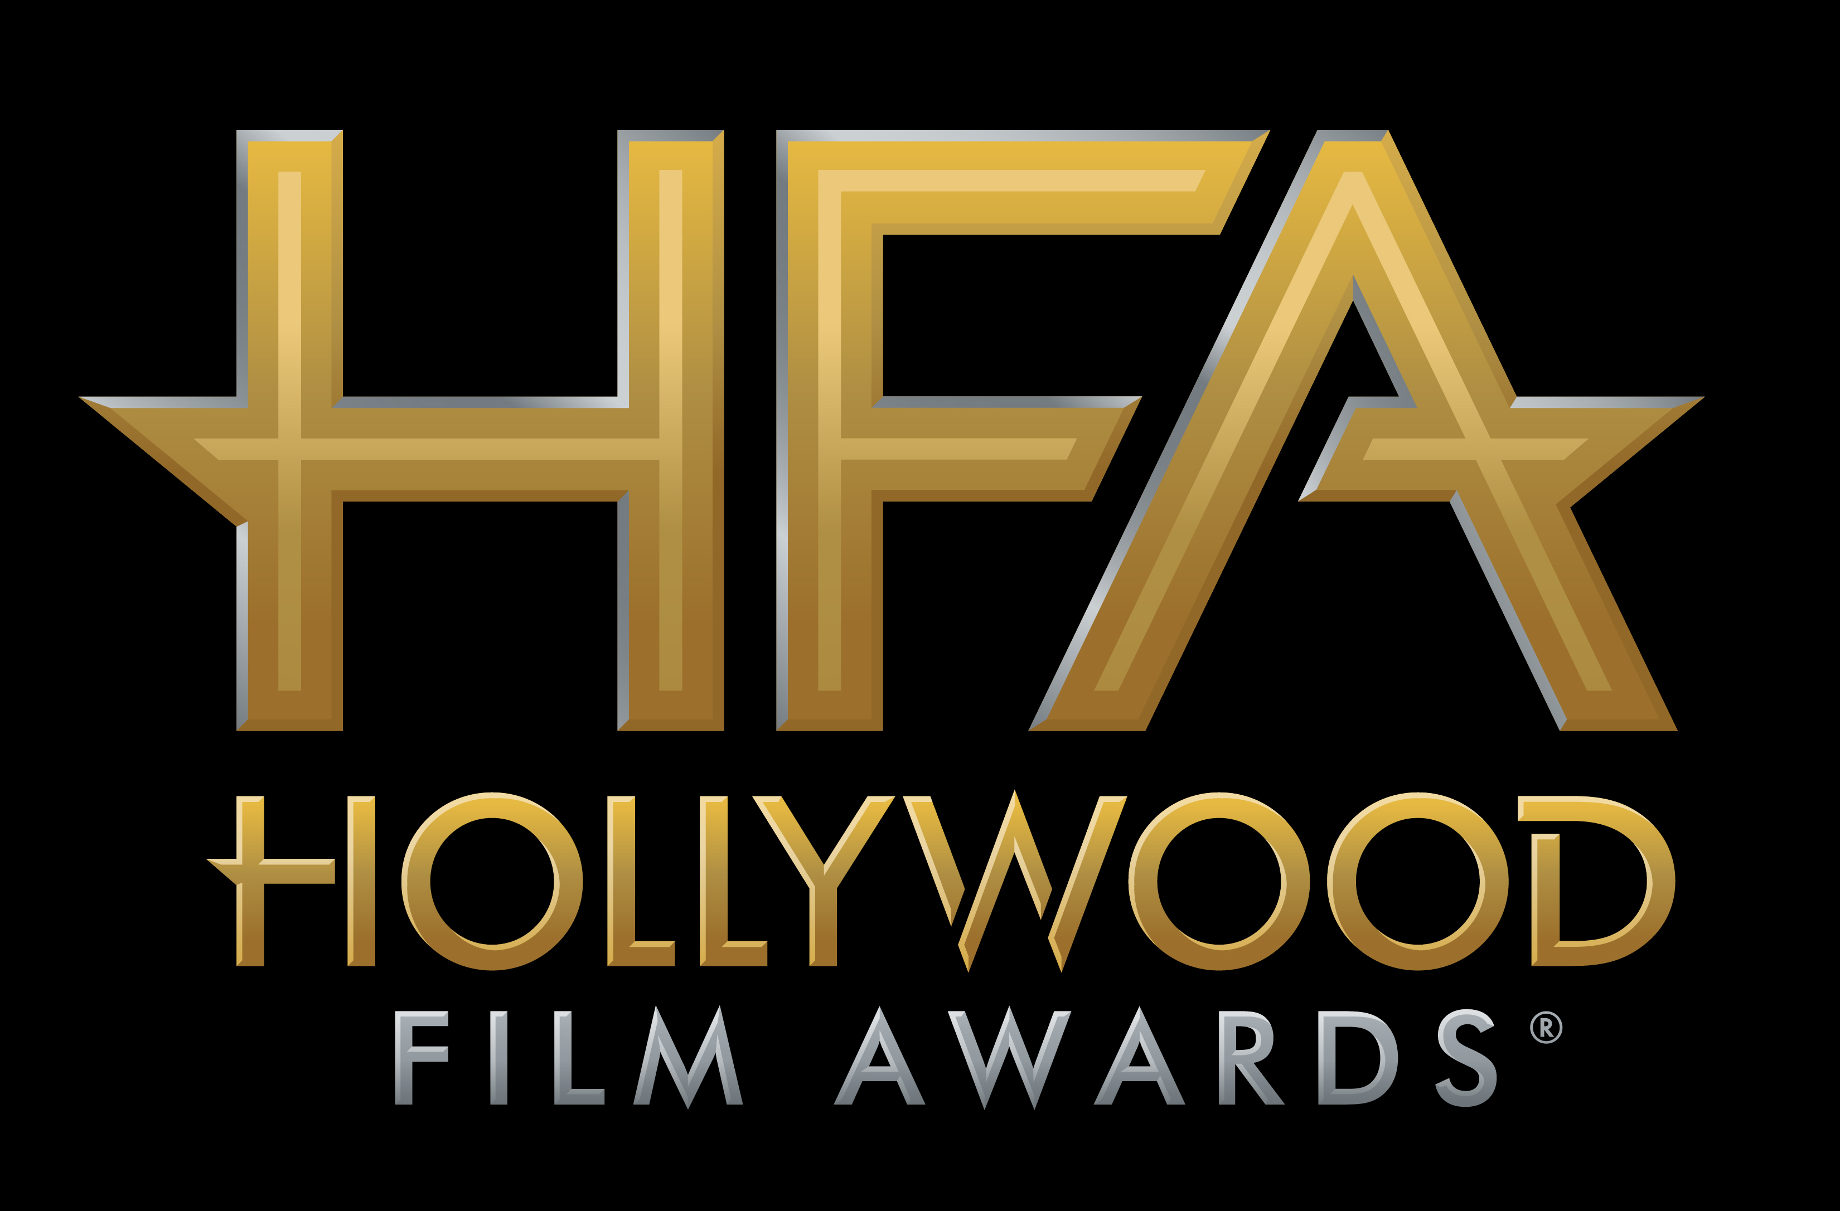

ADAM SANDLER TO BE HONORED WITH THE
“HOLLYWOOD COMEDY AWARD” FOR HIS PERFORMANCE IN NETFLIX’S THE MEYEROWITZ STORIES

JOE WRIGHT TO RECEIVE
“HOLLYWOOD DIRECTOR AWARD”
FOR THE FOCUS FEATURES FILM DARKEST HOUR

AT THE 21ST ANNUAL “HOLLYWOOD FILM AWARDS®”

James Corden to Host Awards Ceremony on
Sunday, November 5, 2017, at The Beverly Hilton

Hollywood, CA (October 26, 2017) – dick clark productions announced today that Adam Sandler will receive the “Hollywood Comedy Award” for his performance in the Netflix feature film, The Meyerowitz Stories, directed by Noah Baumbach, and also starring Ben Stiller and Dustin Hoffman. Director, Joe Wright, will also receive the “Hollywood Director Award” for the Focus Features film Darkest Hour, starring Gary Oldman, about Winston Churchill and the incredible odds he faced during World War II, at the 21st Annual “Hollywood Film Awards.”

The 2017 “Hollywood Film Awards,” known as the official launch of the awards season®, will be hosted by actor and comedian James Corden for the third consecutive year and will take place at The Beverly Hilton in Beverly Hills, CA, on Sunday, November 5, 2017. The ceremony, which honors the most acclaimed films and actors while previewing highly anticipated films and talent for the upcoming year, also acknowledges artists in the categories of Cinematography, Visual Effects, Film Composing, Costume Design, Editing, Production Design, Sound and Makeup & Hairstyling. In its 21-year history, more than 120 of the “Hollywood Film Awards” honorees have gone on to garner Oscar nominations and/or wins. This year’s ceremony will benefit MPTF, which supports the entertainment community in living and aging well, with dignity and purpose, and in helping each other in times of need.

ABOUT THE HONOREES
Adam Sandler – Golden Globe-nominated actor, Adam Sandler, took his first step towards becoming a stand-up comedian when he spontaneously took the stage at a Boston comedy club at the age of 17. He found he was a natural comic. He nurtured his talent while at New York University (graduating with a Bachelor of Fine Arts degree in 1991) by performing regularly in clubs and at universities. During his freshman year, he snagged a recurring role as the Huxtable family's friend Smitty on The Cosby Show (1984). While working at a comedy club in L.A., he was "discovered" by Dennis Miller, who recommended him to Saturday Night Live (1975) producer Lorne Michaels and told him that Sandler had a big talent. This led to his being cast in the show in 1990, which he also wrote for in addition to performing. After Saturday Night Live (1975), Sandler went on to the movies, starring in such hit comedies as Airheads (1994), Happy Gilmore (1996), Billy Madison (1995) and Big Daddy (1999). He has also starred in Mr. Deeds (2002) alongside Winona Ryder; Eight Crazy Nights (2002), an animated movie about the Jewish festival of Chanukah; and Punch-Drunk Love (2002). He also writes and produces many of his own films and has composed songs for several of them, including The Wedding Singer (1998). Sandler has had several of his songs placed on the "Billboard" charts, including the classic "The Chanukah Song."

Joe Wright - Joe Wright is the BAFTA Award-winning and Golden Globe-nominated director behind such acclaimed and award-winning films as Pride & Prejudice, Atonement, Anna Karenina, Hanna, The Soloist and Pan. His upcoming film Darkest Hour, to be released by Focus Features in November 2017, stars Gary Oldman as Winston Churchill leading the charge against Adolf Hitler's army in the early days of World War II. In the theatre, Wright has directed critically acclaimed West End productions including Trelawny of the Wells, A Season in the Congo, and most recently, Life of Galileo. Wright is a director of Shoebox Films, a London based film and television production company.

Previously announced honorees include Jake Gyllenhaal for “Hollywood Actor Award” for the film Stonger; Kate Winslet for “Hollywood Actress Award” for the film Wonder Wheel; The Big Sick for “Hollywood Comedy Ensemble Award”; Jamie Bell for “New Hollywood Actor Award” for his role in Film Stars Don’t Die in Liverpool; Common, Andra Day and Diane Warren for “Hollywood Song Award” for the original song “Stand Up For Something” with music by Diane Warren, lyrics by Diane Warren and Commong and performed by Andra Day featuring Common, in the film Marshall; Andrew Kosove, Broderick Johnson and Cynthia Sikes Yorkin for “Hollywood Producer Award” for the film Blade Runner 2049; Scott Neustadter and Michael H. Weber for “Hollywood Screenwriter Award” for The Disaster Artist; Coco for “Hollywood Animation Award”; and Mudbound for “Hollywood Breakout Ensemble” Award; Sam Rockwell for “Hollywood Supporting Actor Award” for his role in Three Billboards Outside Ebbing, Missouri, Allison Janney for “Hollywood Supporting Actress Award” for her role in I, Tonya, Mary J. Blige for “Hollywood Breakout Performance Actress Award” for her work in the film Mudbound; Timothée Chalamet for “Hollywood Breakout Performance Actor Award” for his role in the film Call Me By Your Name; and the cast of I, Tonya including Margot Robbie, Allison Janney, Sebastian Stan, Paul Walter Hauser, Julianne Nicholson and Caitlin Carver for the “Hollywood Ensemble Award.”

Additional honorees for the 21st Annual “Hollywood Film Awards” will be announced in the coming weeks.

CHEAT TWEET: .@AdamSandler will receive the Comedy Award and Joe Wright will receive the Director Award at the @hollywoodawards: http://hfas.news/honorees7

For the latest news, follow the “Hollywood Film Awards” on social and join the conversation by using the official hashtag for the show, #HollywoodAwards.

Twitter: @HollywoodAwards
Facebook: Facebook.com/HollywoodAwards
Instagram: @hollywoodawards
Tumblr: hollywoodawards.tumblr.com
Snapchat: hollywoodawards

About dick clark productions
dick clark productions (dcp) is the world's largest producer and proprietor of televised live event entertainment programming with the "Academy of Country Music Awards," "American Music Awards," "Billboard Music Awards," "Golden Globe Awards," "Dick Clark's New Year's Rockin' Eve with Ryan Seacrest," “Hollywood Film Awards” and the “Streamy Awards.” Weekly television programming includes "So You Think You Can Dance" from 19 Entertainment and dcp. dcp also owns one of the world's most unique and extensive entertainment archive libraries with over 60 years of award-winning shows, historic programs, specials, performances and legendary programming. For additional information, visit www.dickclark.com.

About The Hollywood Film Awards®
The Hollywood Film Awards®, founded in 1997, were created to celebrate Hollywood and launch the awards season. The recipients of the awards are selected by an Advisory Team for their body of work and/or a film(s) that is to be released during the calendar year. For additional information, visit www.hollywoodawards.com.

SHOW MEDIA CREDENTIALS
To apply for media credentials to cover the 21st Annual “Hollywood Film Awards” please go here. Submissions for credentials will stay open until 6pm PT on Friday, October 27, 2017.

# # #

PR Contacts:

dick clark productions:
Kelly Striewski 310-255-4602 kstriewski@dickclark.com
Lydia Baskharoon 310-255-0319 lbaskharoon@dickclark.com

Slate PR:
Andy Gelb 310-461-0111 andy@slate-pr.com
Rachael Trager 212-235-6817 rachael@slate-pr.com

