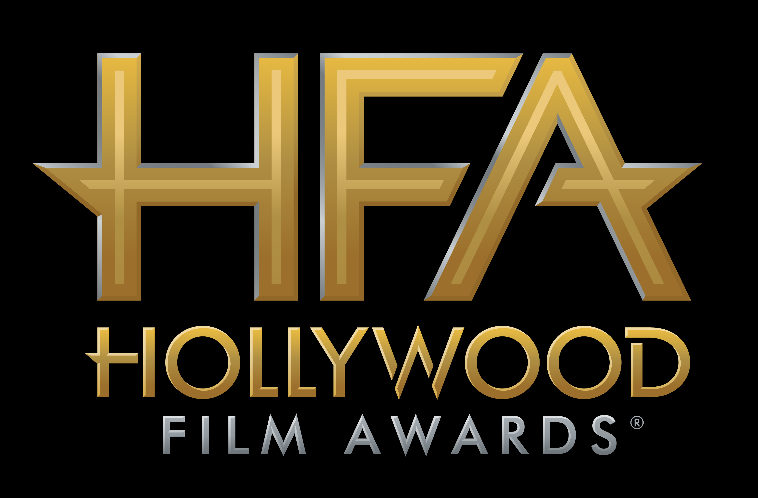

MARY J. BLIGE, Timothée CHALAMET AND
THE CAST OF “I, TONYA” TO BE HONORED AT
THE 21ST ANNUAL “HOLLYWOOD FILM AWARDS®”

James Corden to Host Awards Ceremony on
Sunday, November 5, 2017 at The Beverly Hilton

Hollywood, CA (October 11, 2017) – dick clark productions announced today that Iconic Grammy Award-winning singer, songwriter, actress and philanthropist Mary J. Blige will receive the “Hollywood Breakout Performance Actress Award” for her work in “Mudbound,” and actor Timothée Chalamet will be recognized for his performance in “Call Me By Your Name” with the “Hollywood Breakout Performance Actor Award” at the 21st Annual “Hollywood Film Awards.” Additionally, the cast of “I, Tonya” including Margot Robbie, Allison Janney, Sebastian Stan, Paul Walter Hauser, Julianne Nicholson and Caitlin Carver will be honored with the “Hollywood Ensemble Award” at this year’s ceremony.

The 2017 “Hollywood Film Awards,” known as the official launch of the awards season®, will be hosted by actor and comedian James Corden for the third consecutive year and will take place at The Beverly Hilton in Beverly Hills, CA on Sunday, November 5, 2017. The ceremony, which honors the most acclaimed films and actors while previewing highly anticipated films and talent for the upcoming year, also acknowledges artists in the categories of Cinematography, Visual Effects, Film Composing, Costume Design, Editing, Production Design, Sound and Makeup & Hairstyling. In its 21-year history, more than 120 of the “Hollywood Film Awards” honorees have gone on to garner Oscar nominations and/or wins. This year’s ceremony will benefit MPTF, which supports the entertainment community in living and aging well, with dignity and purpose, and in helping each other in times of need.

ABOUT THE HONOREES
Iconic Grammy Award-winning singer, songwriter, actress and philanthropist, Mary J. Blige is a figure of inspiration, transformation and empowerment making her one of the defining voices of the contemporary music era. With a track record of eight multi-platinum albums, nine Grammy Awards (plus a staggering 32 nominations), a 2012 Golden Globe nomination, and five American Music Awards, Blige is a global superstar. And in the ensuing years, the singer/songwriter has attracted an intensely loyal fan base—responsible for propelling worldwide sales of more than 50 million albums. Previously, Blige has guest-starred on ABC’s Black-ish and How to Get Away with Murder, the FOX musical drama Empire and the NBC musical The Wiz LIVE! playing Evillene, the Wicked Witch of the West. This past April, Blige released her 14th studio album titled Strength of a Woman. In May, VH1 premiered a documentary from Blige titled STRENGTH OF A WOMAN: AN ALBUM DOCUMENTARY. Next up, she is starring in the film MUDBOUND, opposite Carey Mulligan and Garrett Hedlund, which premiered to rave reviews this year at Sundance and will debut on Netflix in November.

Timothée Chalamet has received rave reviews for his leading performance in CALL ME BY YOUR NAME. The film premiered at the Sundance Film Festival in January and will be released in November. Chalamet is currently filming the untitled Woody Allen project in New York City. He recently wrapped production on BEAUTIFUL BOY starring opposite Steve Carell. Timothée will also appear in Greta Gerwig’s directorial debut LADY BIRD, opposite Saoirse Ronan and Lucas Hedges. Chalamet will also be seen in Scott Cooper’s upcoming feature HOSTILES, opposite Christian Bale and Rosamund Pike. Last year, Timothée opened to strong reviews and received Drama League and Clive Barnes nominations and the Lucille Lortel Award for Best Actor for his performance in the world premiere of PRODIGAL SON. He also received glowing reviews for his performance in MISS STEVENS which premiered at SXSW in 2016, as well as the coming-of-age drama HOT SUMMER NIGHTS, which opened at the Austin festival this summer. Timothée previously starred in Christopher Nolan’s INTERSTELLAR, opposite Matthew McConaughey and Anne Hathaway, Jessie Nelson’s LOVE THE COOPERS and Jason Reitman’s MEN, WOMEN & CHILDREN, as well as the independent feature film ONE AND TWO, which premiered at Berlin and SXSW. Timothée was first noticed in the second season of HOMELAND opposite Claire Danes and Damian Lewis for SHOWTIME.

Based on unbelievable but true events, I, TONYA is the darkly comedic tale of American figure skater Tonya Harding and one of the most sensational scandals in sports history. Though Harding was the first American woman to complete a triple axel in competition, her legacy has forever been defined by her association with an infamous, ill-conceived and worse-executed attack on fellow Olympic competitor Nancy Kerrigan. Featuring an iconic turn by Margot Robbie as the fiery Harding, a mustachioed Sebastian Stan as her impetuous ex-husband Jeff Gillooly, a tour-de-force performance from Allison Janney as her acid-tongued mother LaVona Golden, and an original screenplay by Steven Rogers, Craig Gillespie’s I, TONYA is an absurd, irreverent, and piercing portrayal of Harding’s life and career in all of its unchecked––and checkered––glory.

Additional honorees for the 21st Annual “Hollywood Film Awards” will be announced in the coming weeks.

CHEAT TWEET: .@maryjblige, @RealChalamet and the cast of "I, Tonya" will be honored at the 21st Annual @hollywoodawards: http://hfas.news/honorees3 #HFAs

For the latest news, follow the “Hollywood Film Awards” on social and join the conversation by using the official hashtag for the show, #HollywoodAwards.

Twitter: @HollywoodAwards
Facebook: Facebook.com/HollywoodAwards
Instagram: @hollywoodawards
Tumblr: hollywoodawards.tumblr.com
Snapchat: hollywoodawards

About dick clark productions
dick clark productions (dcp) is the world's largest producer and proprietor of televised live event entertainment programming with the "Academy of Country Music Awards," "American Music Awards," "Billboard Music Awards," "Dick Clark's New Year's Rockin' Eve with Ryan Seacrest," "Golden Globe Awards," “Miss America,” “Hollywood Film Awards” and the “Streamy Awards.” Weekly television programming includes "So You Think You Can Dance" from 19 Entertainment and dcp. dcp also owns one of the world's most unique and extensive entertainment archive libraries with more than 55 years of award-winning shows, historic programs, specials, performances and legendary programming. For additional information, visit www.dickclark.com.

About Hollywood Film Awards®
The Hollywood Film Awards®, founded in 1997, were created to celebrate Hollywood and launch the awards season. The recipients of the awards are selected by an Advisory Team for their body of work and/or a film(s) that is to be released during the calendar year. For additional information, visit www.hollywoodawards.com.

# # #

PR Contacts:

dick clark productions:
Kelly Striewski 310-255-4602 kstriewski@dickclark.com
Lydia Baskharoon 310-255-0319 lbaskharoon@dickclark.com

Slate PR:
Andy Gelb 310-461-0111 andy@slate-pr.com
Rachael Trager 212-235-6817 rachael@slate-pr.com

