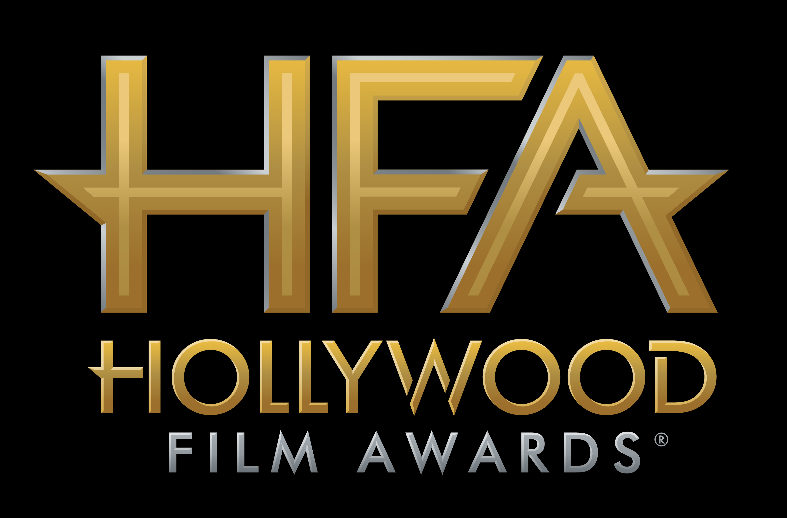

SAM ROCKWELL AND ALLISON JANNEY TO RECEIVE
HOLLYWOOD SUPPORTING ACTOR AND
HOLLYWOOD SUPPORTING ACTRESS AWARDS AT
THE 21ST ANNUAL “HOLLYWOOD FILM AWARDS®”

James Corden to Host Awards Ceremony on
Sunday, November 5, 2017 at The Beverly Hilton

Hollywood, CA (October 12, 2017) – dick clark productions announced today that previous “Hollywood Film Awards” recipient, Sam Rockwell, will receive the “Hollywood Supporting Actor Award” for his role in Three Billboards Outside Ebbing, Missouri, and Emmy Award-winning actress, Allison Janney, will receive the “Hollywood Supporting Actress Award” for her turn as Tonya Harding’s mother in I, Tonya at the 21st Annual “Hollywood Film Awards.”

The 2017 “Hollywood Film Awards,” known as the official launch of the awards season®, will be hosted by actor and comedian James Corden for the third consecutive year and will take place at The Beverly Hilton in Beverly Hills, CA on Sunday, November 5, 2017. The ceremony, which honors the most acclaimed films and actors while previewing highly anticipated films and talent for the upcoming year, also acknowledges artists in the categories of Cinematography, Visual Effects, Film Composing, Costume Design, Editing, Production Design, Sound and Makeup & Hairstyling. In its 21-year history, more than 120 of the “Hollywood Film Awards” honorees have gone on to garner Oscar nominations and/or wins. This year’s ceremony will benefit MPTF, which supports the entertainment community in living and aging well, with dignity and purpose, and in helping each other in times of need.

ABOUT THE HONOREES
Sam Rockwell has established himself as one of the most versatile actors of his generation with an array of emotionally searing and complex roles defining his body of work. Rockwell is known for his standout leading performances in an array of noteworthy films, including George Clooney’s Confessions Of A Dangerous Mind, which he received a Silver Berlin Bear Award for Best Actor at the 2003 Berlin International Film Festival; Ridley Scott’s Matchstick Men opposite Nicolas Cage and Alison Lohman; and Seven Psychopaths opposite Woody Harrelson, Colin Farrell and Christopher Walken, which earned him a 2013 Film Independent Spirit Award nomination for Best Supporting Male. This was followed with a 2014 Critics’ Choice nomination for Best Actor in a Comedy from his heartfelt performance in Nat Faxon and Jim Rash’s coming of age comedy The Way, Way Back. Not only is Rockwell a star on screen, he has owned the stage in a number of theatrical productions, including his most recent performance in Sam Shepherd’s Broadway play Fool For Love alongside Nina Arianda. His love for theater first began while performing multiple productions at the Williamstown Theatre Festival including A Streetcar Named Desire directed by David Cromer, The Dumb Waiter directed by Joe Mantello, and the revival of Lanford Wilson's long-running off-Broadway hit Hot L Baltimore.

Allison Janney is receiving rave reviews for her turn as LaVona Golden, the sharp-tongued mother of Tonya Harding in “I, Tonya” opening December 8th. Other recent movies for Janney include Tallulah, which reunited her with herJuno co-star Ellen Page, Miss Peregrine’s Home for Peculiar Children marked her first time working with director Tim Burton and The Girl On the Train saw her collaborating again with longtime friend, director Tate Taylor. She also appeared in two of the previous summer’s biggest box office titles: the animated Minions and Spy with Melissa McCarthy. Additionally she co-starred in The Help based on the best-selling novel of the same name. For their extraordinary performances, the cast won Ensemble awards from the Hollywood Film Awards, Screen Actors Guild, National Board of Review and the Broadcast Film Critics. The film was also nominated for an Academy Award for Best Picture. Janney delighted audiences with outstanding performances in the Oscar-nominated ensemble Juno and in the movie version of the Tony Award winning play Hairspray, which was also awarded Best Ensemble from the Hollywood Film Awards. She was nominated for Best Supporting Actress by the Independent Spirit Awards for her role in Todd Solondz's film Life During Wartime. She also co-starred in The Way, Way Back with Steve Carell, opposite Meryl Streep in The Hours, which received a SAG Award nomination for Outstanding Ensemble Cast in a Motion Picture and appeared in the Academy Award winning film American Beauty (for which she won a SAG Award for Outstanding Ensemble Cast in a Motion Picture). Janney currently stars alongside Anna Faris in the CBS/Chuck Lorre hit comedy, Mom. Critics also applauded her turn as Margaret Scully on Showtime’s groundbreaking drama Masters of Sex. Janney won Emmys for both roles in the same year; a rare feat in Emmy history. She won a second Emmy for Mom the following year, bringing her total number of ATAS statues to seven. She is renowned for her starring role in the acclaimed NBC series The West Wing, where she won a remarkable four Emmy Awards and four SAG Awards for her portrayal of White House Press Secretary CJ Cregg. In addition, she was recently honored with a star on the Hollywood Walk of Fame.
Previously announced honorees include Mary J. Blige for “Hollywood Breakout Performance Actress Award” for her work in the film Mudbound; Timothée Chalamet for “Hollywood Breakout Performance Actor Award” for his role in the film Call Me By Your Name; and the cast of I, Tonya including Margot Robbie, Allison Janney, Sebastian Stan, Paul Walter Hauser, Julianne Nicholson and Caitlin Carver for the “Hollywood Ensemble Award.”

Additional honorees for the 21st Annual “Hollywood Film Awards” will be announced in the coming weeks.

CHEAT TWEET: Sam Rockwell & @AllisonBJanney will receive the Hollywood Supporting Actor & Actress Awards at the @hollywoodawards: http://hfas.news/honorees2

For the latest news, follow the “Hollywood Film Awards” on social and join the conversation by using the official hashtag for the show, #HollywoodAwards.

Twitter: @HollywoodAwards
Facebook: Facebook.com/HollywoodAwards
Instagram: @hollywoodawards
Tumblr: hollywoodawards.tumblr.com
Snapchat: hollywoodawards

About dick clark productions
dick clark productions (dcp) is the world's largest producer and proprietor of televised live event entertainment programming with the "Academy of Country Music Awards," "American Music Awards," "Billboard Music Awards," "Dick Clark's New Year's Rockin' Eve with Ryan Seacrest," "Golden Globe Awards," “Miss America,” “Hollywood Film Awards” and the “Streamy Awards.” Weekly television programming includes "So You Think You Can Dance" from 19 Entertainment and dcp. dcp also owns one of the world's most unique and extensive entertainment archive libraries with more than 55 years of award-winning shows, historic programs, specials, performances and legendary programming. For additional information, visit www.dickclark.com.

ABOUT THE HOLLYWOOD FILM AWARDS®
The Hollywood Film Awards®, founded in 1997, were created to celebrate Hollywood and launch the awards season. The recipients of the awards are selected by an Advisory Team for their body of work and/or a film(s) that is to be released during the calendar year. For additional information, visit www.hollywoodawards.com.

# # #

PR Contacts:

dick clark productions:
Kelly Striewski 310-255-4602 kstriewski@dickclark.com
Lydia Baskharoon 310-255-0319 lbaskharoon@dickclark.com

Slate PR:
Andy Gelb 310-461-0111 andy@slate-pr.com
Rachael Trager 212-235-6817 rachael@slate-pr.com

