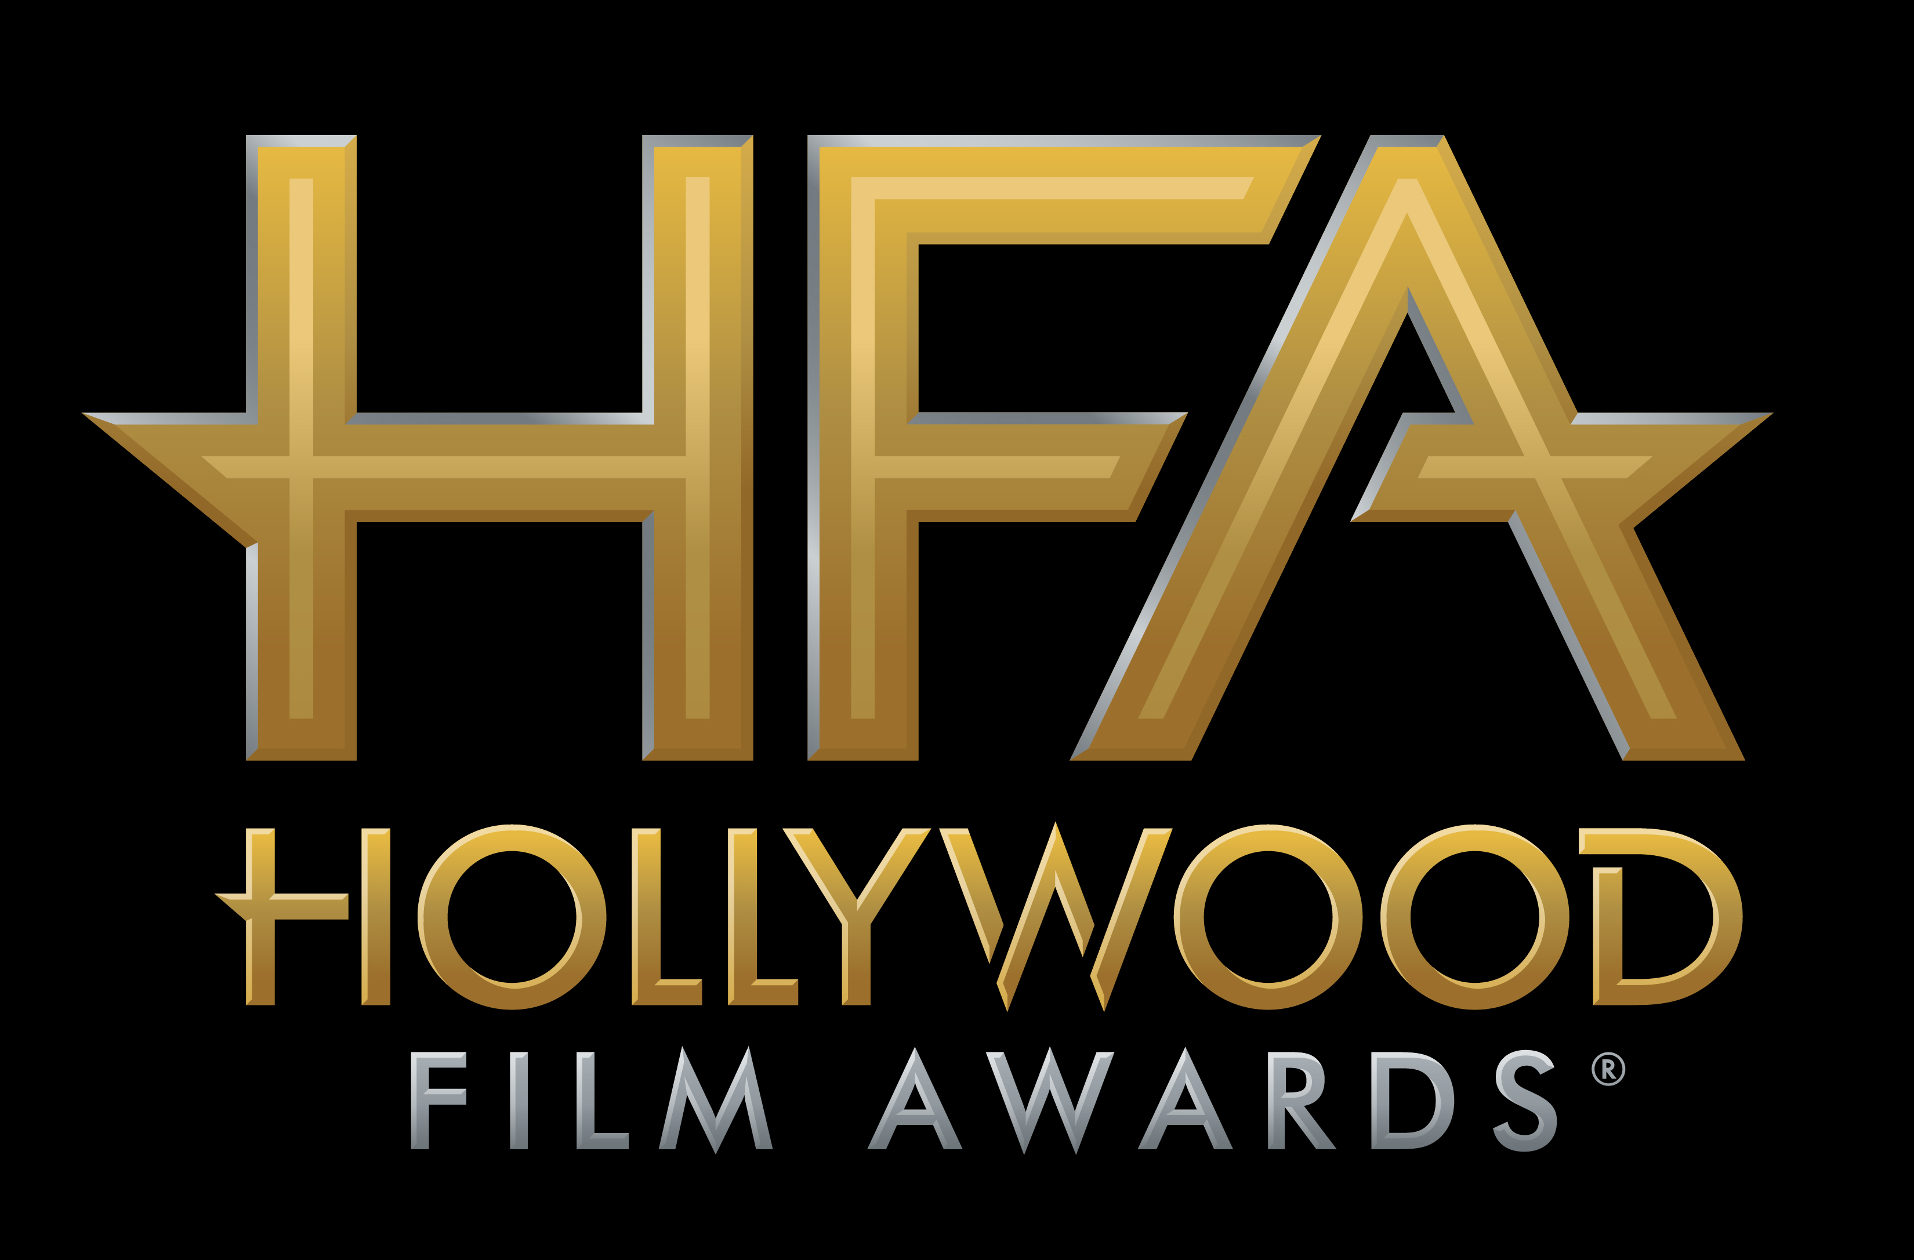

THE BIG SICK TO RECEIVE
“HOLLYWOOD COMEDY ENSEMBLE AWARD”

JAMIE BELL TO RECEIVE
“NEW HOLLYWOOD ACTOR AWARD”

“STAND UP FOR SOMETHING” FROM THE FILM MARSHALL TO RECEIVE
“HOLLYWOOD SONG AWARD”

AT THE 21ST ANNUAL “HOLLYWOOD FILM AWARDS®”

James Corden to Host Awards Ceremony on
Sunday, November 5, 2017, at The Beverly Hilton

Hollywood, CA (October 23, 2017) – dick clark productions announced today that the cast of the film The Big Sick, including Kumail Nanjiani, Zoe Kazan, Holly Hunter and Ray Romano, will receive the “Hollywood Comedy Ensemble Award”; actor Jamie Bell will receive the “New Hollywood Actor Award” for his recent work in “Film Stars Don’t Die in Liverpool”; and musicians Diane Warren, Common and Andra Day will receive the “Hollywood Song Award” for the original song, “Stand Up For Something” with music by Diane Warren, lyrics by Diane Warren and Common and is performed by Andra Day featuring Common from the film Marshall, at the 21st Annual “Hollywood Film Awards.”

The 2017 “Hollywood Film Awards,” known as the official launch of the awards season®, will be hosted by actor and comedian James Corden for the third consecutive year and will take place at The Beverly Hilton in Beverly Hills, CA, on Sunday, November 5, 2017. The ceremony, which honors the most acclaimed films and actors while previewing highly anticipated films and talent for the upcoming year, also acknowledges artists in the categories of Cinematography, Visual Effects, Film Composing, Costume Design, Editing, Production Design, Sound and Makeup & Hairstyling. In its 21-year history, more than 120 of the “Hollywood Film Awards” honorees have gone on to garner Oscar nominations and/or wins. This year’s ceremony will benefit MPTF, which supports the entertainment community in living and aging well, with dignity and purpose, and in helping each other in times of need.

ABOUT THE HONOREES
The Big Sick – The Big Sick is based on the real-life courtship between Pakistan-born comedian Kumail Nanjiani (Nanjiani) and grad student Emily Gordon (Zoe Kazan) who fall in love but struggle as their cultures clash. When Emily contracts a mysterious illness, Kumail finds himself forced to face her feisty parents (Holly Hunter and Ray Romano), his family’s expectations, and his true feelings.

Jamie Bell – While still a teenager, Jamie Bell shot to worldwide fame starring in the title role of Stephen Daldry’s Billy Elliot. Among the many honors he received for his performance, were the BAFTA Award for Best Actor, and the British Independent Film Award for Best Newcomer. He went onto portray Charles Dickens' memorable character Smike in writer/director Douglas McGrath’s screen adaptation of Nicholas Nickleby, for which he and his colleagues shared the National Board of Review Award for Best Acting by an Ensemble. His subsequent films include David Gordon Green's Undertow; Thomas Vinterberg's Dear Wendy; Peter Jackson's epic King Kong and Clint Eastwood's acclaimed Flags of Our Fathers, in which he portrayed real-life WWII hero Ralph Ignatowski. His other films include David Mackenzie's Hallam Foe, for which he earned a British Independent Film Award nomination and a BAFTA (Scotland) Award for Best Actor; Arie Posin's The Chumscrubber; Doug Liman's Jumper; and Edward Zwick's Defiance. He went onto star in Kevin Macdonald's The Eagle, Cary Fukunaga's Jane Eyre and Carl Tibbetts' The Retreat. He played the titular role in Steven Spielberg's The Adventures of Tintin: The Secret of the Unicorn, as Hergé's legendary young adventurer in the motion-capture production filmed in 3-D. He went on to star in Asger Leth's Man on a Ledge, John Baird's Filth, Snowpiercer with acclaimed Korean director Joon-Ho Bong, Josh Trank's Fantastic Four, and most recently Toa Fraser's 6 Days. On the small screen, Bell starred in AMC's TURN: Washington's Spies as the lead role of Abe Woodhull, his first foray into American television. This Fall he stars opposite Annette Bening in Paul McGuigan's Film Stars Don't Die in Liverpool. Bell is currently in production on the indie film Donnybrook for writer/director Tim Sutton, adapted from Frank Bill's noir novel of the same name.

Diane Warren – Diane Warren is one of the most continuously prolific and successful contemporary songwriters of our time. She is the sole owner of her publishing company Realsongs. Her songs have been featured in more than 100 motion pictures resulting in eight Academy Award® nominations. Warren most recently received her eighth Oscar nomination for the original song “Til It Happens To You,” performed by Lady Gaga, from the critically acclaimed documentary The Hunting Ground and her seventh Oscar nomination for her original song “Grateful” performed by Rita Ora for the film Beyond the Lights. In 2016, Warren also earned her first Emmy nomination and her first Emmy win for “Til It Happens To You.” She was nominated for five Golden Globes and won for the powerful ballad “You Haven’t Seen the Last of Me,” performed by Cher in the movie Burlesque. Both Trisha Yearwood and LeAnn Rimes had hit records with her Oscar and Grammy nominated song “How Do I Live” from the movie Con Air. Warren’s popular “Nothing’s Gonna Stop Us Now” from Mannequin, “Because You Loved Me” sung by Celine Dion for the film Up Close and Personal, “Music Of My Heart” performed by *NSYNC and Gloria Estefan for the film Music Of The Heart, “I Don’t Want to Miss a Thing” performed by Aerosmith for Armageddon and “There You’ll Be” sung by Faith Hill from Pearl Harbor were also Oscar nominated and hit songs. Diane has been nominated for 14 Grammys, and received a Grammy for the song “Because You Loved Me.” She was inducted into the Songwriters Hall of Fame in 2001.

Common – Academy Award, Golden Globe, Emmy and Grammy-winning actor and musician, Common continues to break down barriers with a multitude of critically acclaimed, diverse roles, and continued success at the box office. He appeared on the big screen in the Oscar nominated film, SELMA, a film centered around the civil rights marches that changed America. Alongside John Legend, he won the Academy Award and Golden Globe in 2015 for “Best Original Song in a Motion Picture” for “Glory” which was featured in the film. In 2016, he appeared in the David Ayer’s high profile comic book movie, Warner Bros’ SUICIDE SQUAD. The film broke box office records both domestically and around the world. Earlier this year, Common starred opposite Keanu Reeves in the highly anticipated sequel JOHN WICK: CHAPTER 2, and appeared in Judy Greer’s directorial debut A HAPPENING OF MONUMENTAL PROPORTIONS with Allison Janney, which premiered at the Bentonville Film Festival in May. This Summer, he appeared in Bleecker Street’s MEGAN LEAVEY alongside Kate Mara, Tom Felton, Bradley Whitford and Edie Falco, in theaters June 9th. Common most recently wrapped production on action-thriller HUNTER KILLER opposite Gerard Butler, Billy Bob Thornton, and Gary Oldman, as well as indie film SAINT JUDY with Michelle Monaghan, Alfred Molina and Alfre Woodard. It was announced that Common will executive produce and star in “Black Samurai” a TV adaption of Marc Olden’s 1974 book series, which inspired the 1977 film of the same name. He is also set to star in QUICK DRAW, a new revenge action thriller to be produced by TRANSFORMERS producer Lorenzo di Bonaventura and Content Media. He is currently in production on two projects; THREE SECONDS, the upcoming action thriller by Andrea Di Stefano, with an all-star cast including Clive Owen, Rosamund Pike, and Joel Kinnaman, and Sarah Jessica Parker’s romantic drama BEST DAY OF MY LIFE alongside Jacqueline Bisset, Renee Zellweger, Isabella Rossellini, Simon Baker, and Taylor Kinney. Behind-the-scenes, Common recently executive-produced the Netflix drama BURNING SANDS and performed the closing credits original song “The Cross” featuring Lianne Le Havas. The film premiered at the 2017 Sundance Film Festival and was released on Netflix March 10th. He will also executive produce Showtime’s upcoming TV series “The Chi,” a coming-of-age story set in Chicago from writer Lena Waithe. Common’s 11th studio album, BLACK AMERICA AGAIN, was released November 4, 2016 on ARTium/Def Jam Recordings. The album includes socially conscious new single, “Black America Again” featuring Stevie Wonder and the anthem “Letter to the Free,” the end-title track to Ava Duvernay’s powerful Oscar-Nominated documentary 13TH, for which he also received the 2017 Emmy for “Best Music and Lyrics.”

Andra Day – Carried by enough conviction to incite cultural change, Andra Day’s full-length debut Cheers to the Fall [Buskin Records / Warner Bros. Records] garnered a 2016 GRAMMY® Award nomination in the category of “Best R&B Album,” while its anthemic Platinum lead single “Rise Up” achieved a nod for “Best R&B Performance.” The Late Show with Stephen Colbert, Ellen, Dancing with the Stars, The View, Jimmy Kimmel, White House National Christmas Tree Lighting, Hallmark’s Home for the Holiday’s, Audience TV, the CMA Country Christmas, and the America’s Got Talent—just to name a few. Quietly recognized amongst some of music’s most legendary names, the singer paid tribute to Ray Charles at The Smithsonian and shared the stage for performances with everyone from Chinese piano virtuoso Lang Lang, Bonnie Raitt, and Stevie Wonder to Ellie Goulding, Alicia Keys, and John Legend. Her voice abounded throughout the halls of the historic 2016 Democratic National Convention as well as launch of Michelle Obama’s We Will Rise documentary in partnership with Meryl Streep and Freida Pinto on “International Day of the Girl” event at The White House. Along the way, she covered Essence Magazine and achieved the prestigious “Powerhouse Award” at the Billboard Women in Music event. 2017 kicked off with two show-stopping performances by the chanteuse at the 48th Annual NAACP Image Awards and a knockout Bee Gees tribute during the 59th Annual GRAMMYs®. Hyatt welcomed Andra as the voice of its “For A World Of Understanding” campaign, breathing new life into the Burt Bacharach and Hal David classic, “What The World Needs Now Is Love.” Moreover, she voiced Sweet Tea in the summer blockbuster Cars 3, covering Bruce Springsteen’s “Glory Days” during a standout sequence. Closing out 2017, Andra released the moving anthem “Stand Up For Something” [feat. Common] from the Marshall Official Soundtrack Album and film. The original song was written by GRAMMY®, Emmy®, and Golden Globe® Award-winning and eight-time Academy® Award-nominated legend Diane Warren and Oscar®, GRAMMY®, and Emmy® Award-winning hip-hop icon and actor Common. It spotlights her show-stopping and stunning vocals over powerful production as well as thought-provoking rhymes from Common. Meanwhile, the movie marks her on-screen debut.

Previously announced honorees include Andrew Kosove, Broderick Johnson and Cynthia Sikes Yorkin for “Hollywood Producer Award” for the film Blade Runner 2049; Scott Neustadter and Michael H. Weber for “Hollywood Screenwriter Award” for The Disaster Artist; Coco for “Hollywood Animation Award”; and Mudbound for “Hollywood Breakout Ensemble” Award; Sam Rockwell for “Hollywood Supporting Actor Award” for his role in Three Billboards Outside Ebbing, Missouri, Allison Janney for “Hollywood Supporting Actress Award” for her role in I, Tonya, Mary J. Blige for “Hollywood Breakout Performance Actress Award” for her work in the film Mudbound; Timothée Chalamet for “Hollywood Breakout Performance Actor Award” for his role in the film Call Me By Your Name; and the cast of I, Tonya including Margot Robbie, Allison Janney, Sebastian Stan, Paul Walter Hauser, Julianne Nicholson and Caitlin Carver for the “Hollywood Ensemble Award.”

Additional honorees for the 21st Annual “Hollywood Film Awards” will be announced in the coming weeks.

CHEAT TWEET: The @hollywoodawards Hollywood Comedy Ensemble, New Hollywood Actor & Hollywood Song Award honorees announced: hfas.news/honorees5 #HFAs

For the latest news, follow the “Hollywood Film Awards” on social and join the conversation by using the official hashtag for the show, #HollywoodAwards.

Twitter: @HollywoodAwards
Facebook: Facebook.com/HollywoodAwards
Instagram: @hollywoodawards
Tumblr: hollywoodawards.tumblr.com
Snapchat: hollywoodawards

About dick clark productions
dick clark productions (dcp) is the world's largest producer and proprietor of televised live event entertainment programming with the "Academy of Country Music Awards," "American Music Awards," "Billboard Music Awards," "Golden Globe Awards," "Dick Clark's New Year's Rockin' Eve with Ryan Seacrest," “Hollywood Film Awards” and the “Streamy Awards.” Weekly television programming includes "So You Think You Can Dance" from 19 Entertainment and dcp. dcp also owns one of the world's most unique and extensive entertainment archive libraries with more than 55 years of award-winning shows, historic programs, specials, performances and legendary programming. For additional information, visit www.dickclark.com.

ABOUT THE HOLLYWOOD FILM AWARDS®
The Hollywood Film Awards®, founded in 1997, were created to celebrate Hollywood and launch the awards season. The recipients of the awards are selected by an Advisory Team for their body of work and/or a film(s) that is to be released during the calendar year. For additional information, visit www.hollywoodawards.com.

SHOW MEDIA CREDENTIALS
To apply for media credentials to cover the 21st Annual “Hollywood Film Awards” please go here. Submissions for credentials will stay open until 6pm PT on Friday, October 27, 2017.

# # #

PR Contacts:

dick clark productions:
Kelly Striewski 310-255-4602 kstriewski@dickclark.com
Lydia Baskharoon 310-255-0319 lbaskharoon@dickclark.com

Slate PR:
Andy Gelb 310-461-0111 andy@slate-pr.com
Rachael Trager 212-235-6817 rachael@slate-pr.com

