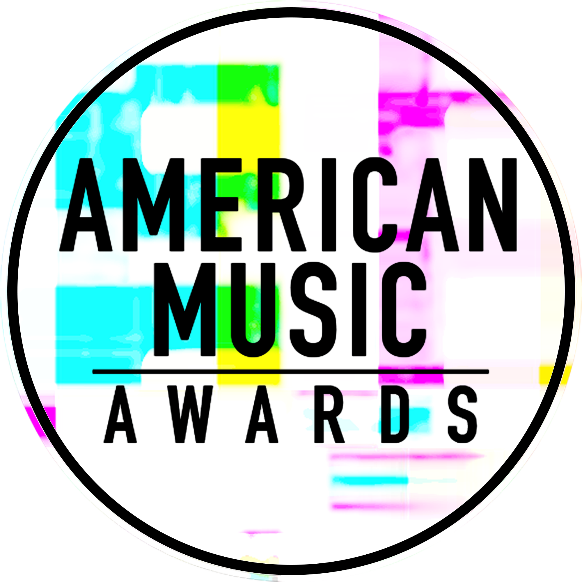

ALL-STAR COLLABORATIONS FROM ALESSIA CARA & ZEDD,
HAILEE STEINFELD & ALESSO FEATURING FLORIDA GEORGIA LINE & WATT
AND A PERFORMANCE BY CHART-TOPPING BAND PORTUGAL. THE MAN
ANNOUNCED FOR THE “2017 AMERICAN MUSIC AWARDS”

ENCORE PERFORMANCE BY BEBE REXHA FEATURING FLORIDA GEORGIA LINE
TO BE AVAILABLE FOR COMCAST’S XFINITY TV CUSTOMERS
FOLLOWING THE “2017 AMERICAN MUSIC AWARDS”

WORLD’S LARGEST FAN-VOTED AWARDS SHOW TO
CELEBRATE 45 YEARS OF GIVING FANS THE VERY BEST IN MUSIC

The Live Broadcast Will Air
Sunday, November 19th at 8:00pm ET on ABC

For digital assets and nominee gif galleries, please go to: http://bit.ly/AMAsMedia17

Los Angeles, CA (November 13, 2017) – dick clark productions and ABC today announced superstar collaborations for the “2017 American Music Awards” from Alessia Cara and Zedd, as well as Hailee Steinfeld and Alesso featuring Florida Georgia Line and watt. Chart-topping band Portugal. The Man will also join the roster of performers, marking their very first visit to the AMAs. Additionally, multi-platinum artist Bebe Rexha will combine with Florida Georgia Line to treat American Music Awards fans to an encore performance for Xfinity TV customers, which will be available following the show on Xfinity On Demand. The “2017 American Music Awards,” the world’s largest fan-voted awards show where music enthusiasts watch their favorite artists and pop culture icons come together to honor idols, newcomers and record-breakers in the contemporary music scene, will broadcast live from the Microsoft Theater in Los Angeles on Sunday, November 19, 2017 at 8:00pm ET on ABC.

Multi-platinum singer-songwriter Alessia Cara and multi-platinum DJ/producer Zedd will come together to perform Zedd and Alessia Cara’s Billboard Hot 100 smash single “Stay,” which topped Billboard’s Pop Songs chart and led the Hot Dance/Electronic Songs chart, for their first performance ever at the American Music Awards. Alessia Cara is nominated this year for Favorite Female Artist – Pop/Rock. Multi-platinum recording artist and Academy® Award-nominated actress Hailee Steinfeld and Swedish DJ/producer Alesso featuring multi-platinum duo Florida Georgia Line and critically acclaimed songwriter and artist watt are set to take the American Music Awards stage for a show-stopping collaboration, featuring their Billboard Hot 100 hit, “Let Me Go.” This will mark Hailee Steinfeld, Alesso and watt’s first American Music Awards performance, and Florida Georgia Line’s second. Five-time American Music Award winner Florida Georgia Line last performed “Cruise” and “Ride Wit Me” with Nelly at the AMAs in 2013, and is nominated this year for Favorite Duo or Group – Country. Additionally, chart-topping band Portugal. The Man will make their American Music Awards performance debut with their irresistible, platinum-certified single, “Feel It Still,” off their latest album, Woodstock. The funky track held the No. 1 spot at Alternative radio for 17 weeks, reached No. 1 at Top 40 radio and has peaked at No. 4 on the Billboard Hot 100. Later in the evening, platinum-selling artist Bebe Rexha will join forces with Diamond-selling Florida Georgia Line to perform “Meant To Be,” which is currently climbing the charts and has amassed over 30M global streams to date, for subscribers to Comcast’s Xfinity TV service, which will be available following the American Music Awards.

In addition to the live broadcast on ABC and encore performance on Xfinity On Demand, Xfinity TV customers will be able to watch a multitude of American Music Awards content via Xfinity On Demand leading up to the live broadcast, including “Behind the Performance,” which will take fans behind the preparations for Bebe Rexha featuring Florida Georgia Line’s encore performance, archival clips from past AMAs and “AMAs Roundtable” which includes expert commentary on the nominees for the show. The content will also be available online at xfinity.com/AMAs.

Republic Records recording artist Hailee Steinfeld has quickly cemented herself as a rising force in pop music with a series of hits under her belt, including her 2015 platinum certified debut single “Love Myself,” double platinum selling smash “Starving” with Grey [feat. Zedd] and recent summer anthem “Most Girls.” To date, the multi-platinum selling artist has amassed a total of nearly 2 billion streams globally. This year, Steinfeld garnered three Teen Choice Award nominations for her work in both film and music, as well as a nomination for “Best Push Artist” at the MTV EMAs. She also won Musical.ly’s “Top Covered Artist” award at the 2017 Billboard Music Awards. Most recently, Steinfeld released her new single “Let Me Go.” Produced by Grammy nominated DJ and producer Alesso and critically acclaimed songwriter and artist watt, “Let Me Go” pairs Steinfeld with one of country music’s best-selling acts Florida Georgia Line. In addition to her thriving music career, Steinfeld is an Academy® Award-nominated and critically acclaimed leading actress. In 2016, she starred in one of the year’s best-reviewed films, The Edge of Seventeen. Her performance earned her two Critics’ Choice Award nominations and a Golden Globe® nomination in the category “Best Performance by an Actress in a Motion Picture – Musical or Comedy.” Steinfeld is currently in production on her next film, Paramount's “Bumblebee,” the first spin-off in the newly created “Transformers” universe, and will star in the blockbuster “Pitch Perfect 3”, which will be in theaters December 22, 2017.

Swedish DJ and producer Alesso has platinum records, a Grammy nomination, and world-renowned tours and performances. His big productions electrify crowds at the world’s biggest music festivals like Coachella, EDC, and Tomorrowland. He also connects with fans through records like “Falling” and the chart-topping “Heroes (We Could Be)” featuring Tove Lo that push the limits of the genre with lyrics that layer raw emotions on top of intoxicating music. Recently, Alesso collaborated with Hailee Steinfeld for “Let Me Go” featuring Florida George Line and watt and created a remix to J Balvin and Willy William’s hit record “Mi Gente.” He combined with Brazilian superstar Anitta to create the international hit “Is That For Me.” With every original song, remix, and live performance, Alesso continues to establish himself as one of his genre’s most important figures.

Florida Georgia Line’s Platinum-certified musical evolution, Dig Your Roots, propelled the history-making duo to No.1 on the all-genre Billboard Artist 100 and Top Country Albums charts. Continuing the epic momentum, the album has delivered three consecutive No. 1 Country Airplay smashes - the 3X Platinum-certified lead single “H.O.L.Y.” [also No. 1 on Billboard's Hot Country Songs chart for 18 straight weeks] and Platinum-certified hits “May We All” (featuring Tim McGraw) and “God, Your Mama, And Me” (featuring Backstreet Boys [the latter FGL's 11th Country Airplay No. 1]. Following a landmark Dig Your Roots Tour that broke attendance records and reached over one million featuring headline-grabbing guest appearances, Florida Georgia Line just wrapped The Smooth Tour 2017 – having played select sold-out stadium dates this summer with special guests Backstreet Boys. Bursting with first-rate reviews of their explosive live shows, MusicRow Magazine praised, "Just in case you’ve forgotten, Florida Georgia Line is one of the hottest country acts alive.” The top-shelf entertainers continue to crush records as the first and only Country act to achieve RIAA’s Diamond certification (10 million copies sold) for their breakout smash “Cruise,” which is the best-selling digital country single of all time (according to Nielsen Music). Since their breakout in 2012, Florida Georgia Line has earned prestigious honors from the American Music Awards, ACM Awards, CMA Awards, Billboard Music Awards and CMT Music Awards. Their previous BMLG Records releases – 2X Platinum debut Here’s To The Good Times and Platinum Anything Goes – have attributed to sales surpassing 30 million tracks and more than 4.2 million albums worldwide. Florida Georgia Line is spreading good vibes to sports fans each week during the 2017 NFL season as they’re featured alongside Hank Williams Jr. and Jason Derulo in “All My Rowdy Friends Are Coming Over Monday Night” during Monday Night Football on ESPN. Their genre-smashing collaborations also include teaming up with The Chainsmokers for “Last Day Alive” (Memories…Do Not Open), Bebe Rexha’s “Meant to Be” on her recent EP All Your Fault: Pt. 2, and Hailee Steinfeld & Alesso’s latest single “Let Me Go” (featuring watt). Fueled by fresh inspiration and keen entrepreneurial spirit, they’ve launched publishing company Tree Vibez Music and their own emoji app, FGLmoji. Following the introduction of their Old Camp Peach Pecan Whiskey, their premiere restaurant and entertainment destination FGL House, a four-story attraction with the largest “Cruise” rooftop Nashville has to offer, is now open.
watt, the New York-born and Los Angeles-based multi-instrumentalist, producer, and singer has lit a fire with every project he touches within the music industry. His debut solo EP, Ghost In My Head, earned critical acclaim from the likes of Guitar World and boasted drumming courtesy of Chad Smith [Red Hot Chili Peppers] and Joey Castillo [ex-Queens of the Stone Age, Danzig]. He has been tapped to perform and share the stage with everyone from Sting, Slash, Justin Bieber, The Roots, Taylor Hawkins, Chad Smith, Tommy Lee, One Republic, Martin Garrix, Jane’s Addiction, The Struts and more. Prior to the EP’s release, he worked as a producer, songwriter, and musical director for the likes of Justin Bieber & Skrillex, Kygo, DJ Snake, Marshmello, Steve Angello, SNBRN and more. In 2016, he co-wrote the highly successful song by DJ Snake featuring Justin Bieber “Let Me Love You,” and co-wrote & produced “Feeling Whitney” on Post Malone’s album Stoney. This year his songwriting and production has been featured all over 2017’s biggest hits including Kygo’s “It Ain’t Me” ft. Selena Gomez (co-wrote & produced),” Camilla Cabello’s “Havanna” ft. Young Thug (co-wrote), Avicii’s “Lonely Together ft. Rita Ora (co-wrote & production), Bebe Rexha’s “Comfortable” ft. Kranium as well as his own track “Burning Man” ft. Post Malone. watt has scored three top 10 Billboard Hot 100 hits as a co-writer, all since late 2016: DJ Snake's "Let Me Love You" (featuring Justin Bieber); "It Ain't Me," by Kygo and Selena Gomez; and Camila Cabello's current hit, "Havana" (featuring Young Thug). He also co-produced the first two aforementioned songs. "Let Me Love You" and "It Ain't Me" also each hit No. 2 on Hot Dance/Electronic Songs, while "Let Me Go," his first charted song as a credited artist, has reached the top 10.
Multi-platinum, GRAMMY award-winning artist/DJ/producer Zedd made his debut with Clarity after signing with Interscope in 2012 and has been breaking down barriers surrounding music genres ever since. With his latest single, “Get Low” with Liam Payne, Zedd ventures into a more urban musical domain that Entertainment Weekly called a “sizzling summer jam.” Earlier this year, Zedd teamed up with Alessia Cara to record “Stay,” a track that veers into a new direction for both artists, and landed Zedd his first No. 1 on Billboard's Pop Songs airplay chart. Zedd also single-handedly organized WELCOME!, an ACLU fundraising concert with a lineup that spans the music spectrum. As an immigrant himself, born in Russia and raised in Germany, the concert was born out of Zedd’s desire to stand up for basic human rights and 100% of its profits benefitted the ACLU. Throughout his career, Zedd has worked with a diverse range of artists, including Foxes on “Clarity,” which soared to No.2 on Pop Songs and has sold 2.6 million downloads in the U.S., according to Nielsen Music, and Hayley Williams on Platinum hit “Stay The Night,” which racked up more than 400 million streams. In 2015, Zedd released True Colors, which debuted at No. 4 on the Billboard Top 200 albums chart, No. 1 on the Top Dance/Electronic Albums chart, and earned Zedd a 2016 Billboard Music Award for “Best Dance Album.” Its lead single “I Want You to Know” (ft. Selena Gomez) spent six weeks at No. 1 on Billboard’s Hot Dance/Electronic Songs chart and has been certified Platinum, while second single, “Beautiful Now” (feat. Jon Bellion), has been certified Gold. In 2016, Zedd teamed up with Aloe Blacc on “Candyman” to kick off M&M’s 75th anniversary celebration and released smash hit “Starving” featuring Hailee Steinfeld and Grey, which soared to the top five on Billboard's Pop Songs chart and amassed over 240 million plays on Spotify alone in just four months.

Award winning Canadian singer/songwriter and Def Jam Recordings artist Alessia Cara emerged onto the music scene in 2015 with the release of her iconic anthem "Here.” "Here" garnered over 500,000 total streams in its first week, going on to become Spotify’s Most Viral Song of 2015 selling over 3 million copies. A five-track EP, Four Pink Walls, soon followed before the release of the full-length certified platinum KNOW-IT-ALL. Alessia lent her voice to “How Far I’ll Go,” the official song for Disney’s animated film Moana, penned by Lin-Manuel Miranda. Her multi-platinum No. 1 Billboard Pop Songs chart hit single, "Scars to Your Beautiful," is Cara's gut-wrenching take on female identity, on body image and on deleterious behaviors in the name of beauty. “Stay”, her No. 1 Pop Songs hit with Zedd has sold over 2 million copies and has been called the “song of the summer.” “1-800-273-8255,” her most recent smash with Logic was recently certified double-platinum, contributing to her 6 global smash hits and 4 billion streams worldwide. She is the most streamed new female artist of 2017. A JUNO award winner for 2016 Breakthrough Artist of the Year, Cara received the “Rule Breaker” honor at the Billboard Women in Music event and has been nominated for Favorite Female Artist – Pop/Rock at the 2017 American Music Awards, People’s Choice Award for Favorite Breakout Artist, Billboard Music Award for Top New Artist, BET Award for Best New Artist, BBC Awards for Song of The Year, and was the winner of 2 MTV Video Music Awards in 2017 for Best Electronic Dance Video for “Stay” and Best Fight Against The System for “Scars To Your Beautiful.”

Portugal. The Man took 2017 by the horns after a considerably long gap, especially for a band that has dropped roughly an album a year since 2006. They spent years working on an album called Doomin + Gloomin before later developing what would become known as their eighth studio album WOODSTOCK. Fate struck lead singer, John Gourley, twice. First, John got some parental tough love from his old man. “What’s taking so long to finish the album?,” John’s dad asked. “Isn’t that what bands do? Write songs and then put them out?” The whole thing got John thinking about why the band seemed to be stuck on a musical elliptical machine from hell and more importantly, about how to get off of it. Second, John found his dad’s ticket stub from the original 1969 Woodstock music festival, which ultimately knocked something loose in his head. He realized that, in the same tradition of bands from that era, Portugal. The Man needed to speak out about the world crumbling around them. With these two ideas converging, the band made a seemingly bat-shit-crazy decision: they took all of the work they had done for the three years prior and threw it out. The band went back to the studio – working with John Hill, Danger Mouse and longtime collaborator Casey Bates. In this new-found creative territory, the album that became WOODSTOCK rolled out naturally from there. Fast forward to present day and it was impossible to escape the album’s first single “Feel It Still,” which dominated the charts and radio airwaves for most of 2017. The platinum-certified hit reigned at #1 at multiple radio formats, including Top 40/Pop radio. Yes, you read that right. 5 guys from Wasilla, Alaska who have played nearly 1,500 shows in their career had a #1 song at pop radio. Billboard even went as far as to call the song, “the unexpected rock crossover hit of 2017.”

Singer/songwriter Bebe Rexha has accumulated over 10 million overall single sales, 3.25 billion total global streams and a radio audience of over 10 billion. She hit No. 1 on both the Billboard Pop Songs and Hot Rap Songs charts with her Platinum-selling smash single “Me, Myself & I” with G-Eazy. Her single “No Broken Hearts” featuring Nicki Minaj has over 217 million YouTube/VEVO views to date, she is featured on Martin Garrix’s single “In The Name of Love” which already has over 200 million YouTube/VEVO views and “I Got You,” has garnered over 199 million YouTube/VEVO views. Bebe Rexha burst onto the scene in 2013 when she penned the song which became a worldwide hit for Eminem and Rihanna—“Monster” – which went RIAA quadruple-platinum stateside and topped the Billboard Hot 100 for four weeks. She wrote and featured on Cash Cash’s “Take Me Home” and Pitbull’s “This Is Not A Drill” in addition to writing Tinashe’s “All Hands On Deck” and Selena Gomez’s “Champion.” Her 2015 debut EP, I Don’t Wanna Grow Up (Warner Bros. Records) boasts the singles “I Can’t Stop Drinking About You” and “I’m Gonna Show You Crazy,” which racked up over 52 million Spotify streams in only six months. That same year, she co-wrote and carried instantly recognizable hooks for the double-platinum “Hey Mama” by David Guetta, Nicki Minaj, and Afrojack which was nominated for a Billboard Music Award for Top Dance/Electronic Song, as well as the No. 7 Billboard Hot 100 smash “Me, Myself, & I” with G-Eazy. Bebe released her first two EPS, All Your Fault: Part 1 and All Your Fault: Part 2 this year to rave reviews. In addition, she is also featured on Louis Tomlinson’s track, “Back to You,” off of his upcoming solo album. Her most recent single, “Meant To Be” with Florida Georgia Line, is currently climbing the charts and has amassed over 30M global streams to date.

As previously announced, music legend, Diana Ross, will take the stage for a rare performance at the “2017 American Music Awards” and will be honored with the “American Music Award for Lifetime Achievement.” Christina Aguilera will pay tribute to Whitney Houston and music from “The Bodyguard” with a performance in honor of the film’s 25th anniversary, which falls on the same week as the awards ceremony. Other previously announced performers include BTS, Kelly Clarkson, Selena Gomez, Niall Horan, Imagine Dragons & Khalid, Demi Lovato and P!NK.

Nominations for the “2017 American Music Awards” were announced last month. Bruno Mars leads with eight nominations, including Artist of the Year, Video of the Year, and Favorite Male Artist – Pop/Rock. The Chainsmokers, Drake, Kendrick Lamar, Ed Sheeran and The Weeknd tied with five nominations each, while Justin Bieber, Daddy Yankee and Luis Fonsi received four nominations each. Additionally, Keith Urban earned three nominations, and Rihanna and Halsey earned two nominations each.

The American Music Awards winners are voted entirely by fans. Voting is now open in all categories. Fans are able to vote using the following methods:

- Via web at billboard.com/amas and theamas.com/vote
- Posting a tweet on Twitter that includes the nominee's name or Twitter handle, the category name and #AMAs within the tweet

For New Artist of the Year presented by T-Mobile and Collaboration of the Year presented by Xfinity, fans can vote for each award 100 times per day, per voting platform in one or both of the ways above. Fans can vote for all other awards once per day, per voting platform.

The Artist of the Year nominees are Bruno Mars, The Chainsmokers, Drake, Kendrick Lamar and Ed Sheeran. Voting for Artist of the Year will close on Thursday, November 16 at 8:59:59pm PT. Voting for all other editorial categories closes on Monday, November 13 at 8:59:59am PT. Voting for New Artist of the Year presented by T-Mobile and Collaboration of the Year presented by Xfinity will close on Sunday, November 19 at 5:59:59pm PT, one hour into the live broadcast.

American Music Awards nominees are based on key fan interactions as reflected in Billboard Magazine and on Billboard.com, including album and digital song sales, radio airplay, streaming, social activity and touring. These measurements are tracked by Billboard and its data partners, including Nielsen Music and Next Big Sound. The eligibility period for the “2017 American Music Awards” was September 9, 2016 to September 14, 2017.

Sponsors for the “2017 American Music Awards” include Comcast’s Xfinity, Security Benefit and T-Mobile. Media partners include Cumulus Media/Westwood One and Music Choice.

The “2017 American Music Awards” is produced by dick clark productions. Allen Shapiro and Mike Mahan are Executive Producers. Larry Klein, Barry Adelman and Mark Bracco are Producers.

For the latest American Music Awards news, exclusive content and more, be sure to follow the AMAs on social and join the conversation by using the official hashtag for the show, #AMAs.

Facebook: Facebook.com/AMAs
Twitter: @AMAs
Instagram: @AMAs
Snapchat: TheAMAs
Tumblr: amas.tumblr.com

Cheat tweet: .@HaileeSteinfeld, @Alesso, @FLAGALine, @thisiswatt, @alessiacara, @Zedd and @portugaltheman ‏announced to perform at the @AMAs! LIVE 11.19 on ABC: amas.news/collaborations #AMAs

Tickets are now on sale at www.axs.com.

About the American Music Awards
The American Music Awards, the world’s largest fan-voted award show, features performances from today’s hottest artists and presents fan-voted awards in the music genres of Pop/Rock, Alternative Rock, Country, Rap/Hip-Hop, Soul/R&B, Adult Contemporary, Contemporary Inspirational, Latin, EDM and Soundtrack, and the categories of Artist of the Year, New Artist of the Year presented by T-Mobile, Collaboration of the Year presented by Xfinity, Tour of The Year and Video of the Year. The American Music Awards pays tribute to today’s most influential and iconic artists. The show is produced by dick clark productions and is seen in more than 200 countries around the world. For more information, visit www.theamas.com, www.dickclark.com or abc.go.com/shows/american-music-awards.
About dick clark productions
dick clark productions (dcp) is the world's largest producer and proprietor of televised live event entertainment programming with the "Academy of Country Music Awards," "American Music Awards," "Billboard Music Awards," "Golden Globe Awards," "Dick Clark's New Year's Rockin' Eve with Ryan Seacrest," “Hollywood Film Awards” and the “Streamy Awards.” Weekly television programming includes "So You Think You Can Dance" from 19 Entertainment and dcp. dcp also owns one of the world's most unique and extensive entertainment archive libraries with over 60 years of award-winning shows, historic programs, specials, performances and legendary programming. For additional information, visit www.dickclark.com.

Media Contacts
dick clark productions:
Kelly Striewski 310-255-4602 KStriewski@dickclark.com
Gina Sorial 310-255-0308 GSorial@dickclark.com

Slate PR
Andy Gelb 310-461-0111 Andy@slate-pr.com
Rachael Trager 212-235-6817 Rachael@slate-pr.com

ABC Media Relations:
Nicole Gonzales 818-460-7421 Nicole.J.Gonzales@abc.com
Nate Reeves 818-460-6422 Nate.Reeves@abc.com

Latin Press Inquiries:
Diana Baron 310-315-5444 diana@dbaronmedia.com

# # #

