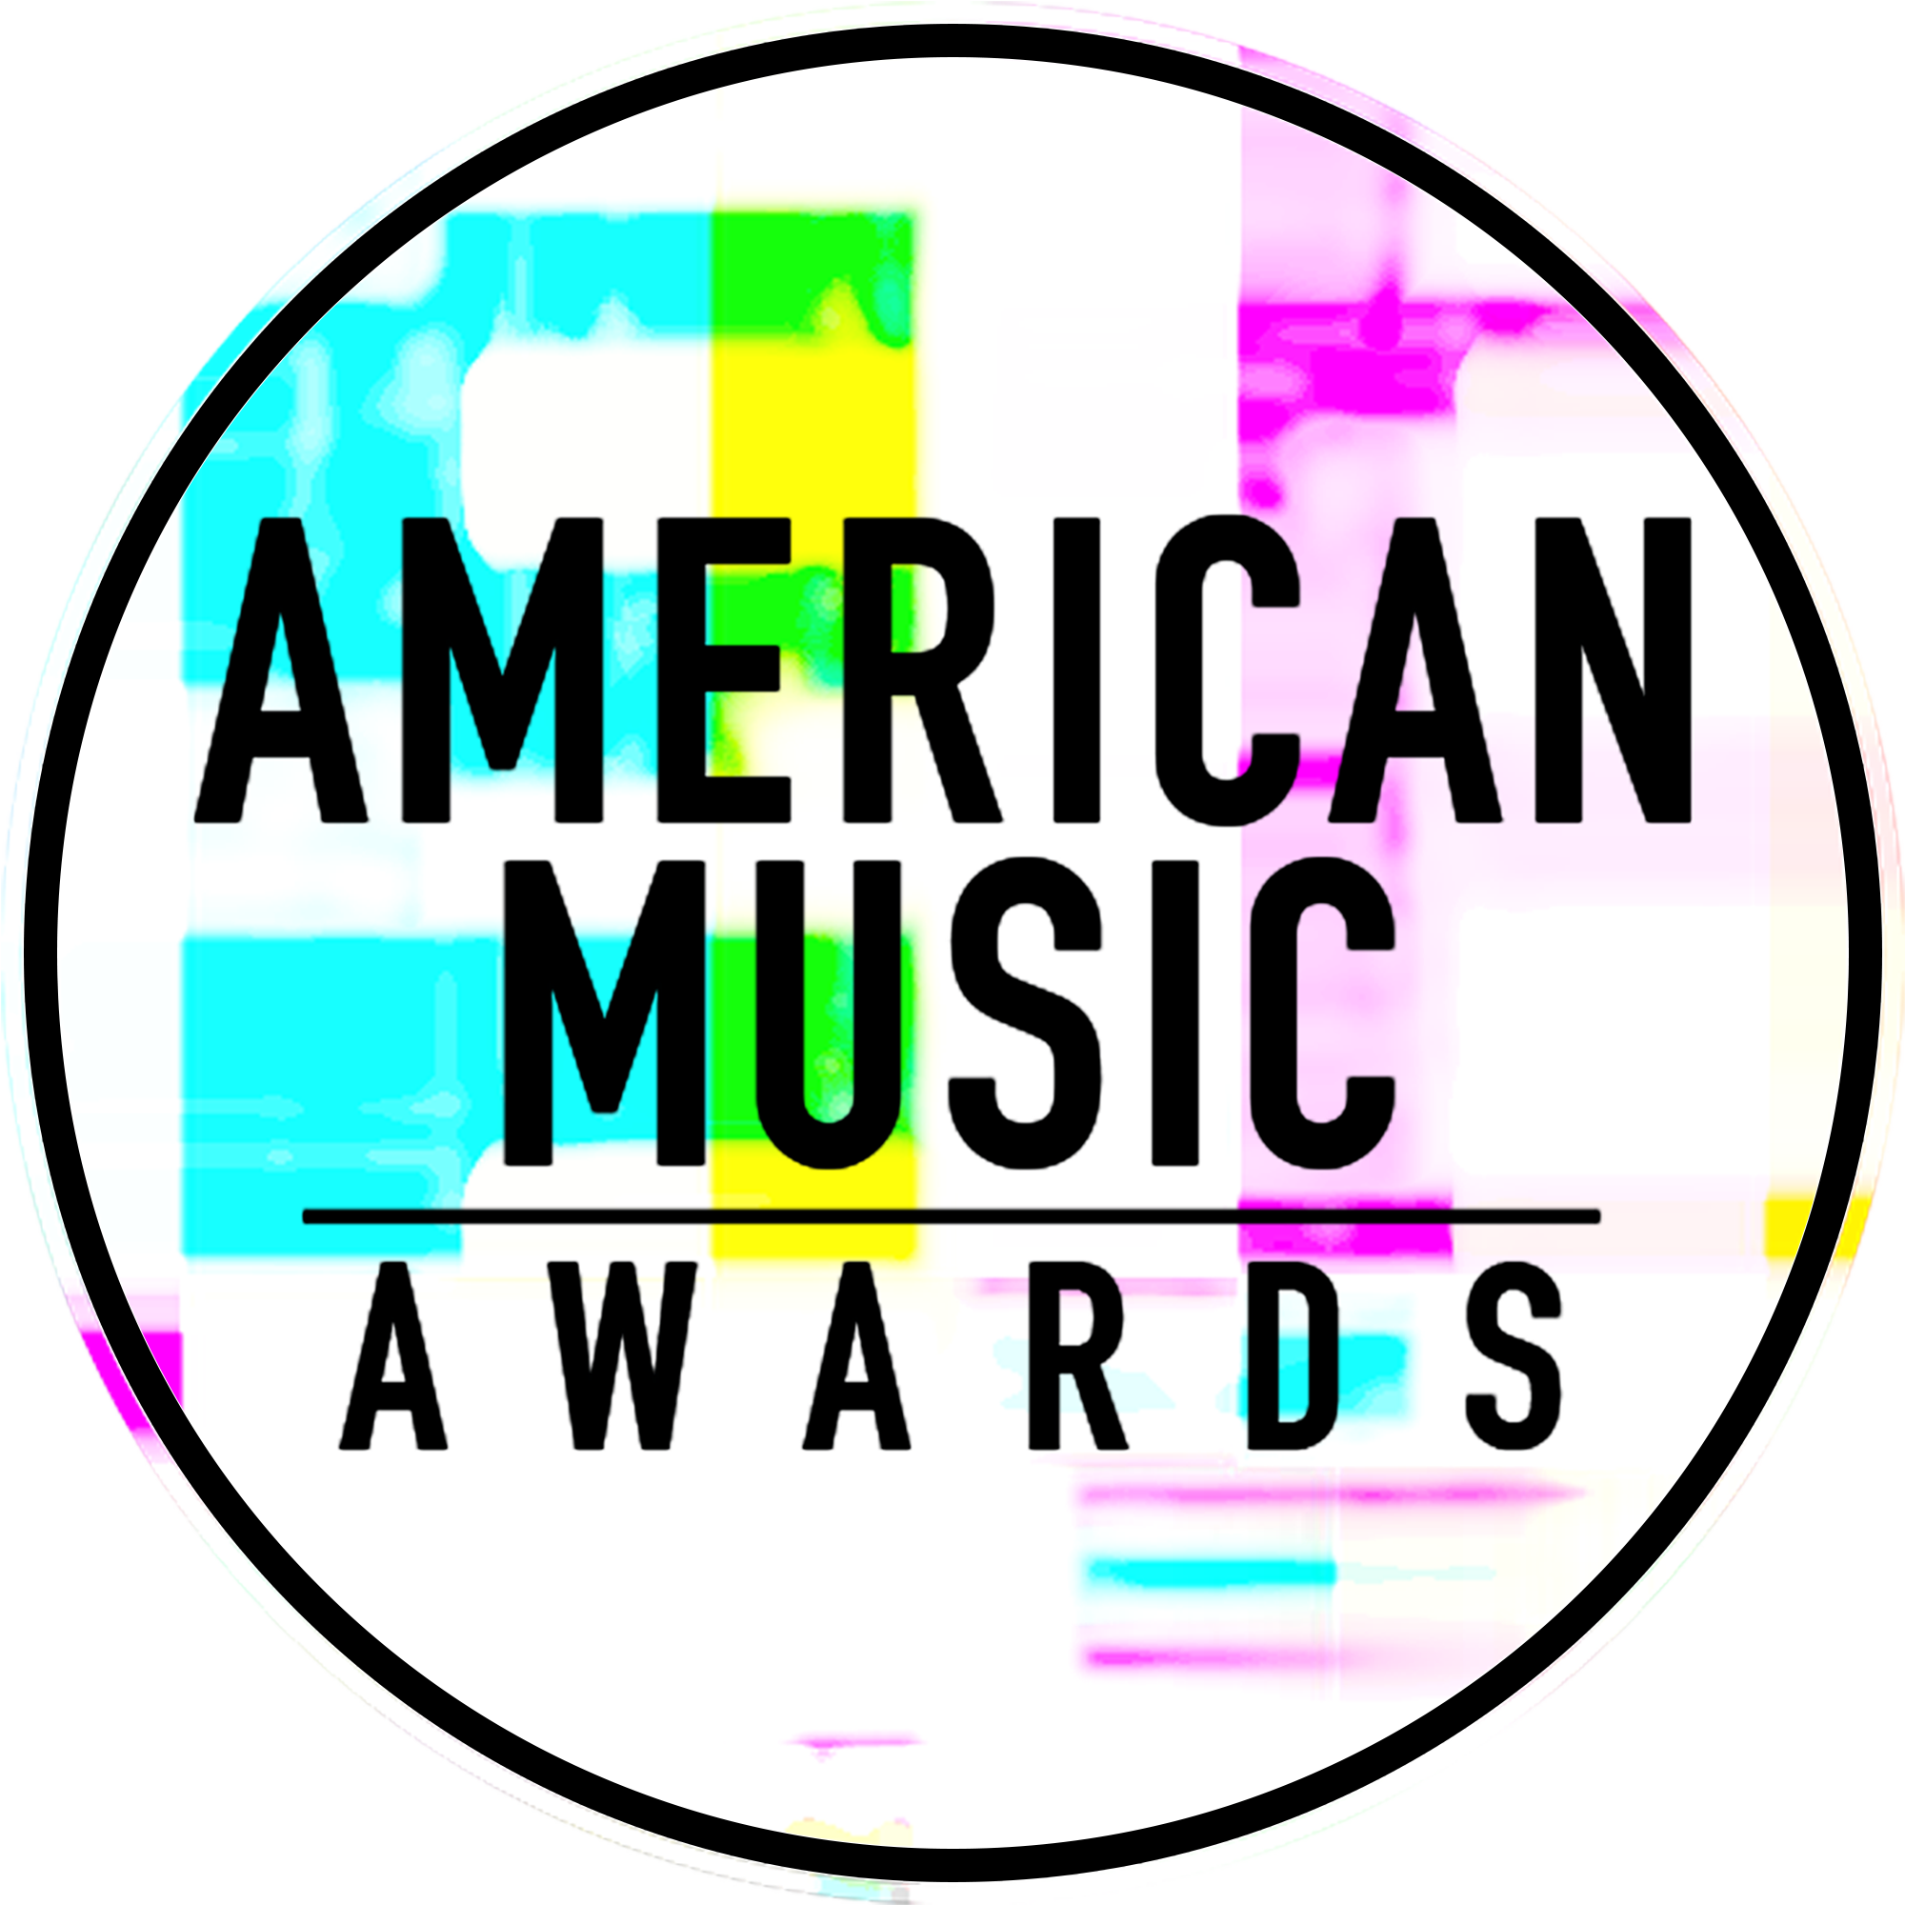

GLOBAL MUSIC SUPERSTARS KELLY CLARKSON & DEMI LOVATO
TO PERFORM AT THE “2017 AMERICAN MUSIC AWARDS®”

WORLD’S LARGEST FAN-VOTED AWARDS SHOW TO
CELEBRATE 45 YEARS OF GIVING FANS THE VERY BEST IN MUSIC

The Live Broadcast Will Air
Sunday, November 19th at 8:00pm ET on ABC

For digital assets and nominee gif galleries, please go to: http://bit.ly/AMAsMedia17

Los Angeles, CA (November 6, 2017) – dick clark productions and ABC announced today that multi-platinum singer-songwriter, Kelly Clarkson, and multi-platinum selling pop artist, Demi Lovato, will perform at the “2017 American Music Awards.” Clarkson, a four-time American Music Award winner, brought the house down during her last American Music Awards performance in 2012 with a medley of her powerful hits, “Miss Independent,” “Since U Been Gone,” “Stronger (What Doesn’t Kill You)” and “Catch My Breath.” This year she takes the stage to perform a brand new single off her just released album Meaning of Life, which marks her eighth top 10 album on the Billboard 200 chart, as well as a second fan-favorite, surprise track. Known for her anthemic songs, Lovato will treat fans to her soulful, unapologetic single “Sorry Not Sorry” off her latest album Tell Me You Love Me, which hit No. 1 on the iTunes album chart in the U.S. and 37 countries around the world. The single is one of the fastest-rising hits in Demi’s career, having become her highest charting single ever on the Billboard Hot 100 and logging over 350 million global streams. Lovato last performed at the American Music Awards in 2015, where she sang her rock/pop track “Confident” as well as joined Alanis Morissette for a rendition of Morissette’s iconic hit “You Oughta Know.”

The “2017 American Music Awards,” the world’s largest fan-voted awards show where music enthusiasts watch their favorite artists and pop culture icons come together to honor idols, newcomers and record-breakers in the contemporary music scene, will celebrate 45 years of music live from the Microsoft Theater in Los Angeles on Sunday, November 19, 2017 at 8:00pm ET on ABC.

Multiple GRAMMY-Award winner Kelly Clarkson recently released her eagerly anticipated eighth studio album Meaning of Life. Her first release with Atlantic Records, Meaning of Life is the album Clarkson was destined to make, a collection of smart and sensual soul-inspired pop that immediately belongs among the legendary label’s classic canon. The Texas-born, Nashville-based singer-songwriter first came to fame in 2002 as the winner of American Idol’s inaugural season, and has grown to be one the most popular artists of this or any other era, with over 100 No. 1 Billboard singles and total worldwide sales of more than 25 million albums and 36 million singles. Clarkson has released eight studio albums (Thankful, Breakaway, My December, All I Ever Wanted, Stronger, Wrapped In Red, Piece By Piece, Meaning of Life), one greatest hits album, and two children’s books (New York Times Top 10 best seller River Rose and the Magical Lullaby and the recent follow up River Rose and the Magical Christmas). She is the recipient of three GRAMMY Awards, four American Music Awards, three MTV Video Music Awards, two Academy of Country Music Awards, two American Country Awards, and one Country Music Association Award. Clarkson was also recently announced as a coach on the 14th season the The Voice, in addition to serving as a Key Advisor on the current season’s Knockout Round.

Demi Lovato is a GRAMMY® nominated and multi-platinum singer, songwriter, actress, advocate, philanthropist and business woman. In addition, she’s one of the biggest names on social media, with an engaged combined following of over 145 million. Lovato's highly-anticipated fifth studio album, Confident, was released in 2015. Within hours of the release of the first single, "Cool for the Summer", the anthem trended worldwide and hit No. 1 on iTunes in 37 countries. Her previous album, 2013's Demi, hit No. 1 on iTunes in over 50 countries around the world - with the lead single "Heart Attack" earning Platinum status just 10 weeks after its release. "Heart Attack" was followed by the top 10 Billboard Hot 100 smash and platinum single "Neon Lights," and her top 10 single "Really Don't Care." The album supported two headlining tours (Neon Lights and Demi World Tour) which made stops throughout North America, Europe, Asia, Australia and New Zealand. In April 2017, Lovato played the voice of Smurfette in the Sony animated film, 'Smurfs: The Lost Village.' Additionally, beyond the stage and the screen, in 2013, her book Staying Strong: 365 Days a Year, became a New York Times best-seller, and in 2014 she became a global ambassador for Sketchers. In 2015, Lovato partnered with Episode, a leading mobile storytelling network, to make Demi Lovato: Path to Fame. Since launching, her story has been read over 225 million times. In 2016, Lovato took on a new venture and was announced as the first-ever collaboration with Fabletics, the innovative active wear brand co-founded by Kate Hudson. As a result of her long-time commitment to raising awareness around LGBT issues and causes, in 2016, Lovato became the recipient of GLAAD's Vanguard award. She continues to be a global advocate for Mental Health, and in 2017 was honored by Semel Institute for Neuroscience and Human Behavior at UCLA, with the Artistic Award for Courage for her work in mental health. In addition, also in 2017, she was named by Global Citizen as the organization's official ambassador for mental health, with a special focus on vulnerable communities around the world. In July 2017, she released the first single “Sorry Not Sorry” off her album Tell Me You Love Me, debuted at No. 3 on the Billboard 200 chart. The album hit No. 1 on iTunes in 37 countries on September 29th.

As previously announced, music legend, Diana Ross, will take the stage for a rare performance at the “2017 American Music Awards” and will be honored with the “American Music Award for Lifetime Achievement.” Christina Aguilera will pay tribute to Whitney Houston and music from “The Bodyguard” with a performance in honor of the film’s 25th anniversary, which falls on the same week as the awards ceremony. Other previously announced performers include BTS and Selena Gomez.

Nominations for the “2017 American Music Awards” were announced last month. Bruno Mars leads with eight nominations, including Artist of the Year, Video of the Year, and Favorite Male Artist – Pop/Rock. The Chainsmokers, Drake, Kendrick Lamar, Ed Sheeran and The Weeknd tied with five nominations each, while Justin Bieber, Daddy Yankee and Luis Fonsi received four nominations each. Additionally, Keith Urban earned three nominations, and Rihanna and Halsey earned two nominations each.

The American Music Awards winners are voted entirely by fans. Voting is now open in all categories.
The Artist of the Year nominees are Bruno Mars, The Chainsmokers, Drake, Kendrick Lamar and Ed Sheeran. Voting for Artist of the Year will close on Thursday, November 16 at 8:59:59pm PT. Voting for all other editorial categories closes on Monday, November 13 at 8:59:59am PT.
For New Artist of the Year presented by T-Mobile and Collaboration of the Year presented by Xfinity, fans can vote for each award 100 times per day, per voting platform in one or both of the ways below. Fans can vote for all other awards once per day, per voting platform.
- Via web at billboard.com/amas and theamas.com/vote
- Posting a tweet on Twitter that includes the nominee's name or Twitter handle, the category name and #AMAs within the tweet

American Music Awards nominees are based on key fan interactions as reflected in Billboard Magazine and on Billboard.com, including album and digital song sales, radio airplay, streaming, social activity and touring. These measurements are tracked by Billboard and its data partners, including Nielsen Music and Next Big Sound. The eligibility period for the “2017 American Music Awards” was September 9, 2016 to September 14, 2017.

Sponsors for the “2017 American Music Awards” include Comcast’s Xfinity and T-Mobile. Media partners include Cumulus Media/ Westwood One and Music Choice.

The “2017 American Music Awards” is produced by dick clark productions. Allen Shapiro and Mike Mahan are Executive Producers. Larry Klein, Barry Adelman and Mark Bracco are Producers.

For the latest American Music Awards news, exclusive content and more, be sure to follow the AMAs on social and join the conversation by using the official hashtag for the show, #AMAs.

Facebook: Facebook.com/AMAs
Twitter: @AMAs
Instagram: @AMAs
Snapchat: TheAMAs
Tumblr: amas.tumblr.com

Cheat tweet: .@kelly_clarkson and @ddlovato added to the @AMAs performer lineup! LIVE 11.19 on ABC: amas.news/kellydemi #AMAs

Tickets are now on sale at www.axs.com.

About the American Music Awards
The American Music Awards, the world’s largest fan-voted award show, features performances from today’s hottest artists and presents fan-voted awards in the music genres of Pop/Rock, Alternative Rock, Country, Rap/Hip-Hop, Soul/R&B, Adult Contemporary, Contemporary Inspirational, Latin, EDM and Soundtrack, and the categories of Artist of the Year, New Artist of the Year presented by T-Mobile, Collaboration of the Year presented by Xfinity, Tour of The Year and Video of the Year. The American Music Awards pays tribute to today’s most influential and iconic artists. The show is produced by dick clark productions and is seen in more than 200 countries around the world. For more information, visit www.theamas.com, www.dickclark.com or abc.go.com/shows/american-music-awards.
About dick clark productions
dick clark productions (dcp) is the world's largest producer and proprietor of televised live event entertainment programming with the "Academy of Country Music Awards," "American Music Awards," "Billboard Music Awards," "Golden Globe Awards," "Dick Clark's New Year's Rockin' Eve with Ryan Seacrest," “Hollywood Film Awards” and the “Streamy Awards.” Weekly television programming includes "So You Think You Can Dance" from 19 Entertainment and dcp. dcp also owns one of the world's most unique and extensive entertainment archive libraries with over 60 years of award-winning shows, historic programs, specials, performances and legendary programming. For additional information, visit www.dickclark.com.

Media Contacts
dick clark productions:
Kelly Striewski 310-255-4602 KStriewski@dickclark.com
Gina Sorial 310-255-0308 GSorial@dickclark.com

Slate PR
Andy Gelb 310-461-0111 Andy@slate-pr.com
Rachael Trager 212-235-6817 Rachael@slate-pr.com

ABC Media Relations:
Nicole Gonzales 818-460-7421 Nicole.J.Gonzales@abc.com
Nate Reeves 818-460-6422 Nate.Reeves@abc.com

Latin Press Inquiries:
Diana Baron 310-315-5444 diana@dbaronmedia.com

# # #

