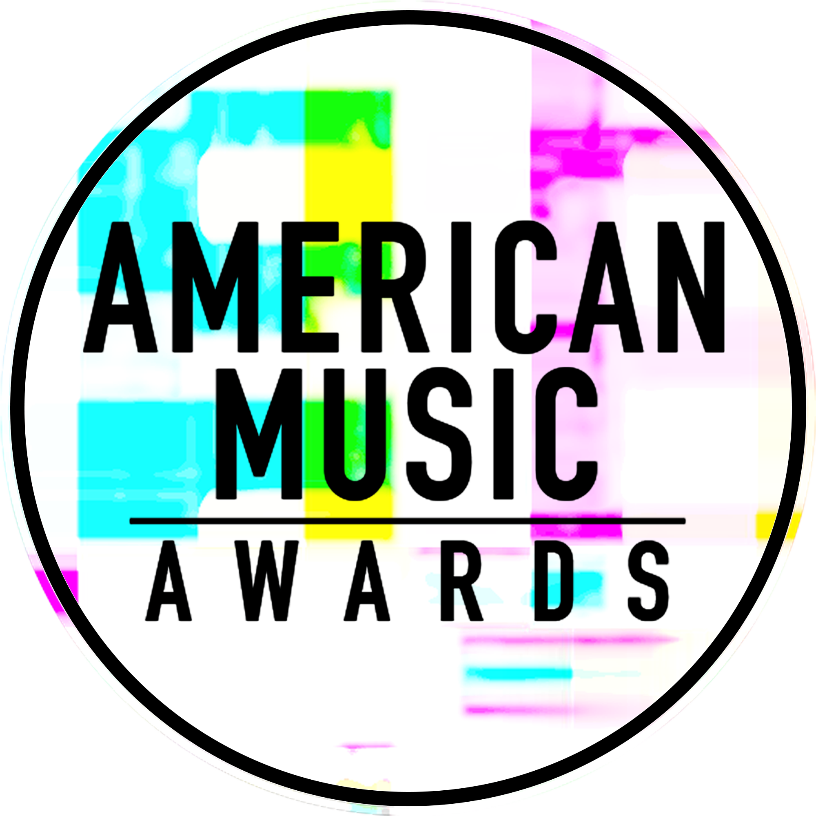

PLATINUM-SELLING MUSIC SUPERSTARS LADY GAGA, NICK JONAS AND SHAWN MENDES
ANNOUNCED AS PERFORMERS ON THE “2017 AMERICAN MUSIC AWARDS®”

WORLD’S LARGEST FAN-VOTED AWARDS SHOW TO
CELEBRATE 45 YEARS OF GIVING FANS THE VERY BEST IN MUSIC

The Live Broadcast Will Air
Sunday, November 19th at 8:00pm ET on ABC

For digital assets and nominee gif galleries, please go to: http://bit.ly/AMAsMedia17

Nick Jonas and Shawn Mendes announced their performances earlier this morning via social media:
Nick Jonas Twitter
Shawn Mendes Twitter

Los Angeles, CA (November 14, 2017) – dick clark productions and ABC announced today that global icon, Lady Gaga, multi-platinum singer/songwriter and actor, Nick Jonas, and multi-platinum singer-songwriter, Shawn Mendes, have joined the roster of superstar performers for the “2017 American Music Awards.” LIVE from her Joanne World Tour stop in Washington D.C. at Capital One Arena, during this year’s awards show, Gaga will take the stage for a rendition of her Billboard Hot 100 synth-pop single on the healing effects of love, “The Cure.” Nick Jonas will perform his romantic pop single “Find You,” which has hit Billboard’s pop airplay and sales charts. Shawn Mendes will rock the crowd with his Top 40 radio No. 1 single “There’s Nothing Holdin’ Me Back” from his second studio album Illuminate, which hit No. 1 on the Billboard 200 albums chart. The “2017 American Music Awards,” the world’s largest fan-voted awards show where music enthusiasts watch their favorite artists and pop culture icons come together to honor idols, newcomers and record-breakers in the contemporary music scene, will celebrate 45 years of music live from the Microsoft Theater in Los Angeles on Sunday, November 19, 2017 at 8:00pm ET on ABC.

Gaga first performed at the American Music Awards in 2009, treating fans to a medley of her popular earworm hits “Bad Romance” and “Speechless.” She last took the American Music Awards stage in 2016, where she gave a heartfelt, stripped-back performance of her Billboard Hot 100 hit “Million Reasons.” Gaga, a nine-time American Music Award nominee, took home the accolade for Favorite Female Artist – Pop/Rock in 2010, and is nominated for the same award this year. Jonas returns to the American Music Awards stage this year following his 2015 show-stopping performance of his popular tracks “Chains,” “Levels” and “Jealous” off Jonas’ self-titled debut studio album, which peaked at No. 6 on the Billboard 200 albums chart. Jonas was nominated for Favorite Male Artist – Pop/Rock that same year. Mendes last performed at the American Music Awards in 2016 for a medley of his hits “Treat You Better” and “Mercy,” where he was also nominated for New Artist of the Year Un-leashed by T-Mobile. Mendes is nominated this year for Favorite Artist – Adult Contemporary.

Grammy and Golden Globe winner and Academy Award-nominated Lady Gaga is a one-of-a kind artist and performer. She has amassed an outstanding 30 million global album sales and 150 million single sales, making her one of the best-selling musicians of all time. Gaga is also one of the biggest living forces in social media with over 60 million likes on Facebook, over 71 million followers on Twitter and over 25 million followers on Instagram. Her fifth studio album “Joanne” was released in October 2016 and debuted at No. 1 on the Billboard 200, marking her 4th consecutive No. 1 proper studio album – and making her the first female to notch four No. 1 albums on the chart in the 2010s. Gaga headlined the 2017 Pepsi Zero Sugar Super Bowl LI Half Time show. Her 13-minute solo performance amassed 117.5 million viewers. She most recently released her documentary “Lady Gaga: Five Foot Two” via Netflix in late September, directed by Chris Moukarbel. Gaga will star alongside Bradley Cooper in the remake of the classic film, “A Star is Born,” set for release May 18, 2018. In 2012, Lady Gaga launched Born This Way Foundation, a non-profit organization dedicated to empowering youth, embracing differences and inspiring kindness and bravery. She is also an outspoken activist, philanthropist and supporter of many important issues including LGBT rights, HIV/AIDS awareness, mental health advocacy and body image issues.

Multi-platinum and Grammy nominated recording artist, actor, and award winning songwriter, Nick Jonas released his self-titled debut album in November 2014. The critically-acclaimed album included the double-platinum and No. 1 U.S. radio hit, “Jealous” and his sultry chart-climbing radio single, “Chains.” A recipient of the Songwriters Hall of Fame's prestigious Hal David Starlight Award, Jonas released his sophomore solo album Last Year Was Complicated in June 2016. The album, which included the platinum him "Close" featuring Tove Lo, debuted as the No. 1 selling album of the week. In 2017, Nick released a new single “Find You” off of his upcoming album. Jonas also wrote an original song titled “Home” for the movie Ferdinand, released by FOX Animation. As an actor, Jonas garnered unanimous critical praise for his lead role in the 2016 Sundance Film Festival favorite Goat, which was produced by and featured James Franco. He also appeared in a guest-starring role in Fox's horror-comedy series, "Scream Queens." Jonas starred in the gritty television show "Kingdom," a mixed martial arts drama that premiered in the fall of 2014. Next, Jonas will appear alongside Dwayne Johnson, Kevin Hart, and Jack Black in Sony’s reimagining of Jumanji, out December 20th. Jonas is currently in production on Lionsgate's post-apocalyptic thriller, Chaos Walking, which also stars Daisy Ridley and Tom Holland, and is scheduled for release in March 2019.

Shawn Mendes scored his second No. 1 debut on the Billboard 200 chart with the release of his sophomore album Illuminate, which hit #1 on iTunes in over 65 countries. The album was recorded with Grammy-nominated producer Jake Gosling (Ed Sheeran’s “+” and “x” albums), and its lead single “Treat You Better” peaked at #1 on iTunes in 44 countries and soared to Top 10 on the Billboard Hot 100 chart. Current single “There’s Nothing Holdin’ Me Back” is approaching 2x Platinum and has scored Shawn his second No.1 single on Billboard’s Pop Songs chart, joining 7x Platinum single “Stitches” from Shawn’s Platinum debut album Handwritten. Throughout his career, Shawn has achieved 2 No. 1 Billboard 200 album chart debuts, 2 Platinum albums, and 7 consecutive Platinum and multi-Platinum singles, including Illuminate’s smash hits “Treat You Better,” “Mercy,” and “There’s Nothing Holdin’ Me Back.” Shawn is currently on his Illuminate World Tour, his first-ever headlining arena tour, with sold-out dates at LA’s Staples Center and Brooklyn’s Barclays Center. Shawn topped Billboard’s “21 Under 21” this year, and has been named one of Time Magazine’s “Most Influential Teens” of 2014, 2015, 2016, and 2017 as well as one of Forbes’ “30 Under 30” in 2016. He won “Favorite New Artist” at the 2016 People’s Choice Awards, and also won awards in the categories of “Best Male” and “Best Worldwide Act” at the 2016 MTV EMAs. He was nominated in the category of “Best Pop” at the 2017 VMAs.

As previously announced, music legend, Diana Ross, will take the stage for a rare performance at the “2017 American Music Awards” and will be honored with the “American Music Award for Lifetime Achievement.” Christina Aguilera will pay tribute to Whitney Houston and music from “The Bodyguard” with a performance in honor of the film’s 25th anniversary, which falls on the same week as the awards ceremony. Other previously announced performers include BTS, Alessia Cara & Zedd, Kelly Clarkson, Selena Gomez, Niall Horan, Imagine Dragons & Khalid, Demi Lovato, P!NK, Portugal. The Man, and Hailee Steinfeld & Alesso ft. Florida Georgia Line & watt. Additionally, Bebe Rexha will combine with Florida Georgia Line to treat American Music Awards fans to an encore performance for Xfinity TV customers, which will be available following the show on Xfinity On Demand.

Nominations for the “2017 American Music Awards” were announced last month. Bruno Mars leads with eight nominations, including Artist of the Year, Video of the Year, and Favorite Male Artist – Pop/Rock. The Chainsmokers, Drake, Kendrick Lamar, Ed Sheeran and The Weeknd tied with five nominations each, while Justin Bieber, Daddy Yankee and Luis Fonsi received four nominations each. Additionally, Keith Urban earned three nominations, and Rihanna and Halsey earned two nominations each.

The American Music Awards winners are voted entirely by fans. Voting is now closed in all categories other than Artist of the Year, New Artist of the Year presented by T-Mobile and Collaboration of the Year presented by Xfinity. Fans are able to vote for these awards using the following methods:
- Via web at billboard.com/amas and theamas.com/vote
- Posting a tweet on Twitter that includes the nominee's name or Twitter handle, the category name and #AMAs within the tweet
For New Artist of the Year presented by T-Mobile and Collaboration of the Year presented by Xfinity, fans can vote for each award 100 times per day, per voting platform in one or both of the ways above. For Artist of the Year, fans may vote once per day, per voting platform.
The Artist of the Year nominees are Bruno Mars, The Chainsmokers, Drake, Kendrick Lamar and Ed Sheeran. Voting for Artist of the Year will close on Thursday, November 16 at 8:59:59pm PT. Voting for New Artist of the Year presented by T-Mobile and Collaboration of the Year presented by Xfinity will close on Sunday, November 19 at 5:59:59pm PT, one hour into the live broadcast.

American Music Awards nominees are based on key fan interactions as reflected in Billboard Magazine and on Billboard.com, including album and digital song sales, radio airplay, streaming, social activity and touring. These measurements are tracked by Billboard and its data partners, including Nielsen Music and Next Big Sound. The eligibility period for the “2017 American Music Awards” was September 9, 2016 to September 14, 2017.

Sponsors for the “2017 American Music Awards” include Comcast’s Xfinity, Security Benefit and T-Mobile. Media partners include Cumulus Media/Westwood One and Music Choice.

The “2017 American Music Awards” is produced by dick clark productions. Allen Shapiro and Mike Mahan are Executive Producers. Larry Klein, Barry Adelman and Mark Bracco are Producers.

For the latest American Music Awards news, exclusive content and more, be sure to follow the AMAs on social and join the conversation by using the official hashtag for the show, #AMAs.

Facebook: Facebook.com/AMAs
Twitter: @AMAs
Instagram: @AMAs
Snapchat: TheAMAs
Tumblr: amas.tumblr.com

Cheat tweet: .@ladygaga, @nickjonas, and @ShawnMendes all added to the @AMAs lineup! Don’t miss it, LIVE 11.19 on ABC: amas.news/performing #AMAs

Tickets are now on sale at www.axs.com.

About the American Music Awards
The American Music Awards, the world’s largest fan-voted award show, features performances from today’s hottest artists and presents fan-voted awards in the music genres of Pop/Rock, Alternative Rock, Country, Rap/Hip-Hop, Soul/R&B, Adult Contemporary, Contemporary Inspirational, Latin, EDM and Soundtrack, and the categories of Artist of the Year, New Artist of the Year presented by T-Mobile, Collaboration of the Year presented by Xfinity, Tour of The Year and Video of the Year. The American Music Awards pays tribute to today’s most influential and iconic artists. The show is produced by dick clark productions and is seen in more than 200 countries around the world. For more information, visit www.theamas.com, www.dickclark.com or abc.go.com/shows/american-music-awards.
About dick clark productions
dick clark productions (dcp) is the world's largest producer and proprietor of televised live event entertainment programming with the "Academy of Country Music Awards," "American Music Awards," "Billboard Music Awards," "Golden Globe Awards," "Dick Clark's New Year's Rockin' Eve with Ryan Seacrest," “Hollywood Film Awards” and the “Streamy Awards.” Weekly television programming includes "So You Think You Can Dance" from 19 Entertainment and dcp. dcp also owns one of the world's most unique and extensive entertainment archive libraries with over 60 years of award-winning shows, historic programs, specials, performances and legendary programming. For additional information, visit www.dickclark.com.

Media Contacts
dick clark productions:
Kelly Striewski 310-255-4602 KStriewski@dickclark.com
Gina Sorial 310-255-0308 GSorial@dickclark.com

Slate PR
Andy Gelb 310-461-0111 Andy@slate-pr.com
Rachael Trager 212-235-6817 Rachael@slate-pr.com

ABC Media Relations:
Nicole Gonzales 818-460-7421 Nicole.J.Gonzales@abc.com
Nate Reeves 818-460-6422 Nate.Reeves@abc.com

Latin Press Inquiries:
Diana Baron 310-315-5444 diana@dbaronmedia.com

# # #

