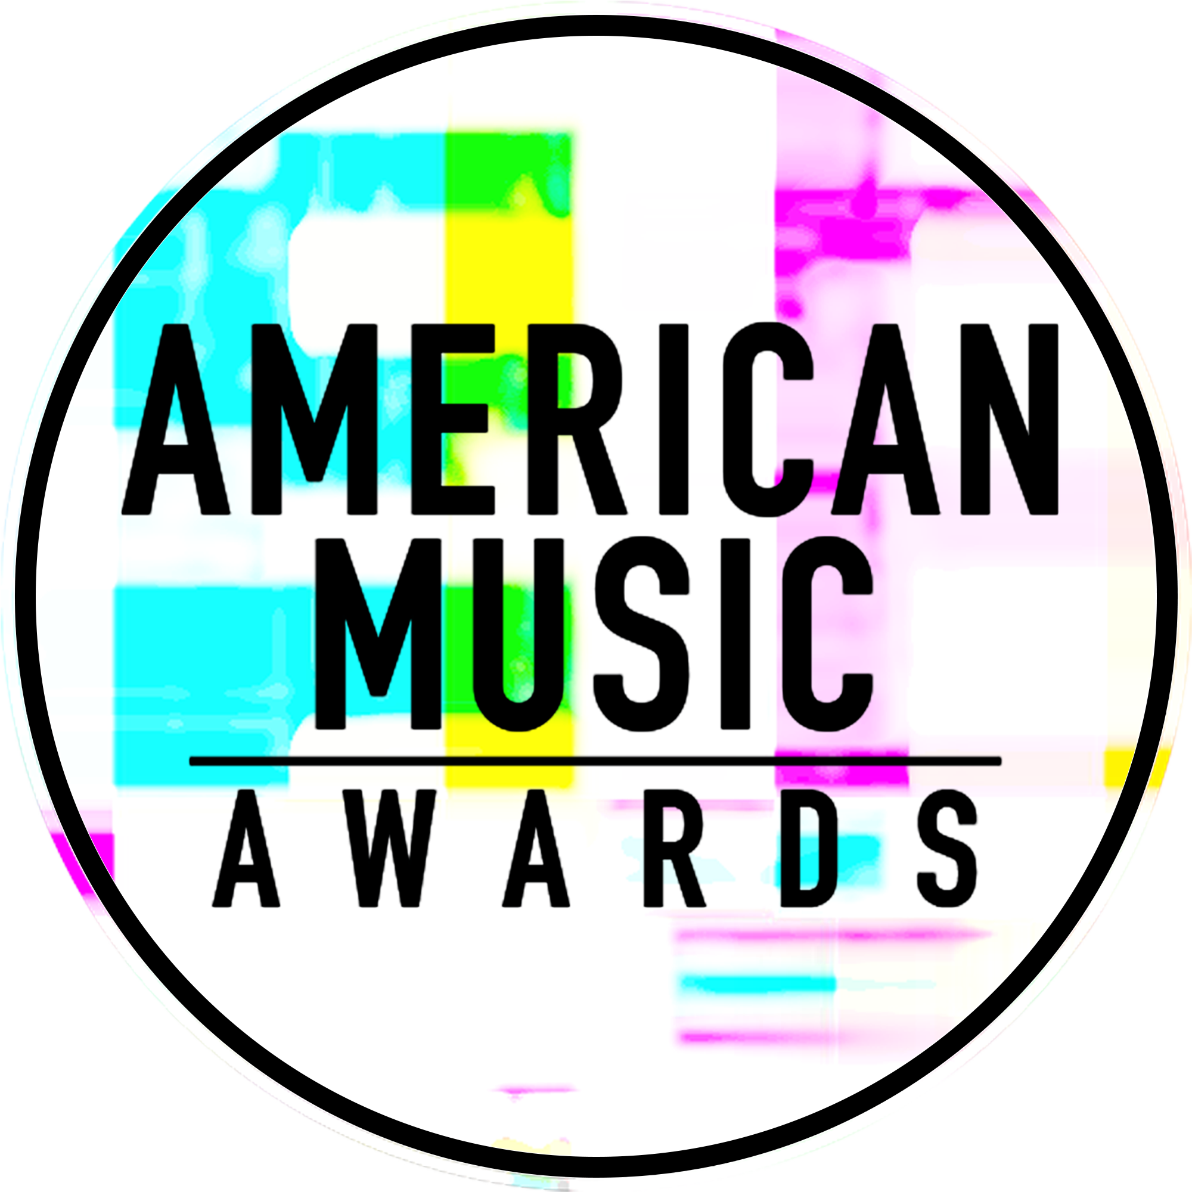

VOTING NOW OPEN FOR
NEW ARTIST OF THE YEAR PRESENTED BY T-MOBILE &
COLLABORATION OF THE YEAR PRESENTED BY XFINITY
AT THE “2017 AMERICAN MUSIC AWARDS”

WORLD’S LARGEST FAN-VOTED AWARDS SHOW TO
CELEBRATE 45 YEARS OF GIVING FANS THE VERY BEST IN MUSIC

Fans can vote for these categories until 8:59:59pm ET on Sunday, November 19,
One Hour into the Live Broadcast

The Live Broadcast Will Air
Sunday, November 19th at 8:00pm ET on ABC

For digital assets and nominee gif galleries, please go to: http://bit.ly/AMAsMedia17

Los Angeles, CA (November 1, 2017) – dick clark productions and ABC, in conjunction with T-Mobile and Comcast’s Xfinity, today announced voting is now open for New Artist of the Year presented by T-Mobile and Collaboration of the Year presented by Xfinity at the “2017 American Music Awards.” The American Music Awards winners are voted entirely by fans. Fans can vote for New Artist of the Year presented by T-Mobile and Collaboration of the Year presented by Xfinity 100 times per day, per category, per voting platform.

Fans can vote for all awards via web at billboard.com/amas and theamas.com/vote, and on Twitter. To vote on Twitter, fans should simply post a tweet that includes the nominee's name or Twitter handle, the category name and #AMAs within the tweet. Note that for Collaboration of the Year presented by Xfinity, Twitter votes must include the name or Twitter handle of the first artist credited on the song (The Chainsmokers, DJ Khaled, Luis Fonsi, Maroon 5, The Weeknd). For all other American Music Awards categories, fans can vote once per day, via one or both of the methods mentioned above.

Nominees for New Artist of the Year presented by T-Mobile:
- James Arthur
- Niall Horan
- Julia Michaels
- Post Malone
- Rae Sremmurd

Nominees for Collaboration of the Year presented by Xfinity:
- The Chainsmokers featuring Halsey “Closer”
- DJ Khaled featuring Justin Bieber, Quavo, Chance the Rapper and Lil Wayne “I’m the One”
- Luis Fonsi and Daddy Yankee featuring Justin Bieber “Despacito”
- Maroon 5 featuring Kendrick Lamar “Don’t Wanna Know”
- The Weeknd featuring Daft Punk “Starboy”

The American Music Awards is the world’s largest fan-voted award show, where music enthusiasts watch their favorite artists and pop culture icons come together to honor idols, newcomers and record-breakers in the contemporary music scene. The “2017 American Music Awards” will celebrate 45 years of music live from the Microsoft Theater in Los Angeles on Sunday, November 19, 2017 at 8:00pm ET on ABC.

As previously announced, music legend, Diana Ross, will take the stage for a rare performance at the “2017 American Music Awards” and will be honored with the “American Music Award for Lifetime Achievement.” Christina Aguilera will pay tribute to Whitney Houston and music from “The Bodyguard” with a performance in honor of the film’s 25th anniversary, which falls on the same week as the awards ceremony. Additionally, multi-platinum pop superstar, Selena Gomez, will treat fans to the world television premiere of her brand new single “Wolves.”

Nominations for the “2017 American Music Awards” were announced last month. Bruno Mars leads with eight nominations, including Artist of the Year, Video of the Year, and Favorite Male Artist – Pop/Rock. The Chainsmokers, Drake, Kendrick Lamar, Ed Sheeran and The Weeknd tied with five nominations each, while Justin Bieber, Daddy Yankee and Luis Fonsi received four nominations each. Additionally, Keith Urban earned three nominations, and Rihanna and Halsey earned two nominations each.

The Artist of the Year nominees are Bruno Mars, The Chainsmokers, Drake, Kendrick Lamar and Ed Sheeran. Voting for Artist of the Year will close on Thursday, November 16 at 8:59:59pm PT. Voting for all other editorial categories closes on Monday, November 13 at 8:59:59am PT.

American Music Awards nominees are based on key fan interactions as reflected in Billboard Magazine and on Billboard.com, including album and digital song sales, radio airplay, streaming, social activity and touring. These measurements are tracked by Billboard and its data partners, including Nielsen Music and Next Big Sound. The eligibility period for the “2017 American Music Awards” was September 9, 2016 to September 14, 2017.

Sponsors for the “2017 American Music Awards” include Comcast’s Xfinity and T-Mobile. Media partners include Cumulus Media/Westwood One and Music Choice.

The “2017 American Music Awards” is produced by dick clark productions. Allen Shapiro and Mike Mahan are Executive Producers. Larry Klein, Barry Adelman and Mark Bracco are Producers.

For the latest American Music Awards news, exclusive content and more, be sure to follow the AMAs on social and join the conversation by using the official hashtag for the show, #AMAs.

Facebook: Facebook.com/AMAs
Twitter: @AMAs
Instagram: @AMAs
Snapchat: TheAMAs
Tumblr: amas.tumblr.com

Cheat tweet: Voting for New Artist of the Year presented by @TMobile & Collab of the Year presented by @XFINITY is OPEN! http://amas.news/voting #AMAs

Tickets are now on sale at www.axs.com.

SHOW MEDIA CREDENTIALS
To apply for media credentials to cover the “2017 American Music Awards” please go to here. Submissions for credentials will stay open until 6pm PT on Friday, November 3, 2017.

About the American Music Awards
The American Music Awards, the world’s largest fan-voted award show, features performances from today’s hottest artists and presents fan-voted awards in the music genres of Pop/Rock, Alternative Rock, Country, Rap/Hip-Hop, Soul/R&B, Adult Contemporary, Contemporary Inspirational, Latin, EDM and Soundtrack, and the categories of Artist of the Year, New Artist of the Year presented by T-Mobile, Collaboration of the Year presented by Xfinity, Tour of The Year and Video of the Year. The American Music Awards pays tribute to today’s most influential and iconic artists. The show is produced by dick clark productions and is seen in more than 200 countries around the world. For more information, visit www.theamas.com, www.dickclark.com or abc.go.com/shows/american-music-awards.
About dick clark productions
dick clark productions (dcp) is the world's largest producer and proprietor of televised live event entertainment programming with the "Academy of Country Music Awards," "American Music Awards," "Billboard Music Awards," "Golden Globe Awards," "Dick Clark's New Year's Rockin' Eve with Ryan Seacrest," “Hollywood Film Awards” and the “Streamy Awards.” Weekly television programming includes "So You Think You Can Dance" from 19 Entertainment and dcp. dcp also owns one of the world's most unique and extensive entertainment archive libraries with over 60 years of award-winning shows, historic programs, specials, performances and legendary programming. For additional information, visit www.dickclark.com.

Media Contacts
dick clark productions:
Kelly Striewski 310-255-4602 KStriewski@dickclark.com
Gina Sorial 310-255-0308 GSorial@dickclark.com

Slate PR
Andy Gelb 310-461-0111 Andy@slate-pr.com
Rachael Trager 212-235-6817 Rachael@slate-pr.com

ABC Media Relations:
Nicole Gonzales 818-460-7421 Nicole.J.Gonzales@abc.com
Nate Reeves 818-460-6422 Nate.Reeves@abc.com

Latin Press Inquiries:
Diana Baron 310-315-5444 diana@dbaronmedia.com

# # #

