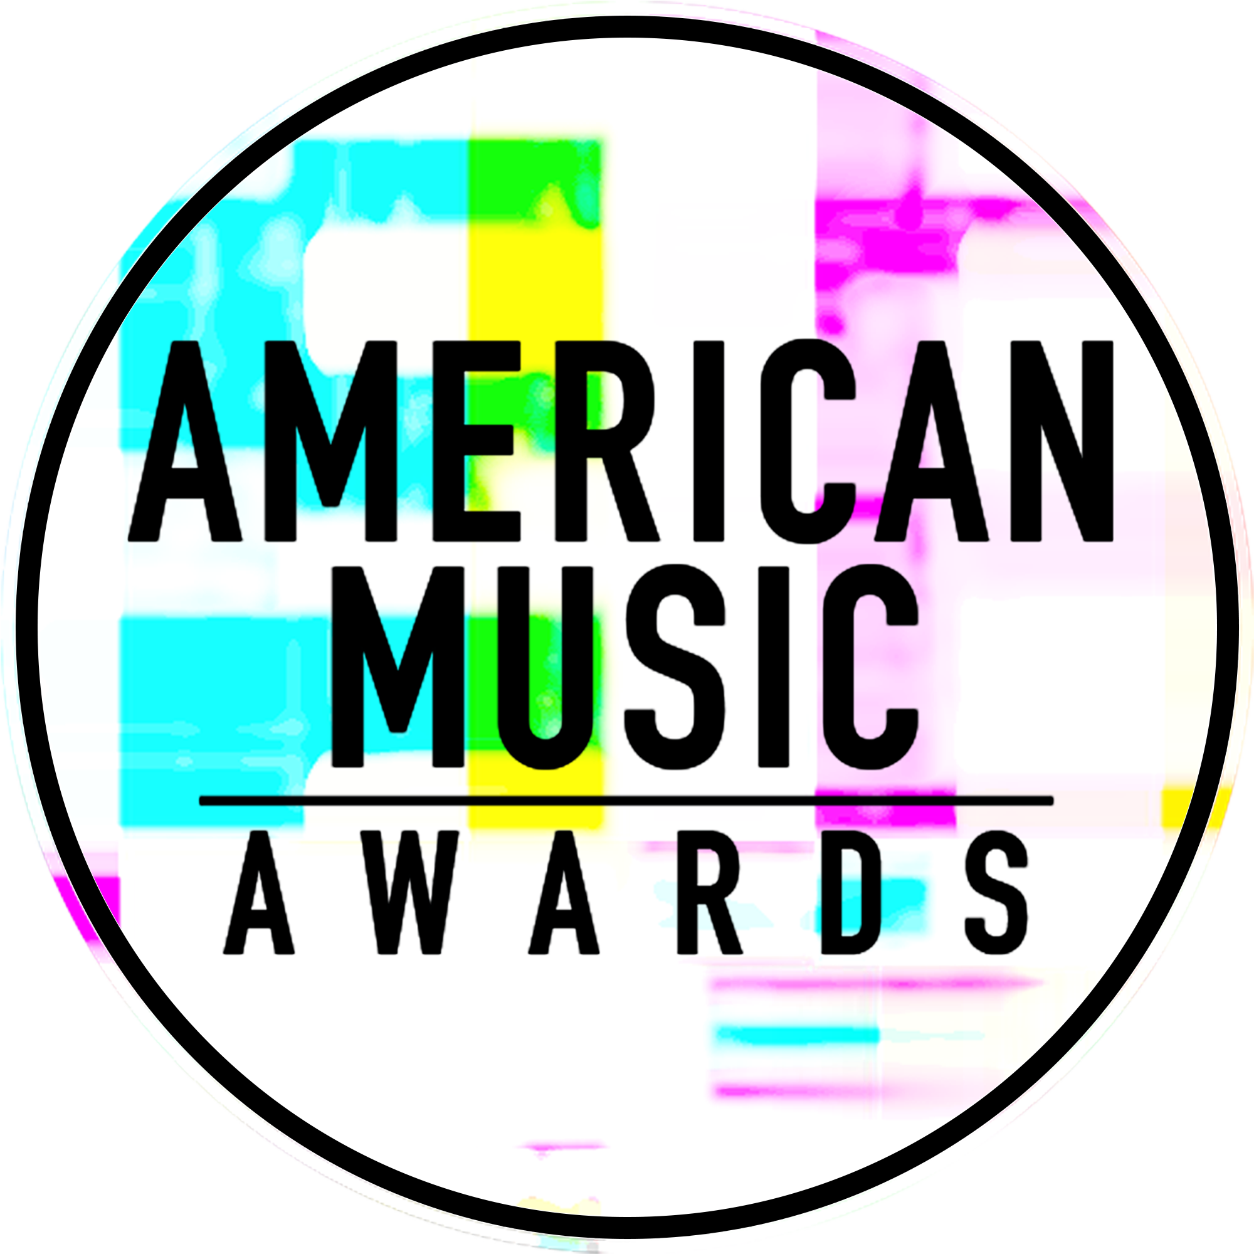

INTERNATIONAL MUSIC SUPERSTAR P!NK
TO TAKE PERFORMING TO THE NEXT LEVEL
WITH HER MOST DARING PERFORMANCE TO DATE
AT THE “2017 AMERICAN MUSIC AWARDS”

WORLD’S LARGEST FAN-VOTED AWARDS SHOW TO
CELEBRATE 45 YEARS OF GIVING FANS THE VERY BEST IN MUSIC

The Live Broadcast Will Air
Sunday, November 19th at 8:00pm ET on ABC

For digital assets and nominee gif galleries, please go to: http://bit.ly/AMAsMedia17

Los Angeles, CA (November 9, 2017) – dick clark productions and ABC announced today that international music superstar, P!NK, will once again elevate her commitment to performance art with a fearless, one of a kind musical experience at the “2017 American Music Awards.” P!NK will perform a show-stopping rendition of the title track from her most recent album Beautiful Trauma, which debuted at No. 1 on the Billboard 200 chart in October and marked a career high for first week sales. The chart-topping singer, songwriter, dancer and actress first took to the American Music Awards stage in 2001 to perform her contemporary R&B track “Most Girls.” She returned in 2003 to perform her pop hit “Trouble,” and again in 2008 for her heartfelt single “Sober” and a memorable duet with Sarah McLachlan for McLachlan’s “Angel.” Taking the American Music Awards stage for the first time since her 2012 buzzworthy acrobatic performance of her Billboard Hot 100 hit “Try,” P!NK is set to make her highly anticipated return with a mind-blowing performance unlike anything that’s been seen before. The “2017 American Music Awards,” the world’s largest fan-voted awards show where music enthusiasts watch their favorite artists and pop culture icons come together to honor idols, newcomers and record-breakers in the contemporary music scene, will broadcast live from the Microsoft Theater in Los Angeles on Sunday, November 19, 2017 at 8:00pm ET on ABC.

Since her debut in 2000, P!NK has released 7 studio albums, 1 greatest hits album, sold over 50 million albums equivalents, over 75 million singles, over 2.4 million DVDs worldwide and has had 15 singles in the top 10 on the Billboard Hot 100 chart (four at No. 1). In addition, she is the recipient of three Grammy Awards (18 nominations), one Daytime Emmy Award, two Billboard Music Awards, six MTV Video Music Awards, two MTV Europe Awards, two People’s Choice Awards, was named Billboard’s Woman of the Year in 2013 and has sold out arenas all over the world. Her seventh studio album, Beautiful Trauma, debuted at No. 1 on the Billboard 200 chart and marked a career high for first week sales. Additionally, the album debuted at No. 1 in 10 other countries, on Billboard’s Top Album Sales Chart and Digital Albums Chart, and is the highest selling debut for a female artist in 2017. Her 2018 “Beautiful Trauma World Tour” is set to kick off on March 1 in Phoenix. P!NK is a huge supporter of various charities, including: Make a Wish Foundation, Autism Speaks, Human Rights Campaign and No Kid Hungry. She remains on the UNICEF team as an Ambassador.

As previously announced, music legend, Diana Ross, will take the stage for a rare performance at the “2017 American Music Awards” and will be honored with the “American Music Award for Lifetime Achievement.” Christina Aguilera will pay tribute to Whitney Houston and music from “The Bodyguard” with a performance in honor of the film’s 25th anniversary, which falls on the same week as the awards ceremony. Other previously announced performers include BTS, Kelly Clarkson, Selena Gomez and Demi Lovato.

Nominations for the “2017 American Music Awards” were announced last month. Bruno Mars leads with eight nominations, including Artist of the Year, Video of the Year, and Favorite Male Artist – Pop/Rock. The Chainsmokers, Drake, Kendrick Lamar, Ed Sheeran and The Weeknd tied with five nominations each, while Justin Bieber, Daddy Yankee and Luis Fonsi received four nominations each. Additionally, Keith Urban earned three nominations, and Rihanna and Halsey earned two nominations each.

The American Music Awards winners are voted entirely by fans. Voting is now open in all categories. Fans are able to vote using the following methods:

- Via web at billboard.com/amas and theamas.com/vote
- Posting a tweet on Twitter that includes the nominee's name or Twitter handle, the category name and #AMAs within the tweet

For New Artist of the Year presented by T-Mobile and Collaboration of the Year presented by Xfinity, fans can vote for each award 100 times per day, per voting platform in one or both of the ways above. Fans can vote for all other awards once per day, per voting platform.

The Artist of the Year nominees are Bruno Mars, The Chainsmokers, Drake, Kendrick Lamar and Ed Sheeran. Voting for Artist of the Year will close on Thursday, November 16 at 8:59:59pm PT. Voting for all other editorial categories closes on Monday, November 13 at 8:59:59am PT. Voting for New Artist of the Year presented by T-Mobile and Collaboration of the Year presented by Xfinity will close on Sunday, November 19 at 5:59:59pm PT, one hour into the live broadcast.

American Music Awards nominees are based on key fan interactions as reflected in Billboard Magazine and on Billboard.com, including album and digital song sales, radio airplay, streaming, social activity and touring. These measurements are tracked by Billboard and its data partners, including Nielsen Music and Next Big Sound. The eligibility period for the “2017 American Music Awards” was September 9, 2016 to September 14, 2017.

Sponsors for the “2017 American Music Awards” include Comcast’s Xfinity and T-Mobile. Media partners include Cumulus Media/ Westwood One and Music Choice.

The “2017 American Music Awards” is produced by dick clark productions. Allen Shapiro and Mike Mahan are Executive Producers. Larry Klein, Barry Adelman and Mark Bracco are Producers.

For the latest American Music Awards news, exclusive content and more, be sure to follow the AMAs on social and join the conversation by using the official hashtag for the show, #AMAs.

Facebook: Facebook.com/AMAs
Twitter: @AMAs
Instagram: @AMAs
Snapchat: TheAMAs
Tumblr: amas.tumblr.com

Cheat tweet: .@Pink will take performing to the next level with a daring performance at the @AMAs! 11.19 on ABC: http://amas.news/pink #AMAs

Tickets are now on sale at www.axs.com.

About the American Music Awards
The American Music Awards, the world’s largest fan-voted award show, features performances from today’s hottest artists and presents fan-voted awards in the music genres of Pop/Rock, Alternative Rock, Country, Rap/Hip-Hop, Soul/R&B, Adult Contemporary, Contemporary Inspirational, Latin, EDM and Soundtrack, and the categories of Artist of the Year, New Artist of the Year presented by T-Mobile, Collaboration of the Year presented by Xfinity, Tour of The Year and Video of the Year. The American Music Awards pays tribute to today’s most influential and iconic artists. The show is produced by dick clark productions and is seen in more than 200 countries around the world. For more information, visit www.theamas.com, www.dickclark.com or abc.go.com/shows/american-music-awards.
About dick clark productions
dick clark productions (dcp) is the world's largest producer and proprietor of televised live event entertainment programming with the "Academy of Country Music Awards," "American Music Awards," "Billboard Music Awards," "Golden Globe Awards," "Dick Clark's New Year's Rockin' Eve with Ryan Seacrest," “Hollywood Film Awards” and the “Streamy Awards.” Weekly television programming includes "So You Think You Can Dance" from 19 Entertainment and dcp. dcp also owns one of the world's most unique and extensive entertainment archive libraries with over 60 years of award-winning shows, historic programs, specials, performances and legendary programming. For additional information, visit www.dickclark.com.

Media Contacts
dick clark productions:
Kelly Striewski 310-255-4602 KStriewski@dickclark.com
Gina Sorial 310-255-0308 GSorial@dickclark.com

Slate PR
Andy Gelb 310-461-0111 Andy@slate-pr.com
Rachael Trager 212-235-6817 Rachael@slate-pr.com

ABC Media Relations:
Nicole Gonzales 818-460-7421 Nicole.J.Gonzales@abc.com
Nate Reeves 818-460-6422 Nate.Reeves@abc.com

Latin Press Inquiries:
Diana Baron 310-315-5444 diana@dbaronmedia.com

# # #

