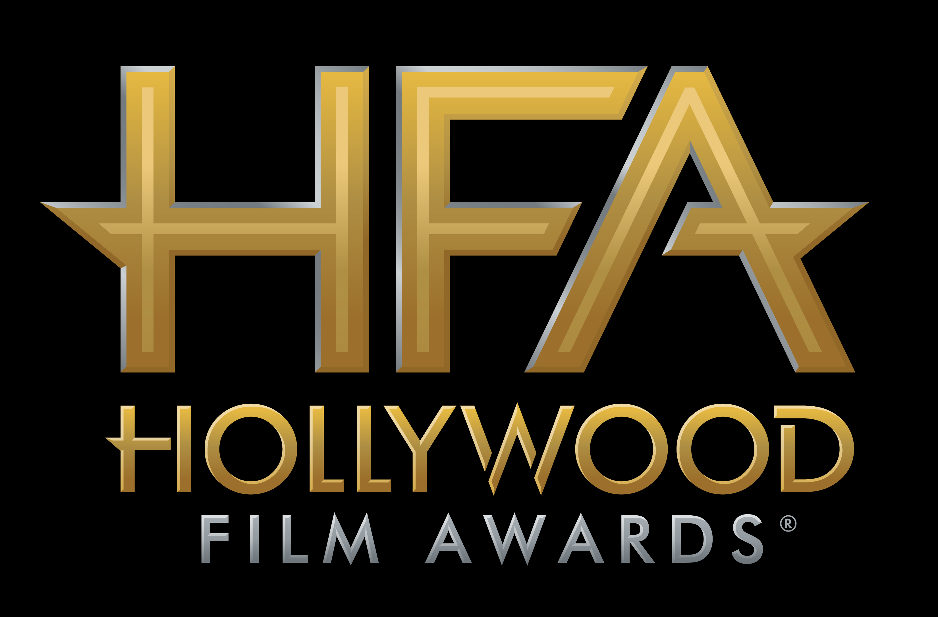

STAR-STUDDED LINEUP OF TALENT SET TO PRESENT
AT THE 21ST ANNUAL “HOLLYWOOD FILM AWARDS®”

ADDITIONAL HONOREES ANNOUNCED IN THE CATEGORIES OF CINEMATOGRAPHY, FILM COMPOSER, EDITOR,
VISUAL EFFECTS, COSTUME DESIGN, MAKE-UP & HAIR STYLING,
PRODUCTION DESIGN AND SOUND

James Corden to Host Awards Ceremony on
Sunday, November 5, 2017, at The Beverly Hilton

Hollywood, CA (November 1, 2017) – dick clark productions announced today an all-star lineup of presenters for this weekend’s 21st Annual “Hollywood Film Awards.” Presenters include Amy Adams, Annette Bening, Jessica Chastain, Viola Davis, Jon Favreau, Harrison Ford, James Franco, Jon Hamm, Bryce Dallas Howard, Dakota Johnson, Eva Longoria, Melissa McCarthy, and Shailene Woodley.

The Hollywood Film Awards, continuing its tradition of recognizing excellence in the art of cinema in all disciplines of filmmaking, also announced today the honorees in the categories of Cinematography, Film Composer, Editor, Visual Effects, Costume Design, Make-Up & Hair Styling, Production Design and Sound:

Hollywood Cinematography Award
Roger Deakins, Blade Runner 2049

Hollywood Film Composer Award
Thomas Newman, Victoria & Abdul

Hollywood Editor Award
Sidney Wolinsky, The Shape of Water

Hollywood Visual Effects Award
Joe Letteri, Dan Lemmon, Dan Barrett and Erik Winquist, War of the Planet of the Apes

Hollywood Costume Design Award
Jacqueline Durran, Darkest Hour and Beauty and the Beast

Hollywood Make-Up & Hair Styling Award
Jenny Shircore, Beauty and the Beast

Hollywood Production Design Award
Dennis Gassner, Blade Runner 2049

Hollywood Sound Award
Addison Teague & Dave Acord, Guardians of the Galaxy, Vol.2

The 2017 “Hollywood Film Awards,” known as the official launch of the awards season®, will be hosted by actor and comedian James Corden for the third consecutive year and will take place at The Beverly Hilton in Beverly Hills, CA, on Sunday, November 5, 2017. The ceremony, which honors the most acclaimed films and actors while previewing highly anticipated films and talent for the upcoming year, also acknowledges artists in the categories of Cinematography, Visual Effects, Film Composing, Costume Design, Editing, Production Design, Sound and Makeup & Hairstyling. In its 21-year history, more than 120 of the “Hollywood Film Awards” honorees have gone on to garner Oscar nominations and/or wins. This year’s ceremony will benefit MPTF, which supports the entertainment community in living and aging well, with dignity and purpose, and in helping each other in times of need.

Previously announced honorees include Gary Oldman for “Hollywood Career Achievement Award” highlighting his work in Darkest Hour; Adam Sandler for “Hollywood Comedy Award” for The Meyerowitz Stories; Joe Wright for “Hollywood Director Award” for Darkest Hour; Kate Winslet for “Hollywood Actress Award” for the film Wonder Wheel; Jake Gyllenhaal for “Hollywood Actor Award” for the film Stonger; the cast of The Big Sick including Kumail Nanjiani, Zoe Kazan, Holly Hunter and Ray Romano for “Hollywood Comedy Ensemble Award”; Jamie Bell for “New Hollywood Actor Award” for Film Stars Don’t Die in Liverpool; musicians Diane Warren, Common and Andra Day for the original song, “Stand Up For Something” with music by Diane Warren, lyrics by Diane Warren and Common and performed by Andra Day featuring Common from the film Marshall for “Hollywood Song Award”; Blade Runner 2049 producers Andrew S. Kosove, Broderick Johnson and Cynthia Sikes Yorkin for “Hollywood Producer Award”; The Disaster Artist screenwriters Scott Neustadter and Michael H. Weber for “Hollywood Screenwriter Award”; Coco for “Hollywood Animation Award”; the cast of Mudbound including Carey Mulligan, Garrett Hedlund, Mary J. Blige, Jason Mitchell, Jason Clarke, Rob Morgan and Jonathan Banks for the “Hollywood Breakout Ensemble Award”; Sam Rockwell for “Hollywood Supporting Actor Award” for his role in Three Billboards Outside Ebbing, Missouri; Allison Janney for “Hollywood Supporting Actress Award” for her role in I, Tonya; Mary J. Blige for “Hollywood Breakout Performance Actress Award” for her work in the film Mudbound; Timothée Chalamet for “Hollywood Breakout Performance Actor Award” for his role in the film Call Me By Your Name; and the cast of I, Tonya, including Margot Robbie, Allison Janney, Sebastian Stan, Paul Walter Hauser, Julianne Nicholson and Caitlin Carver for the “Hollywood Ensemble Award.”

Additional honorees for the 21st Annual “Hollywood Film Awards” will be announced in the coming weeks.

For the latest news, follow the “Hollywood Film Awards” on social and join the conversation by using the official hashtag for the show, #HollywoodAwards.

Twitter: @HollywoodAwards
Facebook: Facebook.com/HollywoodAwards
Instagram: @hollywoodawards
Tumblr: hollywoodawards.tumblr.com
Snapchat: hollywoodawards

About dick clark productions
dick clark productions (dcp) is the world's largest producer and proprietor of televised live event entertainment programming with the "Academy of Country Music Awards," "American Music Awards," "Billboard Music Awards," "Golden Globe Awards," "Dick Clark's New Year's Rockin' Eve with Ryan Seacrest," “Hollywood Film Awards” and the “Streamy Awards.” Weekly television programming includes "So You Think You Can Dance" from 19 Entertainment and dcp. dcp also owns one of the world's most unique and extensive entertainment archive libraries with over 60 years of award-winning shows, historic programs, specials, performances and legendary programming. For additional information, visit www.dickclark.com.

About The Hollywood Film Awards®
The Hollywood Film Awards®, founded in 1997, were created to celebrate Hollywood and launch the awards season. The recipients of the awards are selected by an Advisory Team for their body of work and/or a film(s) that is to be released during the calendar year. For additional information, visit www.hollywoodawards.com.

# # #

PR Contacts:

dick clark productions:
Kelly Striewski 310-255-4602 kstriewski@dickclark.com
Lydia Baskharoon 310-255-0319 lbaskharoon@dickclark.com

Slate PR:
Andy Gelb 310-461-0111 andy@slate-pr.com
Rachael Trager 212-235-6817 rachael@slate-pr.com

