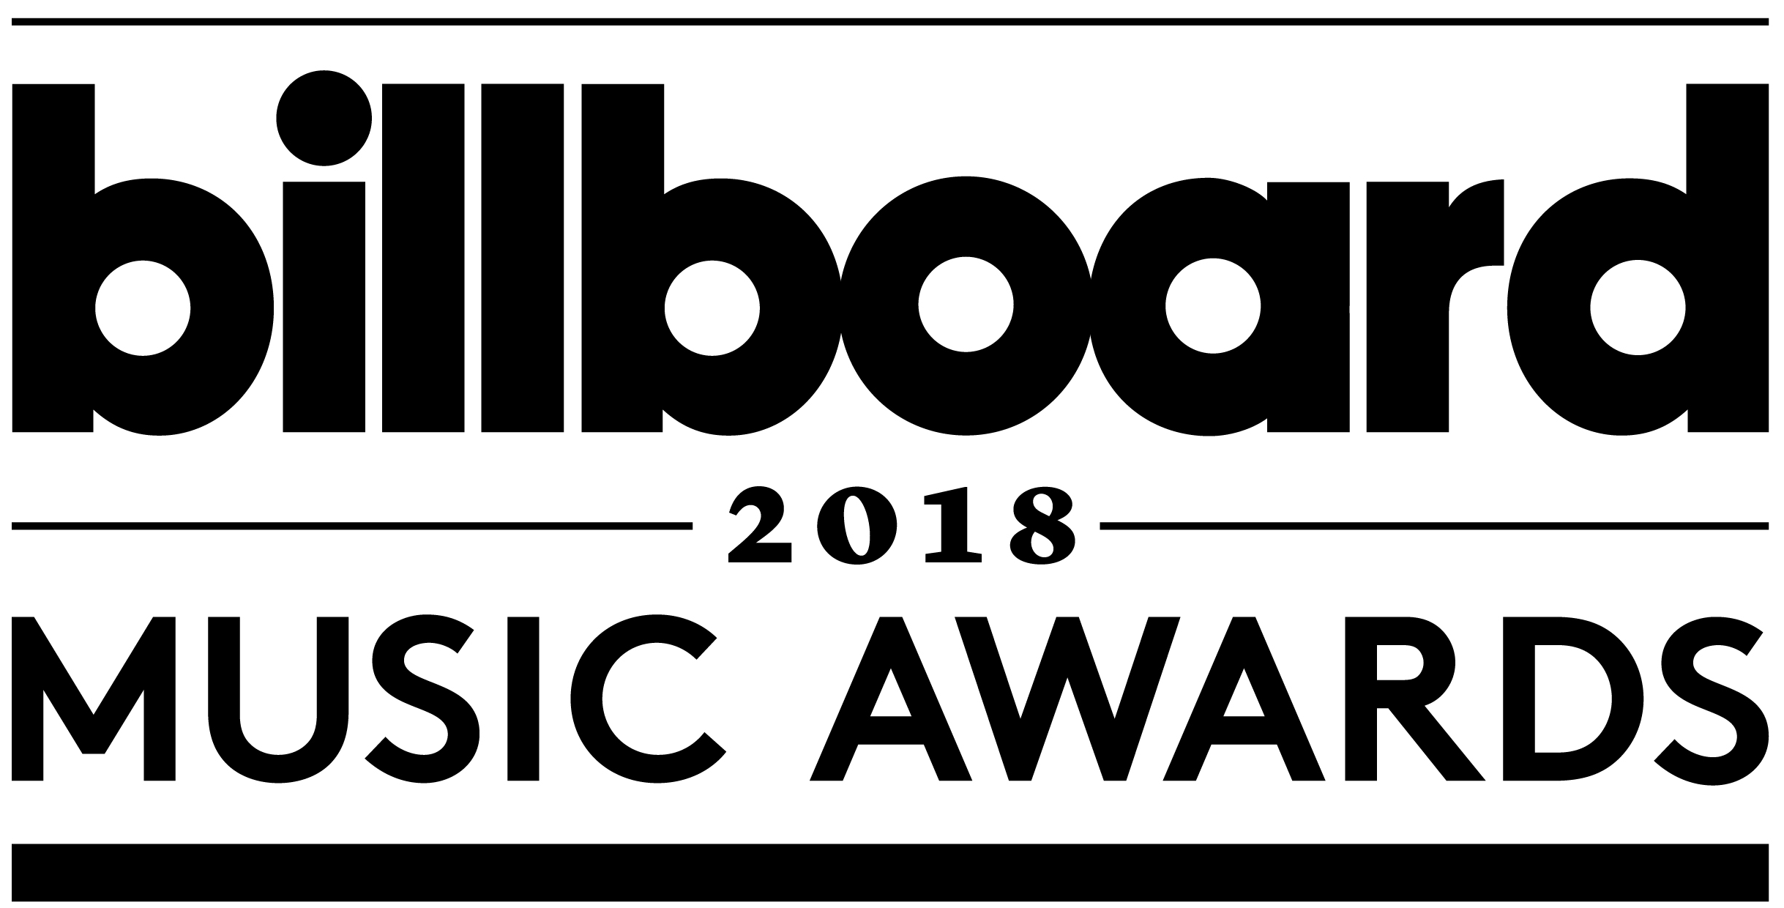

GLOBAL SUPERSTAR
JANET JACKSON
TO RECEIVE THE COVETED ICON AWARD
AND DELIVER A HIGHLY ANTICIPATED PERFORMANCE
AT THE “2018 BILLBOARD MUSIC AWARDS” ON NBC

Jackson’s Billboard Music Awards Performance
to Mark Her First on Television in Nine Years

The “2018 Billboard Music Awards” Will broadcast Live From
MGM Grand Garden Arena on Sunday, May 20th at 8 P.M. ET / 5 P.M. PT

Click here for digital assets for the “2018 Billboard Music Awards”

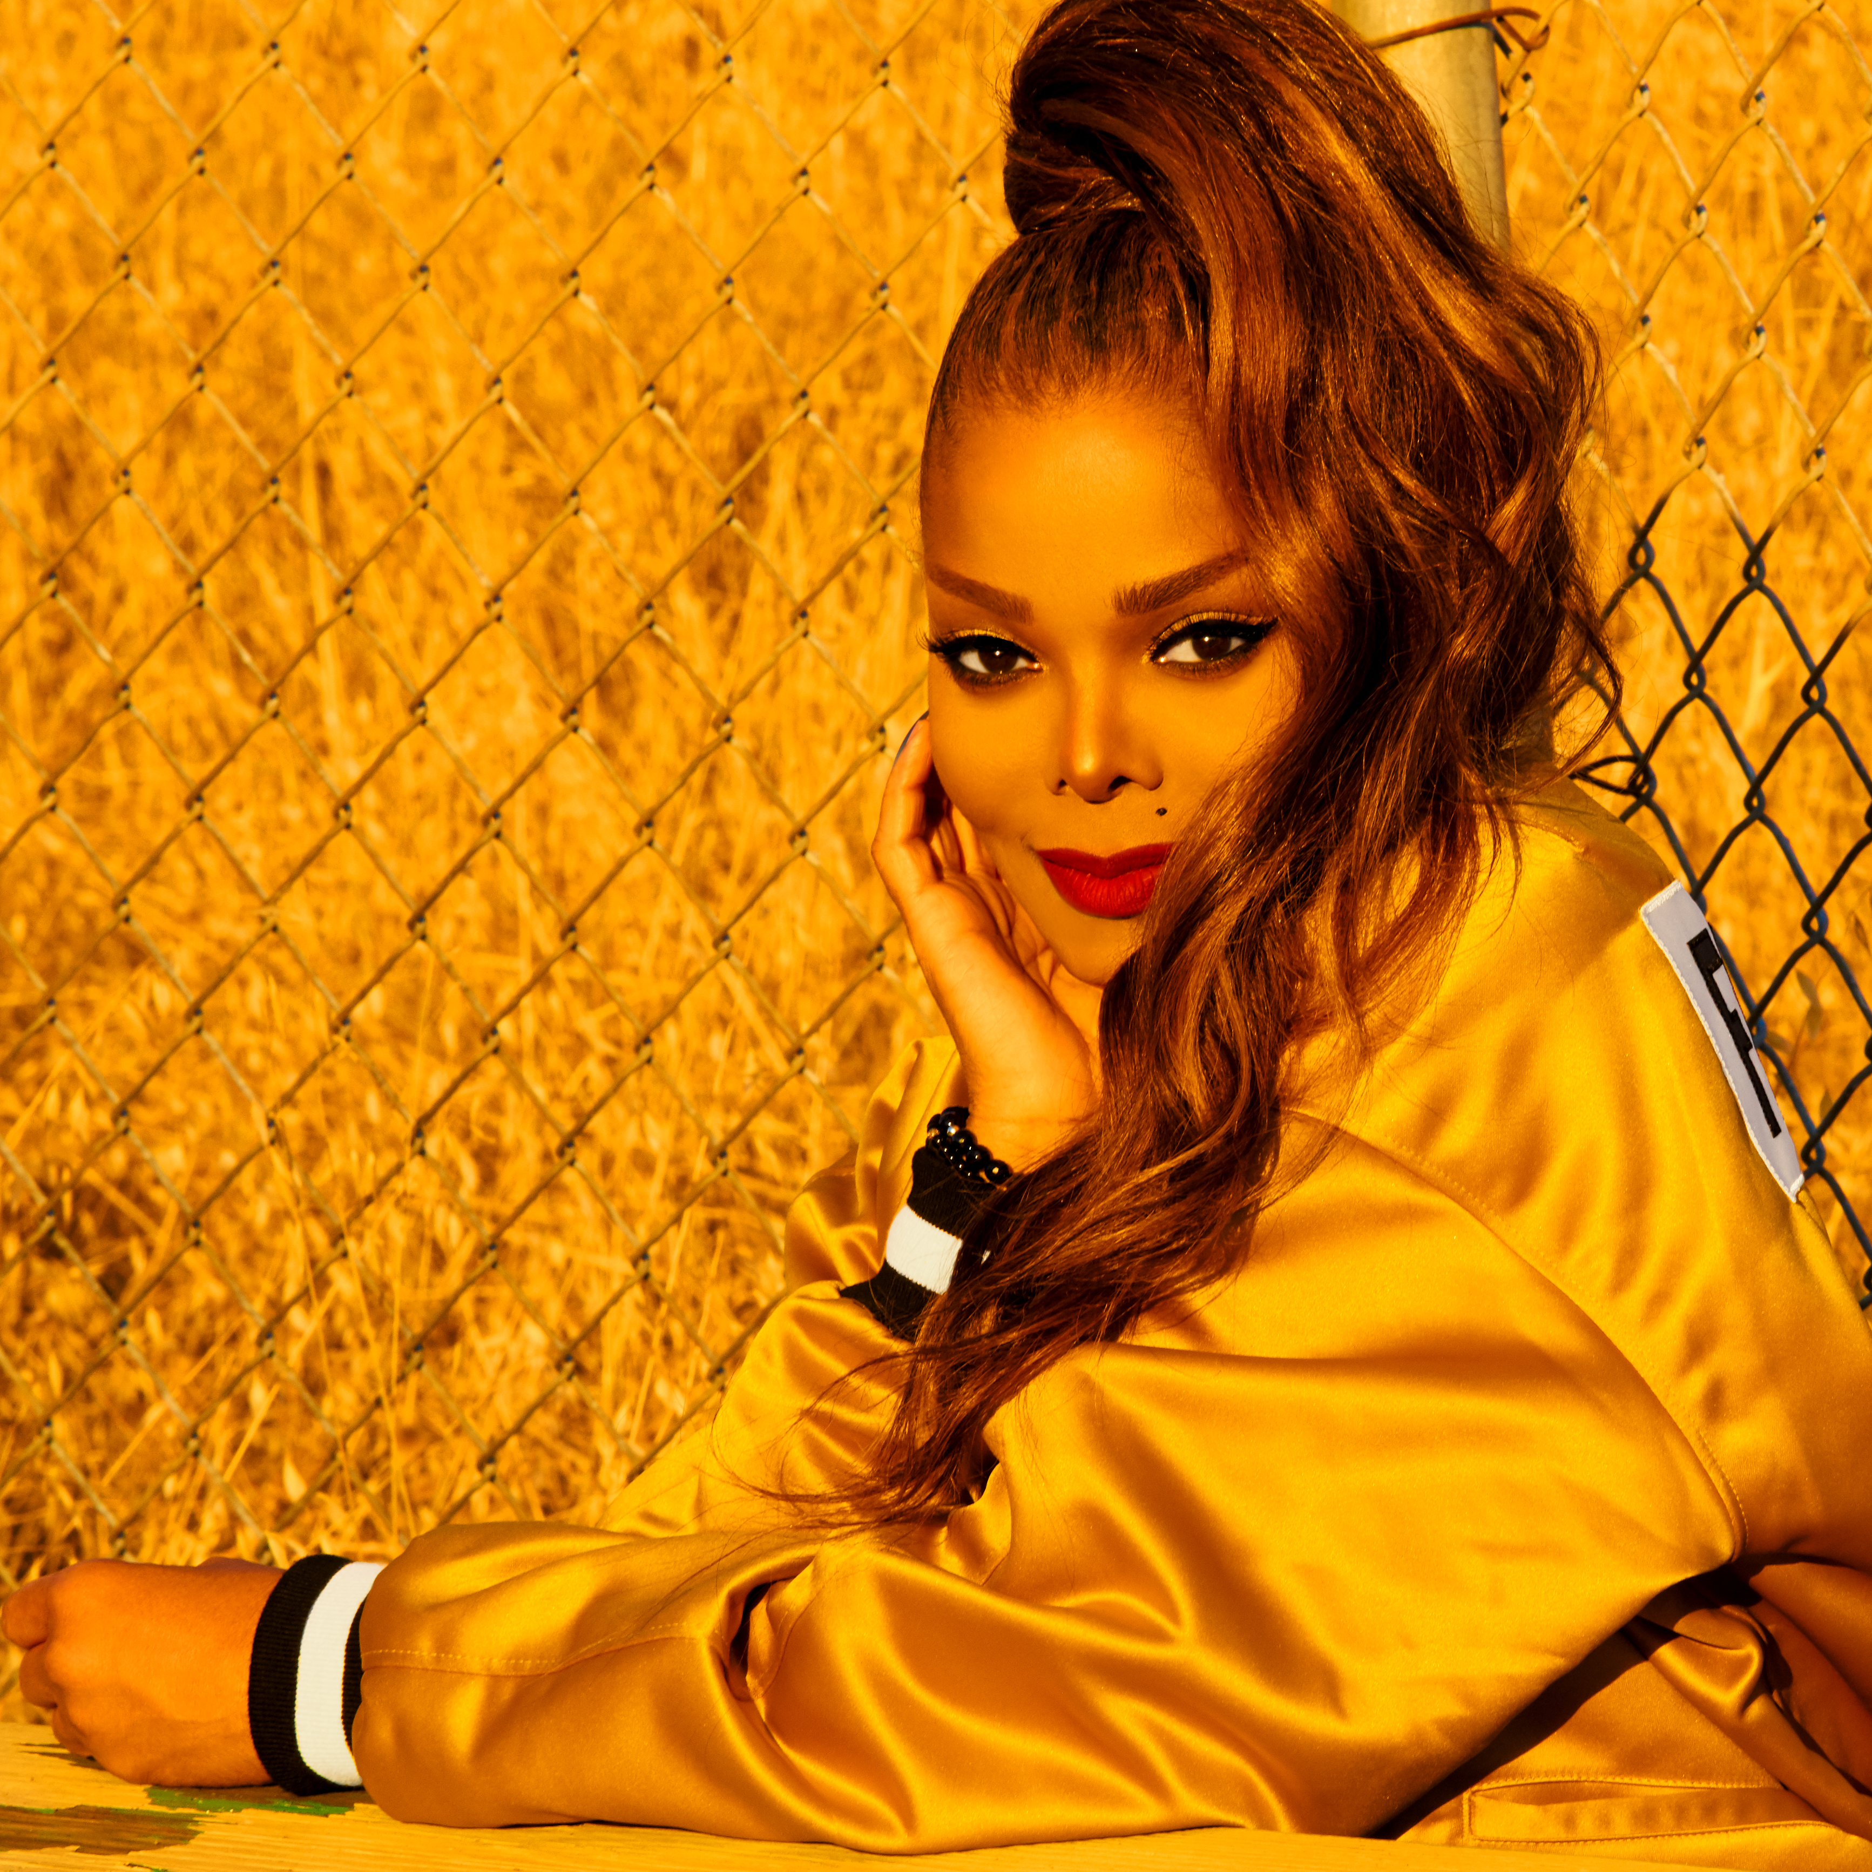
Photo credit: Solamain Fazel
Check out the #ICON_JANET BBMAs Spotify playlist here and embed the playlist into your coverage!
SANTA MONICA, CA (May 7, 2018) – dick clark productions and NBC announced today that music legend, Janet Jackson, will be honored with the prestigious ICON Award at the “2018 Billboard Music Awards,” and will deliver a highly-anticipated performance that will be her first on television in nine years.

Hosted by “The Voice” coach Kelly Clarkson, the “2018 Billboard Music Awards” will broadcast live from MGM Grand Garden Arena in Las Vegas on Sunday, May 20 at 8 p.m. ET / 5 p.m. PT on NBC. The three-hour telecast will feature performances from this year’s hottest musical acts, unexpected collaborations and buzzworthy moments that celebrate 60 years of the Billboard Hot 100.

Janet Jackson Billboard chart facts include:

- As a leading voice in music, Jackson has earned more than 100 No. 1s on Billboard’s charts in her career, spending more than 300 weeks at No. 1.
- She has 19 No. 1s on the Dance Club Songs charts.
- Jackson is one of only four artists to have a No. 1 album on the Billboard 200 in each of the last four decades.
- She was the first woman to debut in the Top 10 of the Billboard Hot 100 (with “Scream,” her duet with brother Michael), and the only artist with seven Top five Hot 100 hits from one album (“Janet Jackson’s Rhythm Nation 1814”).
- She owns a record of 18 consecutive Top 10 hits on the Hot 100 and is also the only artist to have three different albums each contain at least five Top 10 hits on the Hot 100 (“Control,” “Janet Jackson’s Rhythm Nation 1814” and “janet”).

Previous recipients of the ICON Award include Cher, Neil Diamond, Celine Dion, Jennifer Lopez, Prince and Stevie Wonder.

Janet Jackson is one of the most influential entertainers of the modern era. She has won six Grammy® Awards, a Golden Globe Award, earned two Emmy nominations, a nomination for an Academy Award as well as dozens of American Music Awards, MTV Video Music Awards and Billboard Music Awards. She has received accolades as an actress as well, including the NAACP Best Supporting Actor award. Jackson is a published author, dancer, businessperson, philanthropist and one of the biggest-selling artists in popular music history. With sales of over 160 million records worldwide, Jackson stands as one of the best-selling artists of all time with a string of hits that have left an indelible impression on pop culture. Her music and artistry has opened doors through which other top artists have followed, many acknowledging her impact on their musical perceptions. For more information please visit janetjackson.com.

Janet Jackson’s BBMA Giphy stickers are now available! These stickers can be found within Instagram Stories by clicking the GIF button and searching for “BBMAs.”
Nominations for the “2018 Billboard Music Awards” were announced last month on NBC’s “Today” and on a livestream from Billboard’s New York office. Kendrick Lamar, Bruno Mars and Ed Sheeran tie for the most nominations this year with 15 each.

Voting for the two fan voted categories – Billboard Chart Achievement Award and Top Social Artist – will open on Monday, May 14 and additional details will be available soon.

“Billboard Music Awards” nominees and winners are based on key fan interactions with music, including album and digital song sales, streaming, radio airplay, touring and social engagement, tracked by Billboard and its data partners, including Nielsen Music and Next Big Sound. The awards are based on the reporting period of April 8, 2017 through March 31, 2018. Since 1940, the Billboard charts have been the go-to guide for ranking the popularity of artists, songs and albums, and are the ultimate measure of success in music.

For additional information on the “2018 Billboard Music Awards,” visit us at www.billboardmusicawards.com or check out the Billboard hub at www.billboard.com/bbma.

For the latest Billboard Music Awards (BBMAs) news, exclusive content and more, be sure to follow the BBMAs on social media and join the conversation by using the official hashtag for the show, #BBMAs.
Facebook: FB.com/TheBBMAs
Twitter: @BBMAs
Instagram: bbmas
Snapchat: thebbmas

Cheat Tweet: .@JanetJackson will receive the ICON Award at the 2018 @BBMAs. bbmas.news/IconJanet #BBMAs

The “2018 Billboard Music Awards” is produced by dick clark productions. Mark Bracco, Barry Adelman, Kelly Clarkson and Robert Deaton are executive producers.

The “2018 Billboard Music Awards” are sponsored by T-Mobile.
About Billboard
Billboard is the world's largest voice in music, built on the most complete and well-respected database of charts across all music genres. The Billboard charts define success in music. From the iconic Billboard magazine to Billboard.com, the ultimate consumer-facing destination for millions of passionate music fans, to the industry's most elite conference series and influencer events including the Power 100 and Women in Music – the Billboard brand has unmatched authority among fans, artists and the industry alike. Billboard has a social media footprint of 16.4 million social followers across Facebook, Twitter, Instagram, and YouTube, and creates more than 200M cross-platform video views per month. Billboard magazine has published major news-generating covers recently including Travis Scott, Zayn, Lorde, Marshmello, Demi Lovato, Cardi B, Selena Gomez, Eminem, DJ Khaled, Charlie Puth, and an open letter to Congress signed by 180+ of the music industry’s biggest stars and executives. In December 2017, the Billboard Women in Music ceremony, which honored Selena Gomez as Woman of the Year, was live-streamed globally on Twitter. In 2016, The Hollywood Reporter-Billboard Media Group acquired SpinMedia’s storied music assets Spin, Vibe, and Stereogum, establishing the world’s largest music brand by digital traffic, social reach, and audience share. The combined entity of music and entertainment properties now reaches 47 million unique visitors and one in every three U.S. millennials.
About dick clark productions
dick clark productions (dcp) is the world's largest producer and proprietor of televised live event entertainment programming with the "Academy of Country Music Awards," "American Music Awards," "Billboard Music Awards," "Golden Globe Awards," "Dick Clark's New Year's Rockin' Eve with Ryan Seacrest" and the “Streamy Awards.” Weekly television programming includes "So You Think You Can Dance" from 19 Entertainment and dcp. dcp also owns one of the world's most unique and extensive entertainment archive libraries with over 60 years of award-winning shows, historic programs, specials, performances and legendary programming. dcp is a division of Valence Media, a diversified media company with divisions and strategic investments in premium television, wide release film, specialty film, live events and digital media. For additional information, visit www.dickclark.com.

SHOW MEDIA CREDENTIALS
To apply for media credentials to cover the “2018 Billboard Music Awards,” please click HERE and fill out the online form. Credential application process closes Wednesday, May 9, 2018.

Media Contacts
dick clark productions:
Kelly Striewski, 310-255-4602, KStriewski@dickclark.com
Gina Sorial, 310-255-0308, GSorial@dickclark.com

Slate PR:
Andy Gelb, 310-461-0111, andy@slate-pr.com
Rachael Trager, 212-235-6817, rachael@slate-pr.com

NBC Media Relations:
Rebecca Marks, 818-777-3030, Rebecca.Marks@nbcuni.com
Traci Saulsberry, 818-777-6649, Traci.Saulsberry@nbcuni.com
Stuart Levine, 818-777-9828, Stuart.Levine@nbcuni.com
Janet Jackson PR:
Ken Sunshine
Paula Witt – 212-691-2800, witt@sunshinesachs.com

###

