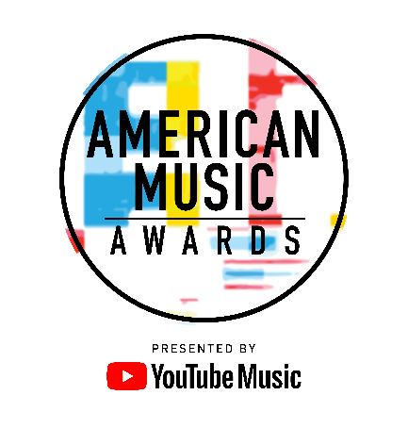

THE “AMERICAN MUSIC AWARDS”
FORMS FIRST-EVER PARTNERSHIP WITH YOUTUBE MUSIC

Global Brands Come Together with Multi-Year Deal to
Celebrate the Best in Music

The 2018 American Music Awards will Broadcast Live on
Tuesday, October 9th at 8:00 p.m. ET on ABC

Los Angeles, CA (August 22, 2018) – dick clark productions today announced a multi-year partnership between the “American Music Awards” and YouTube Music, marking the first-ever presenting partnership of the show. The partnership celebrates YouTube Music as a “go-to” music platform for streaming music, videos, live performances and more -- the same type of iconic content that has made the “American Music Awards” a staple event for the world’s greatest artists and the world’s biggest music fans for 46 years.

Through this historic partnership, music enthusiasts can watch their favorite artists and pop culture icons come together to honor idols, newcomers and record-breakers in the contemporary music scene. The “2018 American Music Awards” will broadcast live from the Microsoft Theater in Los Angeles on Tuesday, October 9, 2018 at 8:00 p.m. ET on ABC.

“YouTube Music’s partnership with The American Music Awards is a natural extension of the intimate artist-fan connection that is made possible on YouTube’s global platform,” said Angela Courtin, Director, Global Head of YouTube Music, TV and Originals Marketing. “The American Music Awards are the world’s largest fan-voted awards show and YouTube is the world’s largest platform for discovering music with more than 1 billion fans each month coming to be a part of music culture and engage with over 2 million artists who share their voices and art with the world.”

“YouTube brings global reach, awareness and engagement to the ‘American Music Awards’ unlike ever before,” said Mike Mahan, CEO, dick clark productions. “We look forward to enhancing the AMAs in a unique, innovative and immersive way.”

American Music Awards nominees are based on key fan interactions as reflected on Billboard.com, including streaming, album and digital song sales, radio airplay, social activity and touring. These measurements are tracked by Billboard and its data partners, including Nielsen Music and Next Big Sound, and reflect the time period of September 15, 2017 through August 9, 2018.

The “2018 American Music Awards” is produced by dick clark productions.
For the latest American Music Awards news, exclusive content and more, be sure to follow the AMAs on social and join the conversation by using the official hashtag for the show, #AMAs.

Facebook: Facebook.com/AMAs
Twitter: @AMAs
Instagram: @AMAs
Snapchat: TheAMAs
YouTube: YouTube.com/TheAMAs

Cheat Tweet: .@youtubemusic and @AMAs have formed a multi-year partnership, marking the first-ever presenting partner for the show! amas.news/YouTubeMusic #AMAs

About the American Music Awards
The American Music Awards, the world’s largest fan-voted award show, features performances from today’s hottest artists and presents fan-voted awards in the music genres of Pop/Rock, Alternative Rock, Country, Rap/Hip-Hop, Soul/R&B, Adult Contemporary, Contemporary Inspirational, Latin, EDM and Soundtrack, and the categories of Artist of the Year, New Artist of the Year, Collaboration of the Year, Tour of The Year and Video of the Year. The American Music Awards pays tribute to today’s most influential and iconic artists. The show is produced by dick clark productions and is seen in more than 200 countries and territories around the world. For more information, visit www.theamas.com, www.dickclark.com or abc.go.com/shows/american-music-awards.
About dick clark productions
dick clark productions (dcp) is the world's largest producer and proprietor of televised live event entertainment programming with the "Academy of Country Music Awards," "American Music Awards," "Billboard Music Awards," "Golden Globe Awards," "Dick Clark's New Year's Rockin' Eve with Ryan Seacrest" and the “Streamy Awards.” Weekly television programming includes "So You Think You Can Dance" from 19 Entertainment and dcp. dcp also owns one of the world's most unique and extensive entertainment archive libraries with over 60 years of award-winning shows, historic programs, specials, performances and legendary programming. dcp is a division of Valence Media, a diversified media company with divisions and strategic investments in premium television, wide release film, specialty film, live events and digital media. For additional information, visit www.dickclark.com.

About YouTube Music
YouTube Music is a completely reimagined streaming music service with music videos, official albums, singles, remixes, live performances, covers and hard-to-find music you can only get on YouTube. It’s ALL here! YouTube Music serves music based on your tastes and what’s moving the community around you. Discover something new or keep up with what’s trending. Basic functions such as playing music and watching videos are totally free, but you can upgrade to YouTube Music Premium to explore the world of music ad-free, offline, and with the screen locked. Available on mobile and desktop. For additional information, visit www.youtube.com/musicpremium.

Media Contacts
dick clark productions
Kelly Striewski 310-255-4602 KStriewski@dickclark.com
Gina Sorial 310-255-0308 GSorial@dickclark.com

YouTube Music
Marni Greenberg 415-680-4387 Marnigreenberg@google.com

ABC Media Relations
Nicole Gonzales 818-460-7421 Nicole.J.Gonzales@abc.com
Nate Reeves 818-460-6422 Nate.Reeves@abc.com

# # #

